PVKN.Govt.College(A), Chittoor
Department of English
Activities 2019-20
1. Name of the Activity | Workshop on Hard Skills and Soft skills for Career
2. S.no of the Activity | 04
3. Date | 23\10\2019
4. Number of students participated | 127
5. Number of faculty involved | 05
6. Aim & Objectives:
(i) To introduce and Hard Skills and Soft Skills for Career
(ii) To improve Vocabulary Practice
(iii) To develop Presentation Skills
7. Brief Report:
One Day Workshop on Hard Skills and Soft Skills for Career is conducted on 23/10/2019. The sessions aimed at improving Hard Skills, Soft Skills and Presentation Skills to face interviews. Dr.V.Sunitha, Assistant Professor Senior, Department of English, School of Social Sciences and Languages, Vellore Institute of Technology acted as resource person.Dr.G.Ananda Reddy, Principal presided the program. Dr.T.Malathi Gabriel, Sri G.Babu Chetty, Dr. S.V.Ramesh Kumar, Dr.K.Rajani and Sri S.Md.Shafiullah addressed the students on the importance of Skills. Interactive sessions, feedback by students and valedictory followed.

8. Programme outcomes:
(i) This program helped to develop Hard Skills and Soft Skills among the students.
(ii) It helped the students to develop their vocabulary through activities.
(iii) Inspiration videos motivated the students to overcome hindrances to achieve success.
Photo Gallery
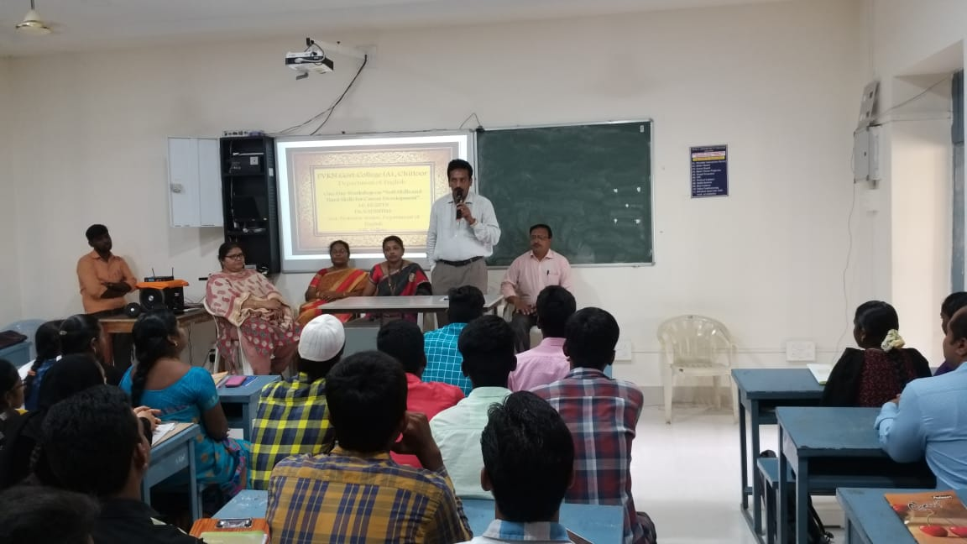
Dr.G.Ananda Reddy,Principal Presidential Address
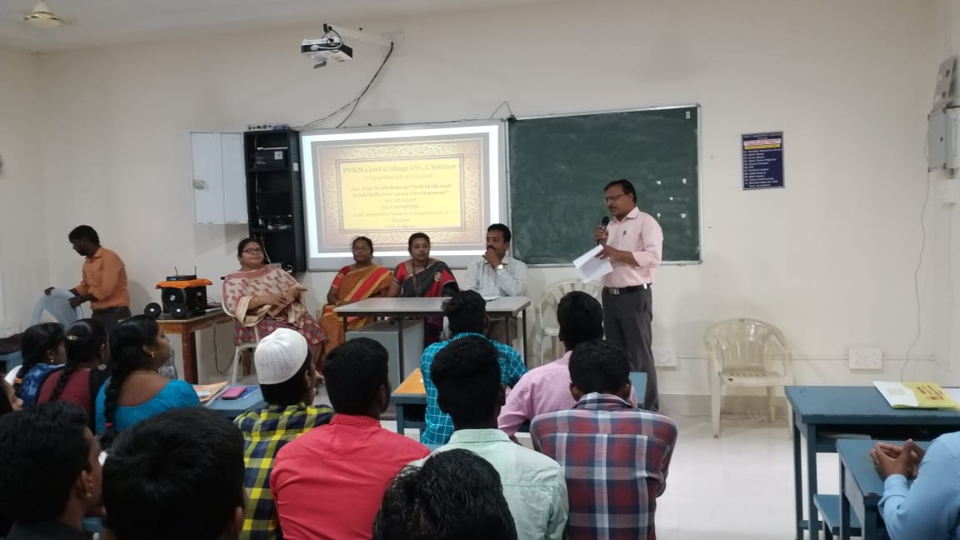
Introducing the Resource Person by Dr.S.V.Ramesh Kumar, Lecturer inEnglish

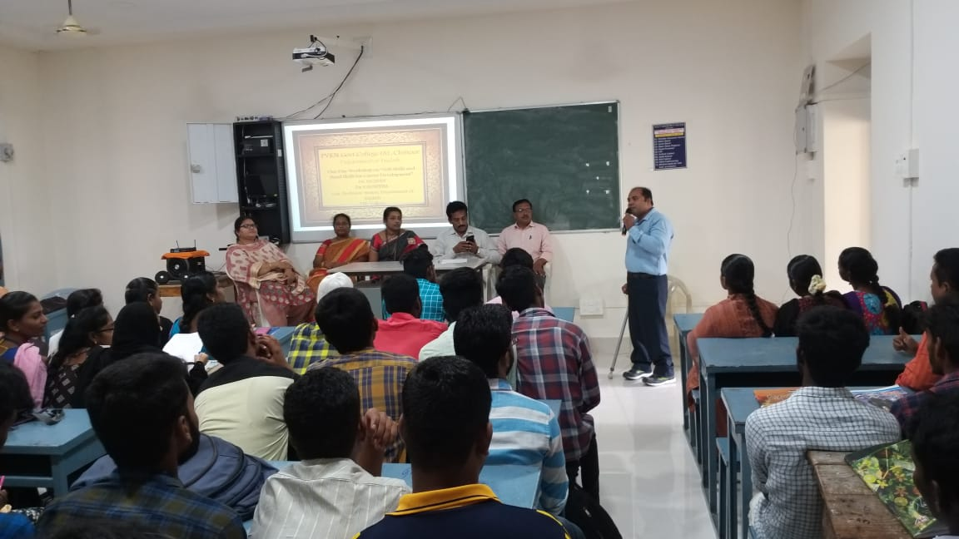
Sri.Mohammed Shafiullah addressing the students on importance of Skills

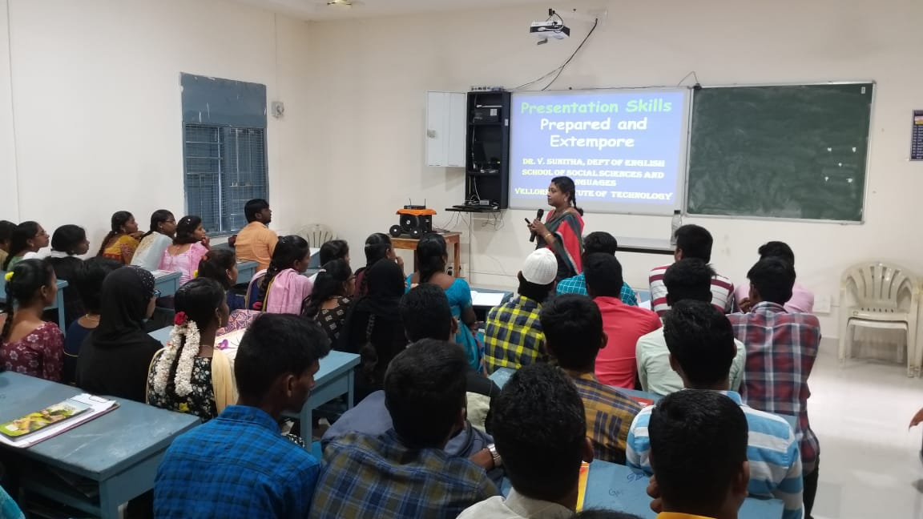
Dr.V.Sunitha, Assistant Professor, Senior conducted session on Presentation Skills

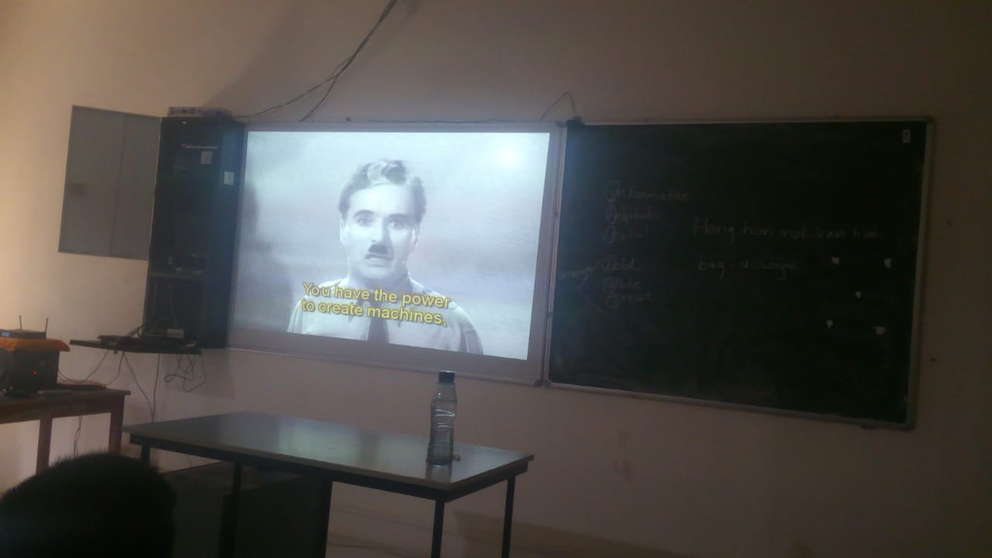
Motivational Video
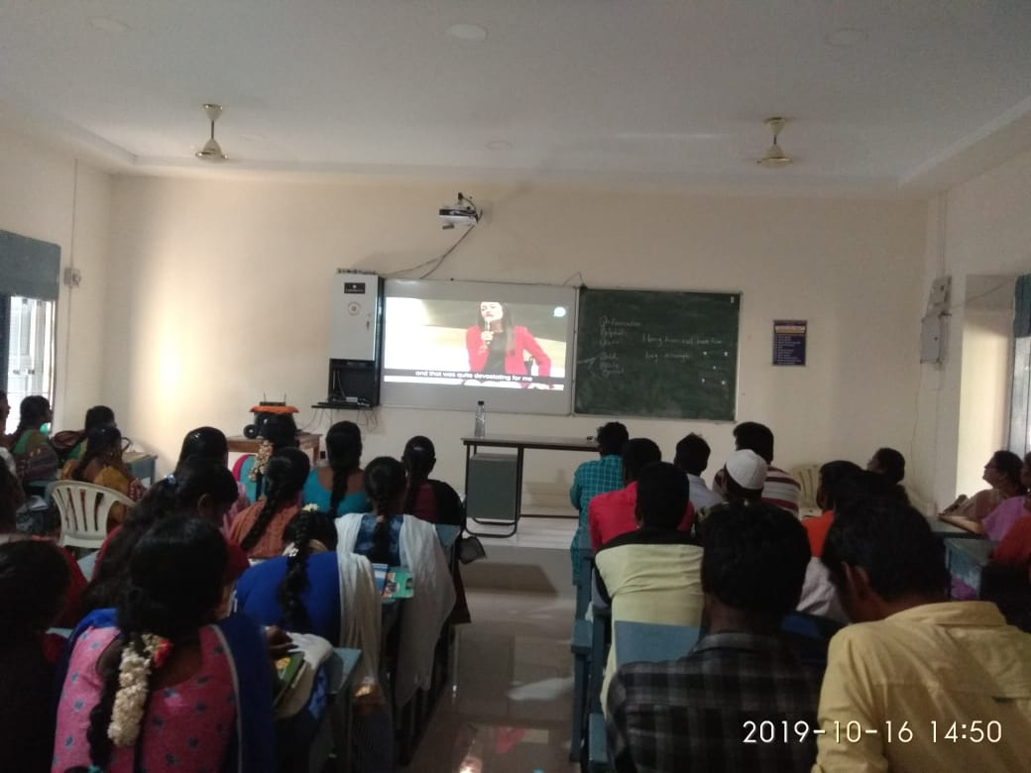
Gif – Video on Presentation Skills

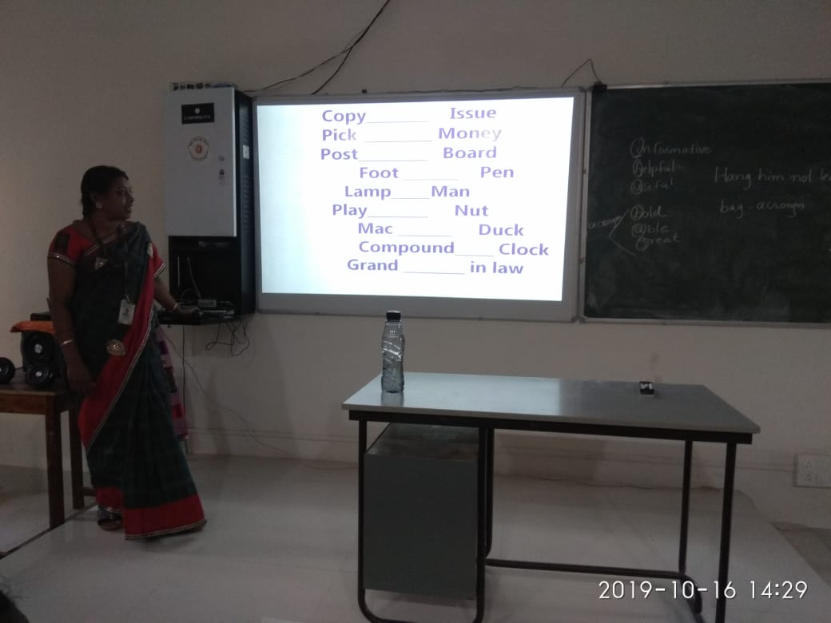
Vocabulary Practice -Activity
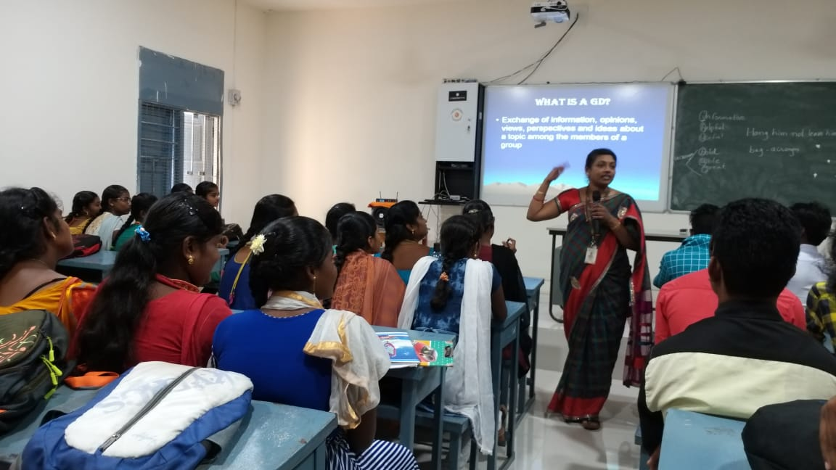

Session on Group Discussion by Dr.V.Sunitha
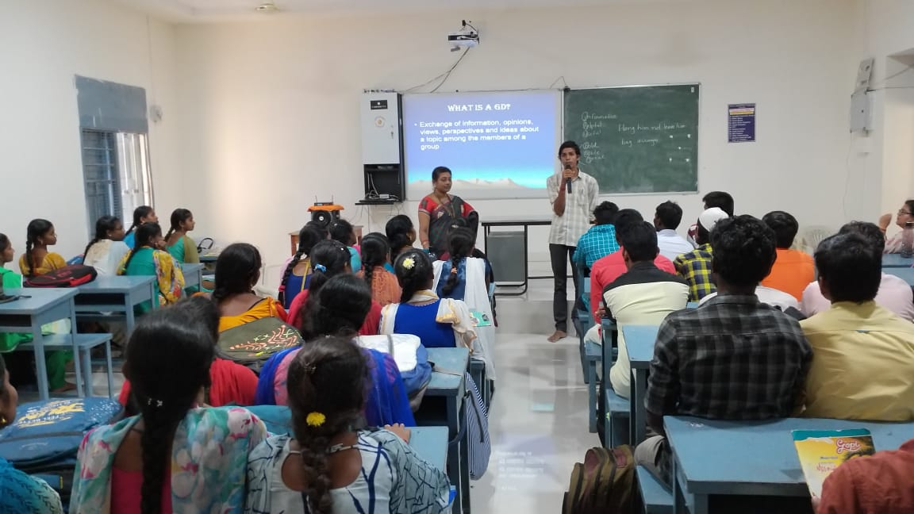
Feedback by Likith Reddy of III BSC (MSCs)

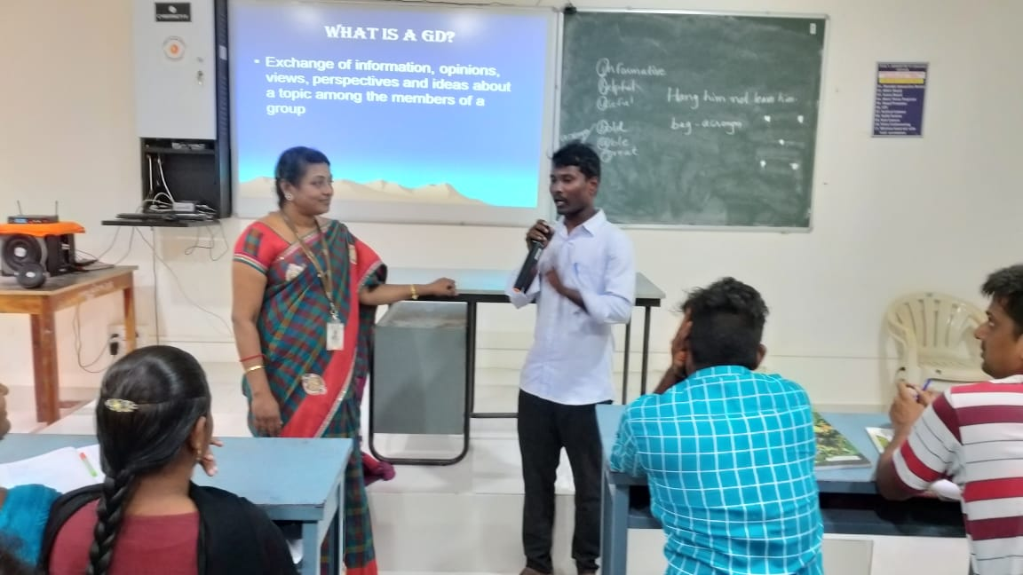

Feedback by Vardarajof IM.A (English)

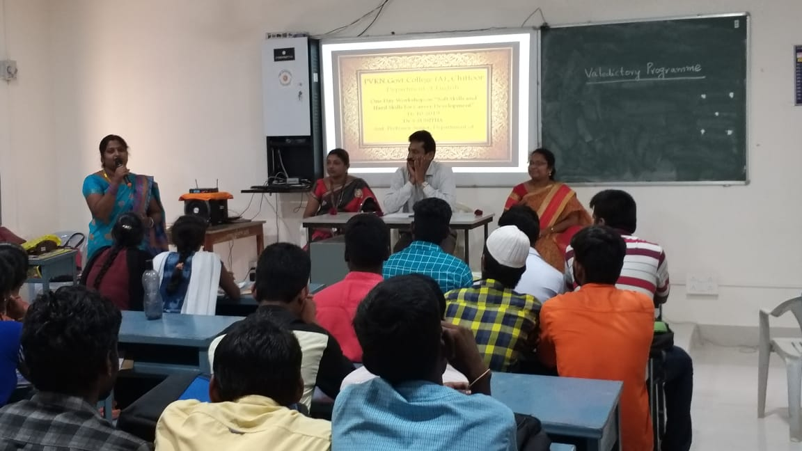

Feedback by Hemalatha of II M.A (English)

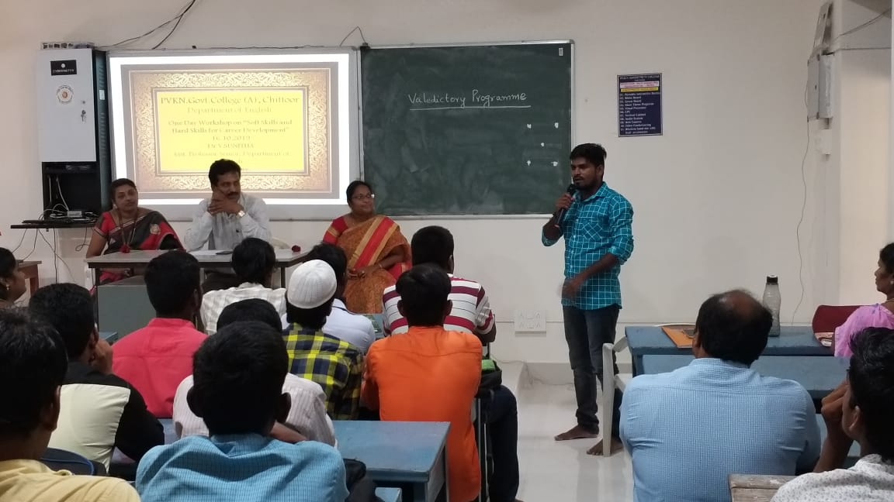
Feedback by Chinna of (II M.A English)

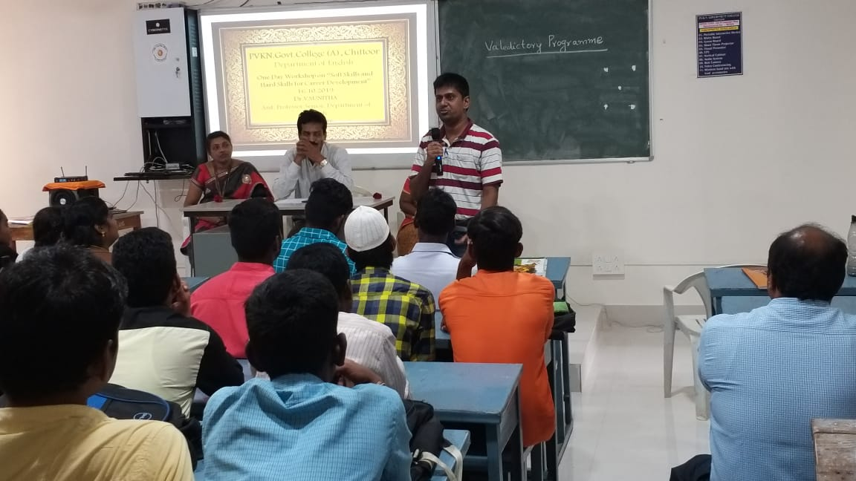
Feedback by Ranjit of (I M.A English)

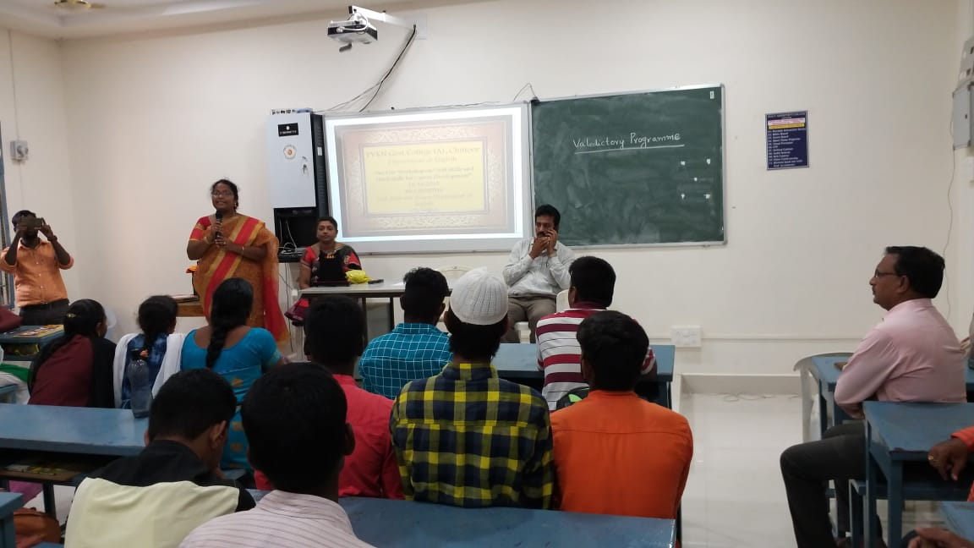

Dr.T.Malathi Gabriel,incharge of the Department of English, proposed Vote of Thanks

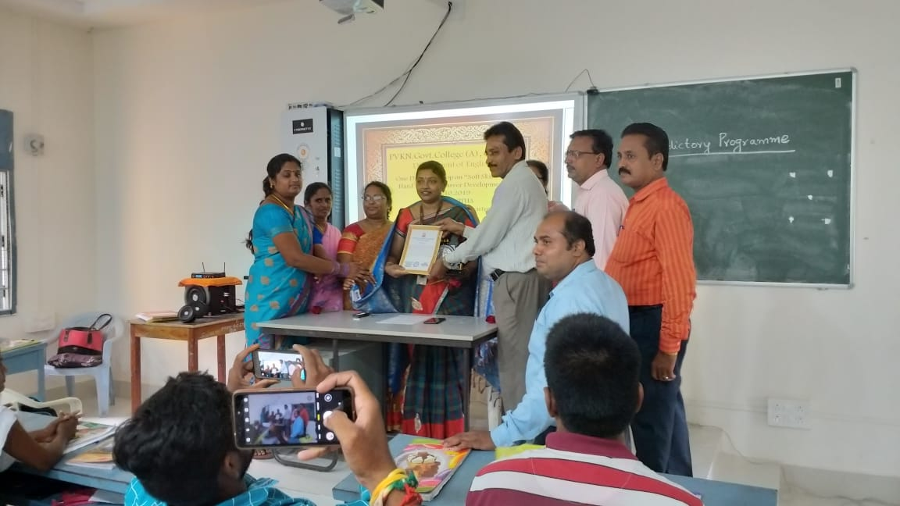
Felicitation to Dr.V.Sunitha, Resource Person of the Workshop

Signature of the Department in Charge/Coordinator:

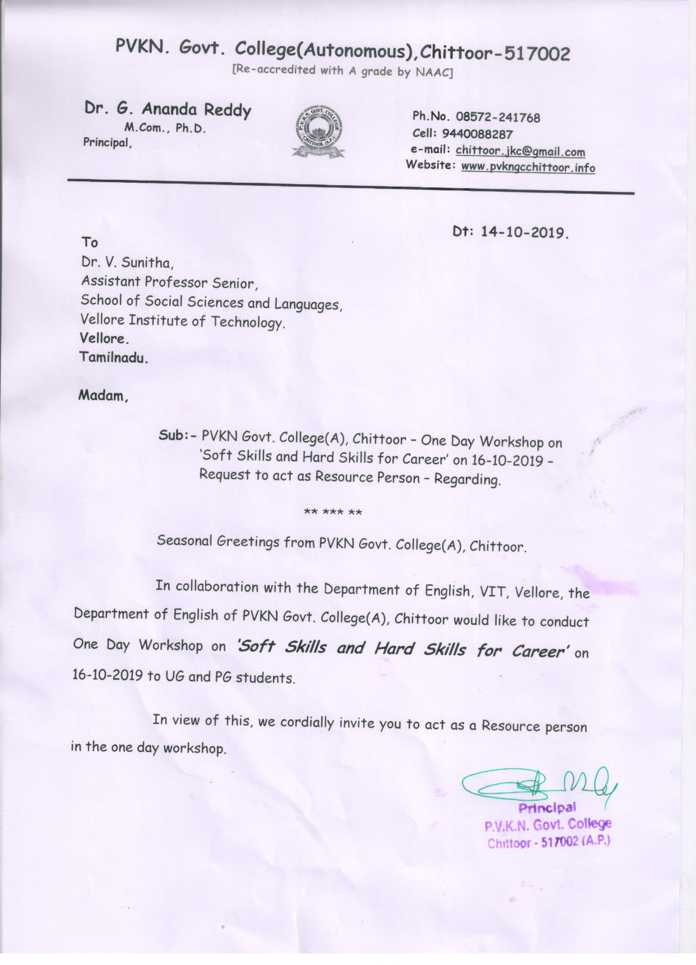

CURRICULUM VITAE
Dr. V. Sunitha
Assistant Professor Senior
Department of English
School of Social Sciences and Languages
Vellore Institute of Technology, Vellore-632014
Mobile: 9490277123 Email : v.sunitha@rediffmail.com, vsunithaster@gmail.com
Academic preparation
• Ph.D. English, Mother Teresa Women’s University, Kodaikanal Title: Exploration of Human Psyche in the Select Novels of Anita Desai. January 2012.
• M Phil., English, Mother Teresa Women’s University, Kodaikanal, 2006
Dissertation: Representation of God in Hopkins’ poems.
• M .A. in English Annamalai University, Chidambaram, 2003.
• B.A. in English, Economics, Psychology NMKRV College for Women, Bangalore, 1996.
Professional Experience
 Assistant Professor (Senior), Vellore Institute of Technology, Vellore June 2016 till date.
Ratified faculty of Jawaharlal Nehru Technological University-Ananthapur.
 Associate Professor and Head of the English Department, October 2005- April 2016, Sreenivasa Institute of Technology and Management Studies, Chittoor.
 Lecturer: Vijayam Degree College, Chittoor. June-Oct 2005.
 Lecturer: Marudhar Kesari Jain College for Women,Vaniyambadi. Oct 2004- April 2005.
 Teacher: T. Abdul Wahid Matriculation School, Ambur. June 2003- Sep2004.
Technical Skill
Diploma in Computer Application.
Resource Person –Invited Talks
- Honoured as the Chief Guest for a seminar and gave a talk on “From Repression to Revolution- Transformation in the Writings of Select Women Writers” Govt. Arts College for Women. Krishnagiri. 20 Mar 2019
- Honoured as the Chief Guest for the Citizenship camp, delivered speech on the roles and responsibilities of a teacher at Vidyavihar BEd. and Teacher’s Training College, Ambur on 26 Jan. 2018.
- Chaired the session at Reva University’s Int. Conf. on “Revisions and Re-interpretations in Story Telling” on 3-4 Feb, 2017.
- Resource person, workshop “Learning English is Fun” to students and “Pedagogical Skills and Professional Development” for professors at Marudhar Kesari Jain College for Women, Vaniyambadi on 10th August 2015.
- Resource person for UGC sponsoredNational Seminar “Can the Subaltern Speak? The Emergence of Women Writers after 1950” at Jayaraj AnnapackiyamCollege for Women, Periyakulam, Tamilnadu on 12th & 13th December 2013.
Board of Review Member
• Journal of English Language, Literature and Translation Studies.ISSN-2349-9451(online): ISSN (PRINT): 2395-2628
• Nominated as a member of the Evaluation Board to adjudicate PhD Thesis at Madurai Kamaraj Univ., Manonmaniam Sundaranar Univ. since 2013.
• As an external examiner conducted viva on 11 Feb. 2017 to Nagamani and awarded PhD at V. V. Vanniaperumal College for Women, Virudhunagar, affiliated to MKU, Madurai.
• Question paper setter to Madanapalle Institute of Technology and Science, Madanapalle.
Research Guidance
Supervised 2 scholars for M. Phil in English, Mother Teresa Women’s University, Kodaikanal.
Presently supervising 4 scholars- PHD English.
Book Published
“Exploration of Human Psyche in the Select Novels of Anita Desai.” Scholars’ Press, Germany. ISBN- 978-3-639-51846- 13 Sep 2013. Pgs. 340.
International Publications
1. Cyber Literature. Article, “The Psychic Trauma in Anita Desai’s, ‘Cry, The Peacock.”22:2.58-65. ISSN 0972-0901 Dec 2008.
2. Bride-in-Making. Article, “Is despondency the Epithet of Wedding? An Appraisal of Anita Desai’s Voices in the City.” 53 and 54, 46-51, ISSN: 0975-1610, Jul 2009
3. Atlantic Literary Review. Article, “An Appraisal of Anita Desai’s Voices in the City” 10:3. 67-80. ISSN 0972-3269. July-Sep 2009
4. Rock Pebbles Article, “Evolution in the psyche of Anita Desai’s Women: From the Terror and Trepidation of Psychosis to a Sanguine and Bullish View - An Appraisal.”13.2. ISSN 0975-0509.July - Dec. 2009. http://www.rockpebbles.in/2010/12/evolution-in-psyche-of-anita-desais.html
5. Language in India Article, “Utopia, Dystopia, Conflict between Two Extremes, An Appraisal of Anita Desai’s Cry, The Peacock.” Pg.273-278 10:1.ISSN 1930-2940. Jan 2010. www.languageinindia.com
6. Voice of Kolkata. Poem, “Oh Women!”11:1. 23Jun 2010
7. Poetry World Poem, “Woman, a Paradigm of Pulchritude” 3:4. 61 Rn. No. TN ENG 2008/25546. Aug 2010
8. Labyrinth- A Refereed Journal. Short story, “Positive Outlook to Life.” 1:2. 217-219 ISSN 0976-0814 Sep 2010
9. Poetry World Poem, “From Womb to Tomb.” 3: 7. 34 Rn. No. TN ENG 2008/25546 Nov 2010
10. Poetry World Poem, “Value Based Education-a Cry in the Wilderness” 3: 9.33 Rn. No. TN ENG 2008/25546 Jan 2011
11. Poetry World. Poem, “Oh god! Bless us a Boon.”3:11. 19 Rn. No. TN ENG 2008/25546 Mar 2011
12. The Journal of Contemporary Literature. Short story, “Venerable Old-Venomous Young.” 3:1&2. 79-86 ISSN: 0975-1637 Jan 2011
13. Bizzbuzz. Poem, “Tommorrow….?” 14:1. 39 Rn.no. KAR- Eng 02128. Dec 2011
14. The Criterion Book Review on, “Taj Mahal, The Monument of My Love A Poetic Monologue by Dr. T. Swamidoss.”titled, “Mastery, Magnificence and Majesty, in the Poetic Soliloquy.”Pg.1-8.4.2.ISSN: 0976-8165 Apr 2013. www.the-criterion.com/v4/nz/sunitha.pdf
15. The Criterion Poem, “A Clarion Call to the Concupiscence Coves.”4.4. ISSN: 0976-8165.July 2013. http://www.the-criterion.com/V4/n4/Sunitha.pdf
16. The Criterion Poem, “Question mark”. 5.2.ISSN: 0976-8165. April 2014
http://www.the-criterion.com/V5/n2/Sunitha.pdf
17. Trans. Short Story from Tamil, “Discount.” Virtuoso. A Refereed Transnational Journal. 2:2. ISSN: 2249-6076. Feb 2015. Pp. 145-149.
18. Path of Thorns Leads One to a Bed of Roses- Short story. The Literary Herald. 1.2. ISSN: 2454-3365.Imp.Fac-2.24(IIJIF). Sep. 2015. Pg. 223-227
http://tlhjournal.com/Current-Issue.html
19. “Is Marriage a Mirage? An Analysis of Volga’s Short Story Experiment.” Journal of English Literature. 14. ISSN: 2229-4236. Jan 2016.
20. “Women’s Quest for Self-knowledge and Self- realization- An Appraisal of Volga’s Select Works”. Roots. 3.2. ISSN 2349-8684. Oct 2016. Pp. 80-84.
21.Virtues Vital for the Current Cohort- An Appraisal of the Select Poems of the Legendary and Erudite Bards of India. Daath Voyage. Referred. ISSN 2455-7544. Dec 2016. 1.4. Pg-36-52. http://www.daathvoyagejournal.com/current-issue.html
22. Group Dynamics in Group Discussion. The Journal of English Language Teaching (India). 59/2. ISSN: 0973-5208. Imp.Fac- 4.756. March-April 2017. pp. 42-48.
23. Security Issues in Cloud Computing. Journal of Advanced Research in dynamical and Control Systems. 02/2017. ISSN 1943-023X. Indexed in Scopus. SJR-0.136 SNIP-0.294 Cite score-0.16 DOI- Volume no- Source ID-Apr.2018. Pp.1001-1014. Apr. 2017
24.Growth and Development of Start-ups in India. A study with respect to Mechanical and Production Engineering. International Journal of Mechanical and Production Engineering Research and Development IJMPERD 8/2 Imp. Fac- (JCC): 6.8765. Index Copernicus Value (ICV): 60.6. NAAS Rating: 3.11. IBI Factor: 3.2. ISSN (P)-2249-6890. (O)- 2249-8001. Paper ID- IJMPERDAPR201888. DOI: 10.24247/ijmperdapr201888. 775-780. Apr.2018.http://www.tjprc.org/view-archives.php?keyword=Growth+and+development+of+start-ups+in+India++A+study+with+respect+to+mechanical+and+production+engineering&jtype=&fromdate=&to_date=&journal=
http://jardcs.org/archives-special.php?year=2017&issue=02-Special Issue&page=10
http://www.eltai.in/pdf/JOURNAL-MAR-APR-2017.pdf
25. Poem. Wail of Parents-in-law. The Criterion. 9/2. ISSN 2278-9529. May 2018. pp-281-282. http://www.the-criterion.com/V9/n2/Sunitha.pdf
26. Article, “Review Article on K.V.Raghupathi’s Between Me And The Babe.” Research Journal of English Language and Literature (RJELAL). Vol.7.Issue 2. June 2019. ISSN:2395-2636 (P); 2321-3108(O)Pp. 311-317.
27. Article, “The nitty-gritties of Effective Presentations for Technologists.”International Journal of Recent Technology and Engineering. 8.2. ISSN:2277-3878. B impact factor: 5.92. July 2019.Pp.948-952.https://www.ijrte.org/wp-content/uploads/papers/v8i2/B1730078219.pdf
http://www.rjelal.com/7.2.19/311-317%20%20Dr.%20V.%20SUNITHA.pdfScopus Indexed.
Book Chapters Published
1. Indian Fiction in English, Recent Criticism. The Psychic Trauma in Anita Desai’s Cry The Peacock. 187-196.Adhayan. Delhi. 978-81-8435-120-0.2010
2. Indian Fiction in English, Recent Criticism. Repression, Eruption and Edification of Sita in Desai’s Where Shall we go this Summer.176-186.Adhayan.Delhi. 978-81-8435-120-0.2010
3. A Spectrum of Indian Fiction in English. When Cupid’s Arrows Fail? An Appraisal of Anita Desai’s Select Novels. 252-267. Sarup New Delhi. 978-93-80902-34-0. Mar 2011.
4. Anthology of Poetry World. Poems, “Chair”, “Pathetic Cry of Birds”, “Religion.” 214-217.S. Krishnan, Chennai. Rn. No. TN ENG 2008/25546. Apr. 2011
5. Opinions and Critiques on World Renowned Literature Precepts of Propriety and Probity in the Select Works of English Literature. 19-24.Vital Pub., Jaipur.978-93-80274-12-6.2011
6. Teaching English, New Dimensions. Professional Proficiency and Pioneering Practices in English Classroom. 287-298.Alfa Pub. New Delhi.978-93-81465-52-3.2012
7. Ethics and Identity in Contemporary Indo- English Poetry.Ethics and Identity in the Select Poems of Dr. A.P. J Abdul Kalam and Dr. A. Padmanaban.120-131.Authorspres.New Delhi.978-81-7273-654-5.2012
8. Beauty Pageant, Woman’s World, Words and Wounds Sophie and Laila- Sanguine Women of Anita Desai: An Appraisal of Journey to Ithaca. 109-123.Vital. Jaipur.978-93-81169-16-2.2013
9. Post Feminism in India Myth or Reality? The Dauntless Dame of Anita Desai: A Review of her Select Novels.118-128. Adhyayan. New Delhi. 978-81-8435-378-5.2013
10. Emerging Issues in English Language Teaching Innovations in English Language Teaching Methods and Approaches. 244-254. Authors Press. New Delhi. 978-93-81030-46-2.2013
11. Great Women Writers of the World Are Women the Victims of Fate? A Study of Volga’s Select Short Stories. 251-260.Sarup. New Delhi.978-81-7625-940-8.2013
12. “Is Seclusion the Sanctum for the Melancholic Mind?- An Appraisal of Anita Desai's Fire on the Mountain.”Fictional Transformation-Sahitya Akademy Award Winning English Novels. Authors Press. NewDelhi. 978-93-8264-705-8. 2014.
13. “Treatise on Dispersed Symphonies by Dr. K. V. Raghupathi”. Introspective Voyager. Authors Press. NewDelhi. 978-81-7273-850-1. 2014. Pp. 241-256.
14. “Theme of Love and Loss of Companion in the Select Poems of T.Vasudeva Reddy.” An Anthology of Criticism on Six Indian English Poets. Sarup. New Delhi. 978-81-7625-987-3. 2015. Pp. 334-345.
15. “Succinct Lines, Immense Thoughts and Lofty Concepts: A Study of the Select Poems of Chambial.Mapping Thematic Variations in The Poetry of D. C. Chambial.Authors Press. New Delhi. 978-93-5207-022-0. 2015. Pp.376-386.
16. “Exploration of Human Nature and Emotions in the Select Stories of Aju Mukhopadhyay.”The Heterogeneity of Story Writing- A Critical Evaluation of Eight Indian Short Story Writers in English.Authors Press. New Delhi. 978-93-5207-038-1. 2015. Pp.440-453.
17.“Is Isolation and Incompatibility the Blight of Post-Modern Civilization? An Appraisal of Majumder’s Select Short Stories.”The Heterogeneity of Story Writing- A Critical Evaluation of Eight Indian Short Story Writers in English.Authors Press. New Delhi. 978-93-5207-038-1. 2015. Pp. 353-364.
18. “Lessons of Life- An Appraisal of Select Short Stories of Anil. K. Sharma’s Compilation Candid Confession.”The Heterogeneity of Story Writing- A Critical Evaluation of Eight Indian Short Story Writers in English.Authors Press. New Delhi. 978-93-5207-038-1. 2015. Pp. 250-259.
19. “Does Astha Patronize the Ideal of Indian Womanhood? An Appraisal of Manju Kapur’s A Married Woman”. Critical Readings on the Fictional World of Manju Kapur.Aadi, Jaipur. 978-93-82630-88-3. 2016. Pp. 40-48.
20. Poem. “Woman, a Paradigm of Pulchritude.” Oh My Sweetest Love: A Timeless Treasure. Vishwabharati Research Centre, Latur. 978-93-86242-42-6. 2017. Pp. 95.
21. “Shujaat Hussain’s Civic Concern: A Critical Appraisal of his Selected Poems.”The Social, Cultural and Spiritual Dimensions of Modern Indian Poetry in English.InternationalCambridge Scholars Publishing. 978-1-4438-7968-2. 2017. Pp. 53-61
22. “Precepts to People from the Peepal Tree: An Appraisal of K. V. Raghupathi’s Wisdom of the Peepal Tree.” The Social, Cultural and Spiritual Dimensions of Modern Indian Poetry in English.InternationalCambridge Scholars Publishing. 978-1-4438-7968-2. 2017. Pp. 53-61.
23. “Integrity and Compassion in the Poetry of I. K. Sharma.An Appraisal of his Select Poems”.The Poetry of I. K. Sharma. New Tracks and Literary Swings. Authors Press. 978-93-5207-554-6. 2017. Pp. 90-101
24. An Appraisal of Volga’s short story Experiment.Contemporary Indian Women Novelists in English. Atlantic. 978-81-269-2522-3. 2017. Pp. 187-196.
25. “Effectuate Ebullience in English Class by Activity Centred Teaching.”Innovations in English Language Teaching and Literary Studies. Lordine Nuova. 978-81-933682-8-2. 2017. Pp. 1-7
26. “A Detailed Conception on Reading Comprehension.”English Language and Literature. Lordine Nuova. 938678233-2. 2018. Pp. 205-212.
27. “An Appraisal of the Select Short Stories of P. Raja’s My Father’s Bicycle”. Critical Spectrum- The Short Stories of P. Raja. Authors Press. 978-93-87281-91-2. 2018. Pp. 264-275.
Publication in News paper
1. Article, “Where are our Ethics?” The Hindu 1-2-2013
www.thehindu.com/todays-paper/...our-ethics/article4367063.ece
2. Article, “Is it a School or Jail?” The Hindu, Openpage.5-2-2012.
Conference Proceedings
1. “Evolution in the Writings of Select Indian Women Writers”. Can the Subaltern Speak? The emergence of Women Writers after 1915. Jayaraj Annapackiam Collegefor Women. Periyakulum. ISBN 978-81-923038-3-3 2014. Pp. 5-20.
2. Karunya University’s National Conference.Article, “Maya, a Citizen of Utopia, An Appraisal of Anita Desai’s, Cry, The Peacock”.219-222.28 - 29 Nov 2008.
3. Vivekananda College of Arts and Science for Women National Seminar Article, “Identity Crisis in the Select Novels of Anita Desai”.77-80.3 Oct 2007
Publications with Scholars
1. Mohan Raj, V. Sunitha. “ Margaret Atwood’s The Edible Women: A Revolt against Patriarchal Society”. Indian English Literature: A New Approach. Aruthi. 2018.ISBN 978-81-934685-3-1. Pp.15-22.
2. Kalyan Chakravarthy, V. Sunitha. “Brain Training for Learning Vocabulary to enhance Language Competencies in the students of Mechanical Engineering.” International Journal of Mechanical Engineering and Technology. Scopus. 9:12. Dec 2018. ISSN- 0976-6359. IF- 9.2 Pp. 948-953.
3. Mohan Raj, V. Sunitha. “A Study of Confucian Life and Thoughts with reference to the Analects”. International Journal of Research and Analytical Reviews. I F- 5.75, E-ISSN 2348-1269, P- ISSN
2349-5138. Aug. 2018. Pp. 495-497.
4. Mohan Raj, V. Sunitha. “Voice of the Voiceless- Subaltern Predicament in the Select Songs of Two Tamil Movies.” Polemics of Subaltern Consciousness in Academia. Emerald. ISBN- 978-81-7966-488-9. Pp. 166-170.
5. Mohan Raj, V. Sunitha. “Educational Psychology in Tirukkural: An Overview” International Thirukural Conference. Malaysia. Sep. 2019. Tamil Thai Arakatallai. ISBN- 978-81-909877-5-2. Pp 43-50.
6. Mohan Raj, V. Sunitha. “Rabindranath Tagore’s Chandalika: An Amalgamation of Spiritual Conflict, Liberation and Rebel against Marginality.” Shanlax International Journal of English. SSN: 2320-2645.DOI: https://doi.org/10.34293/ english.v7i3.458. Pp. 16-20.

Papers Presented
International Conferences
1. Presented a paper titled, “Skills for Employability.” ELTAI at Crescent Engineering College, Chennai. 10 Feb 2007.
2. Presented a paper titled, “New Learning Technologies and Teacher’s Development.” ELTAI at Sathyabama Univ. Chennai. 9 Feb 2008.
3.Presented a paper titled, “Buoy up your Students by Communication Games.” ELTAI at Anna Adarsh College, Chennai. 5-7 Aug 2010
4. Presented a paper titled, “Humane Teaching and Learning through Literature”. Anna Univ. Chennai. Feb 18-19, 2011.
5. Presented a paper titled, “Professional Development and Innovative Practices in English Classroom” ELTAI at VIT, Vellore. Jun 16-18, 2011.
6. Presented a paper titled, “The Heroines of Anita Desai, an Appraisal of her Select Novels.” Sri Padmavathi Mahila Univ. Tirupathi. Jan 28-30, 2012
7. Presented a paper titled, “Women’s Quest for Self-knowledge and Self- realization- An Appraisal of Volga’s Select Works.” Govt. Arts and Science College for Women, Barugur. 7 Oct 2016.
8. Presented a paper titled, “Indian Women’s Tenacity in Tackling Tight Corners-An Appraisal of the Select Short Stories of Four Indian Writers” at Reva Univ. Bangalore. 3,4 Feb 2017.
9. Presented a paper titled, “Effectuate Ebullience in English class by Activity Centered Teaching” at Auxilium College, Vellore. 17 Feb 2017
10. Presented a paper titled, “New Dimensions in Teaching English” at SSN Engineering College, Chennai. 10-11 Nov 2017.
11. Presented a paper titled, “A Detailed Conception on Reading Comprehension” at Karunya Ins. of Tech. and Sciences, Coimbatore. 2 Feb 2018
12. Presented a paper titled, “Methodologies to use Literary Language in English Teaching” in an Int. conf. on English language Teaching at VIT, Vellore. 2-3 Apr.2018
13. Presented a paper titled, “Online and Offline Practices in EFL Classes” at SCSVMV, Kanchepuram 14 Aug. 2019
National Conference

1. Presented a paper, “Different Attitudes of Women in the Select Short Stories of O.Henry and Mark Twain” IAAS at Auxillium College, Vellore. 7 Sep 2007.
2. Presented a paper, “Feminism in the Select Novels of Anita Desai” Avvaiyar Govt College for Women, Karaikal. 21 Sep 2007.
3. Presented a paper, “Identity Crisis in the Select Novels of Anita Desai” Vivekananda College of Arts and Science for Women. Tiruchengode. 3 Oct 2007.
4. Presented a paper, “MulkRaj Anand’s Social Consciousness and his Zeal to reform the Society as Portrayed in his Select Short Stories” SV University, Tirupathi. 29 Mar. 2008.
5. Presented a paper, “Maya, a citizen of Utopia, An Appraisal of Anita Desai’s Cry, The Peacock”. Karunya University, Coimbatore. 28-29 Nov 2008
6. Presented a paper, “Multicultural Communication” CRR College, Tirupathi. 9-10 Aug. 2010.
7. Presented a paper, “Global Warming- God’s Warning” SITAMS, Chittoor. 7 Jan 2011.
8. Presented a paper entitled, “A Study on Gender Issues as seen in Bama’s Sangati: An Ideological Perception.” Loyola College, Vettavalam. 10 Oct. 2017.
Programmes Organized
1. FDP on “ Academics as Critical Thinkers” VIT 11 Feb.2017.
2. Guest lecture “Communicare: An Effective Personality Trait” VIT, Vellore 15 Feb 2017.
3. Virtual Guest Lecture, “Act now to Embrace the Brighter Future” VIT, 26 Oct 2018.
4. Guest Lecture, “Resume Writing and Interview Skills”, VIT, 4 Feb 2019.
5. Guest Lecture, “Professional Skills for Engineers” VIT, 22 Feb 2019.
6. FDP, “Moving towards Professional Excellence” VIT, 7 Mar 2019.
7. Industrial Visit to Modern Breads Chennai, VIT students 19 Mar 2019.
8. Guest lecture on, “Writing Skills for Graduates” VIT 6 Sep 2019, Prof. Nagakala K.S.A.
9. GL on, “Career Skills for Engineers” 19 Sep 2019, Harshitha Yadav, Quinox, Bangalore.
Training Programmes / Workshops Attended
Attended 30 FDPs for the past 3 years at VIT.
1. Residential Programme, “Teaching Skills and Co-operative Spirit in the Institutions.” Marudhar Kesari Jain College for Women, Vaniyambadi. 29 - 31 Jan 05.
2. Training, Soft Skills “Train the Trainer Programme”. JNTU, Hyderabad. 23 - 27 July 07
3. “FDP on Soft Skills”. IEG-JKC & Globarena Technologies at SVCET, Chittoor. 26 Nov-1 Dec 07
4. Two Workshops, “PhD Scholars’ Research Orientation”. Mother Teresa Women’s University & Extension centre, Chennai. 23.8.07 and 29.1.08
5. Summer School “Developing Interpersonal Communication Strategies.” IIT, Kharagpur. Aug 10-19/ 2009
6. Workshop, “Shakir’s Personality Development Program,“Six Secrets of Success”SITAMS, Chittoor12 Sep 2009
7. Workshop, “Soft skills through the Aesthetics of Literature.”VIT, Vellore. 6 Oct 2010
8. Workshop, “Practical and Psychological Approaches to Language Learning”VIT, Vellore.4 Dec 2010
9. Workshop, “Global Perspectives on becoming better Business English Teachers.”Cambridge English Teacher. ESOL Chennai. Hotel Pride.17 Nov 2012
10. FDP, “Empowering Faculty on Life Skills.”Vidyanikethan, TirupathiApr 5-6 2013
11. Training, “Human Values and Professional Ethics.”PVKN Government College, Chittoor. July 25-27, 2014.
12. Workshop, “Making Teaching and Learning a Fun Filled Experience.” VIT, Vellore. 16 Mar. 2016
13. Workshop, “Academic Writing and Publication Ethics.” VIT, Vellore. 5 Aug. 2016.
Responsibilities
- Member - NAAC team, SSL, VIT.
- Handling classes for Research Scholars of PHD English.
- Course Co-ordinator for English for Engineers and Basic English courses.
- School level Research Coordinator
- Soft Skills Course In-charge
Achievements
- Felicitated as a chief guest on Women’s Day, 2019 by Vanitha club, Chittoor.
- Received Research award for 2016, 2017, 2018 in recognition of contribution to research publications at VIT, Vellore.
- Felicitated as one of the chief guests for the installation function of Vasavi Club, Ambur on 2 Feb 2014 along with Tamilnadu Education minister. Got applause for illuminating speech on welfare activities.
- Bestowed ‘Best Teacher Award’ by Lions Club Gold, Chittoor on 15 Sep 2012.
- The Handouts prepared on the latest English software and its features, the latest English websites that enhance English learning, presented in the International Conference won word of praise and recognition among the delegates in an international conference.
- Secured the highest mark and won award during 2nd year of graduation.
Strengths
• Capability to inspire students by effective teaching skills.
• Proficient to motivate and instill confidence in English to regional medium students.
• Has incorporated computer training with English language instruction in the computer lab.
• Ability to draft poems, stories and articles on any issue that affects the society.
• Capability to design many innovative activities and games to teach English and make the class highly interactive at UG and PG level. (a few of them were also published as chapters in books)
Details of Past Work Experience in SITAMS.
• Handled English theory and lab for I &III B Tech, I MCA, Professional Ethics for II B Tech, Business Communication for I MBA, Placement-Training for IV B Tech.
•As thehead of English department,took care of work load, classes’ allotment, timetable, placement training, organizing college events, updating website etc.
•Designed autonomous syllabus for I B Tech English, I MBA, I MCA both theory and lab.
• As ECS ( English Communication Skills) Coordinator designed syllabus, plan of action, material (Teacher’s,Students’ copy) for II, III 1st and 2nd semesters of B Tech course.
• Established e-classroom, installed Walden software to promote technology oriented English learning to students. Μember- College Academic Committee, Disciplinary Committee, NBA Committee. Coordinator for NSS, I BTech student counseling.
- Secured top position in college feedback since the academic years 2006-16.
- Motivated and enabled many students to present papers in conferences.
- One of the students won second prize at GISTCollege, Nellore.
- Shaped the lives of many perverted students by counseling.
- Achieved 100% result by breaking down seemingly large learning tasks into meaningful and manageable segments.
- Awarded with a cash prize and a certificate for the support and co-operation extended towards National Board of Accreditation, AICTE, New Delhi.
- As a secretary of SITAMS college’s Literary Club, co-ordinated Group Discussion which was published in The Hindu, Education Plus on 6-10-2008, Chittoor Edition.
- Motivated students and edited their articles which were published in The HINDU, Education Plus.
• Drafted write-ups and updated events in the college website.
• As an NSS Coordinator conducted eye camps, organized various outreach Programmes-Global Handwash Day, Road Safety Measures, Environmental Awareness, Education Awareness Campaign, AIDS awareness day, National Science Day, Voter’s day etc
• Organized a workshop on Human Values and Professional Ethics to engineering students and instilled in them dissipating values and ethics necessary for peaceful life on 11th August 2014.
• Edited college calendar, newsletter, NAAC application.
• Coached homemakers with Basic English speaking skills through number of activities.
• Educated seven batches of unemployed youth hailing from poor background and composed material on Resume preparation, Telephone skills, Grammar, Phonetics under ‘Yuva Nirman’ programme organized by the college.
- Trained Degree college students in soft skills in a symposium held on 9th Nov, 2008 at VijayamCollege, Chittoor.
• Organized two workshops focusing on JKC ( Jawahar Knowledge Centre) initiatives and equipped students to face interviews, GDs, Presentation skills etc. August 2007.
Professional Memberships
• English Language Teachers Interaction Forum, ELTIF
• Indian Book Chronicle. IBC
• Poetry World
• Labyrinth, • All-Round
• English Language Teachers Association of India, ELTAI
• Indian Association for American Studies, IAAS
• Indian Society for Technical Education, ISTE
• Forum for Musings, JNTU Journal of English Studies.
• Cyber Literature, an International Journal of English Studies
• Bridge-in-Making, an International Journal of English Studies
• Rock Pebbles, an International Literary Magazine
• Contemporary Vibes, Literary Magazine
• International Journal of English Language, literature and Translation Studies
- Voice of Kolkata, an international bi-annual magazine
- The Atlantic Literary Review, Quarterly
- The Indian Science Congress Association

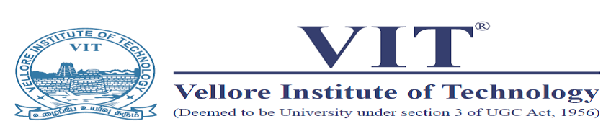
One day Workshop on
"Soft Skills and Hard Skills for Career"
Date- 16 October 2019
PVKN Govt. College, Chittoor.AP.

Schedule
S.no | Time | Sessions
1. | 10 oo -10.15a.m | Inauguration
2. | 10.15 to 10.30a.m | Introduction, An overview on Soft Skills
3. | 10.30 – 11.30a.m | What are presentation skills and how to enthral your audience by giving an Effective Presentation’
 | 11.30- 11.40 | Break
4. | 11.40- 1.00a.m | Videos, Gifs on Good and Bad Presentation
 | 1.00 -2.00 | Lunch Break
555 | 2.00- 3.00pm | Vocabulary Practice
 | 3.00 -4.00Pm | Interactive Session & Feedback by Students
 | 4.00 – 4.30 | Valedictory

Dr. V. Sunitha
Asst. Professor (Senior), English
Department of English
School of Social Sciences and Languages
Vellore Institute of Technology
Vellore-632014
Mob-9490277123
sunitha.venugopal@vit.ac.in
v.sunitha@rediffmail.com

