INAUGURATION OF “CERTIFICATE COURSE IN ENGLISH FOR TEACHER ASPIRANTS”
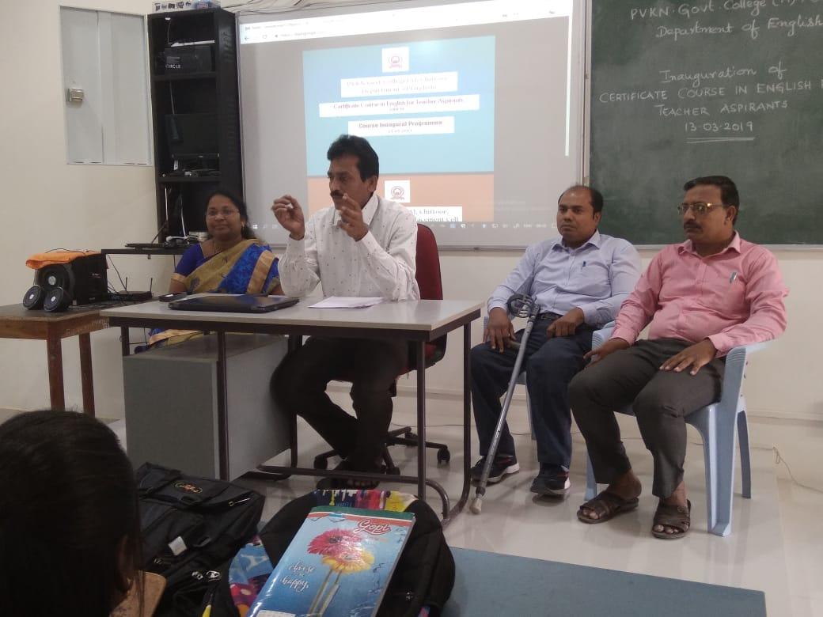
Inauguration of “Certificate Course in English for Teacher Aspirants” by the Principal of PVKN Govt College (A), Dr.G. Ananda Reddy on 13.03.2019 in the Arts Virtual Lab. On this occasion, PG students from all the Departments participated. 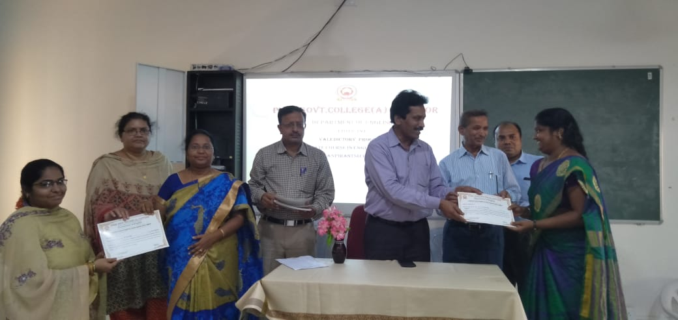Certificate Distribution to the PG students of CETA Course offered by the Department of English, by the Principal of PVKN Govt College (A).
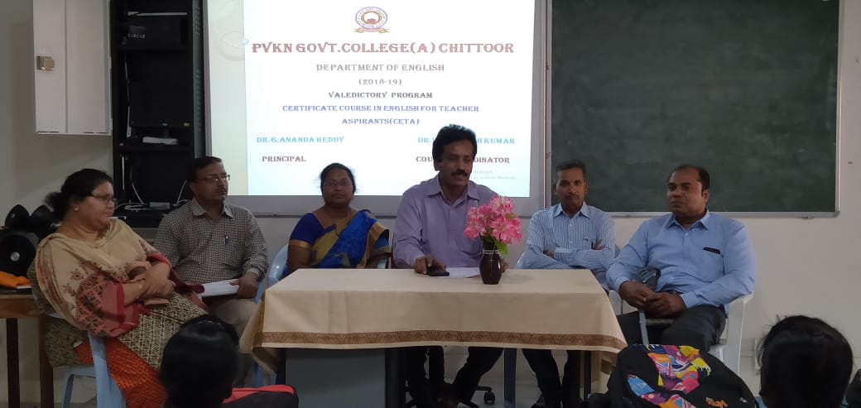
Valedictory function of “Certificate Course in English for Teacher Aspirants” by the Principal of PVKN Govt College (A) by Dr.G. Ananda Reddy in the Arts Virtual Lab.

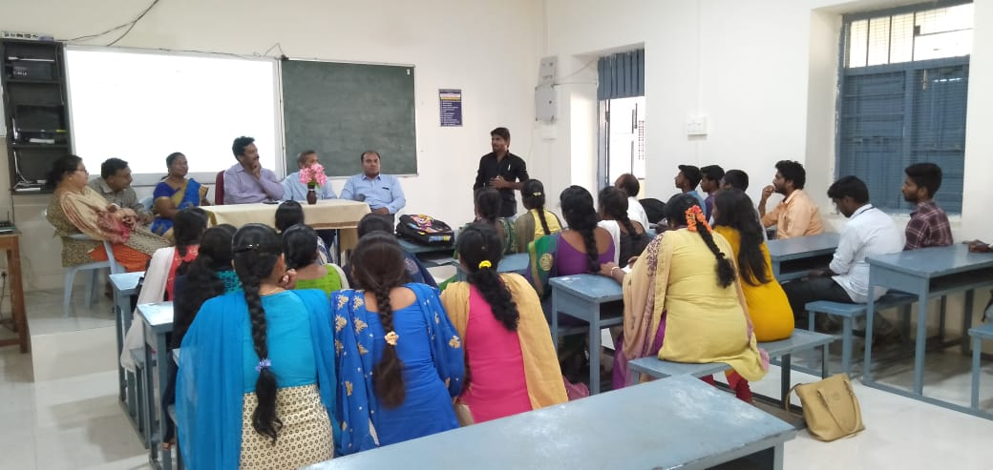
In the Validictory function, students share their experience while undergoing the CETA Course.

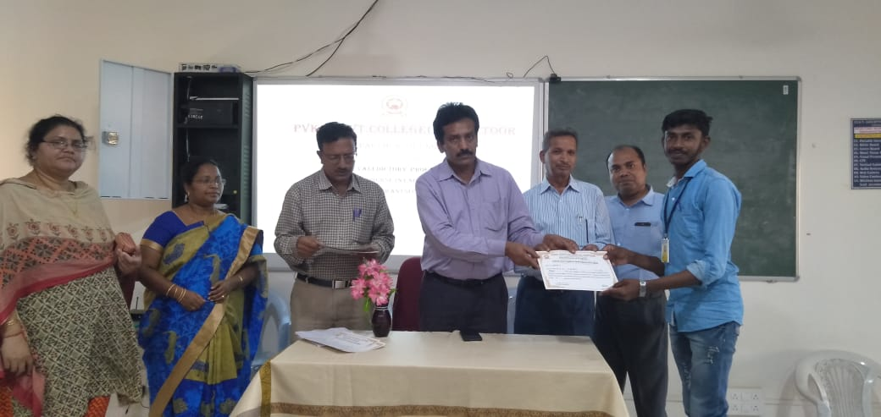
Students of CETA Course received their certificates after their successful completion of the course

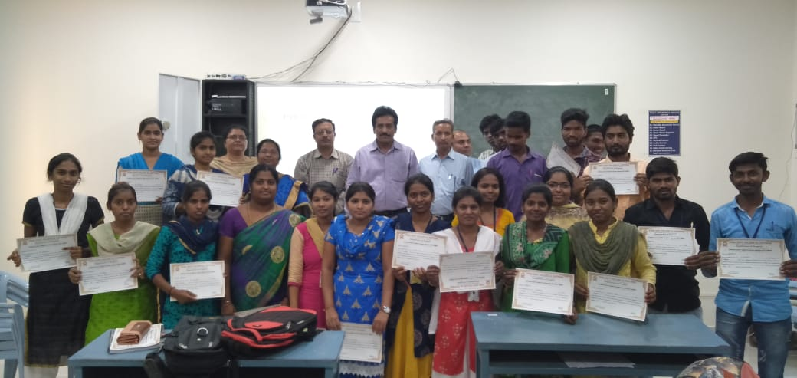
Students of CETA Course received their certificates after their successful completion of the course

