**DEPARTMENT OF COMMERCE**

**BRIDGE COURSE PHOTOS 16-12-2020**

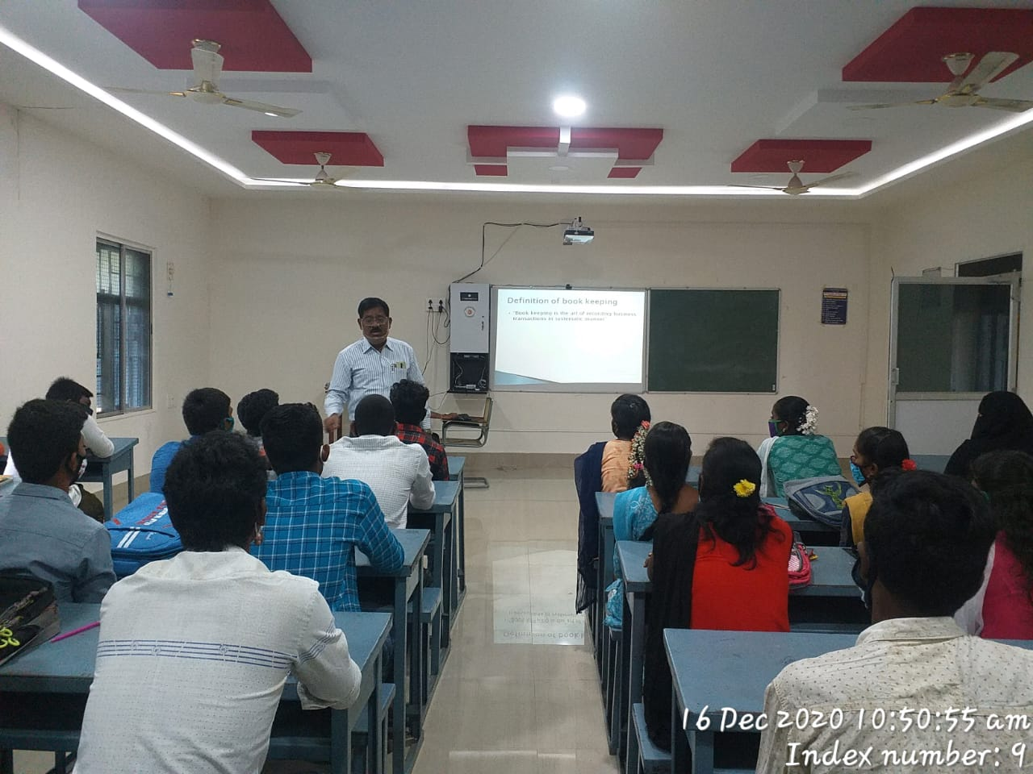

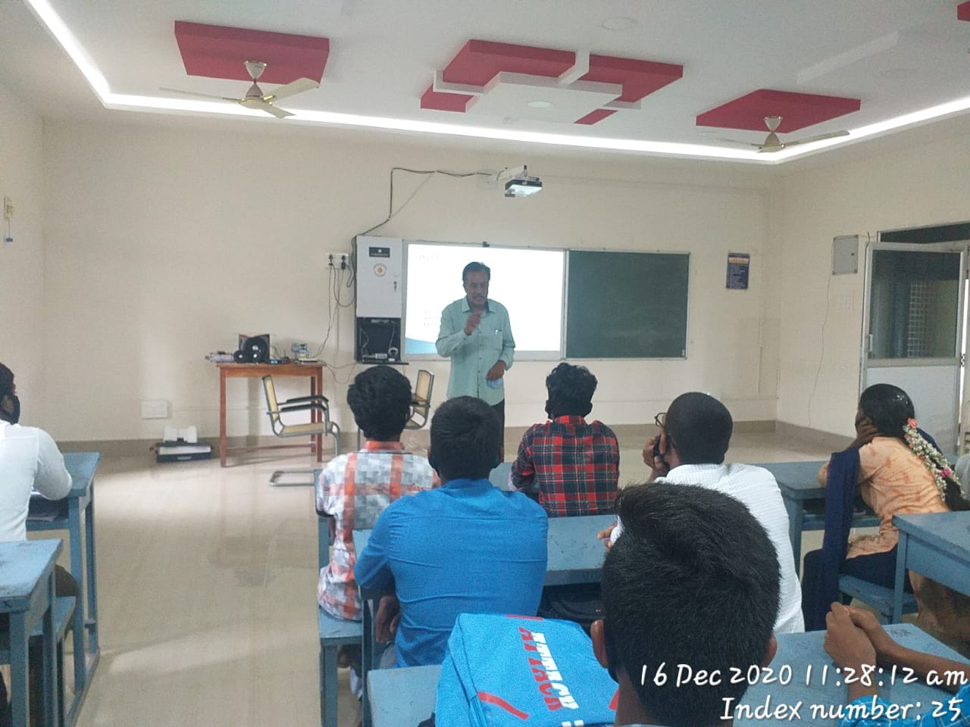

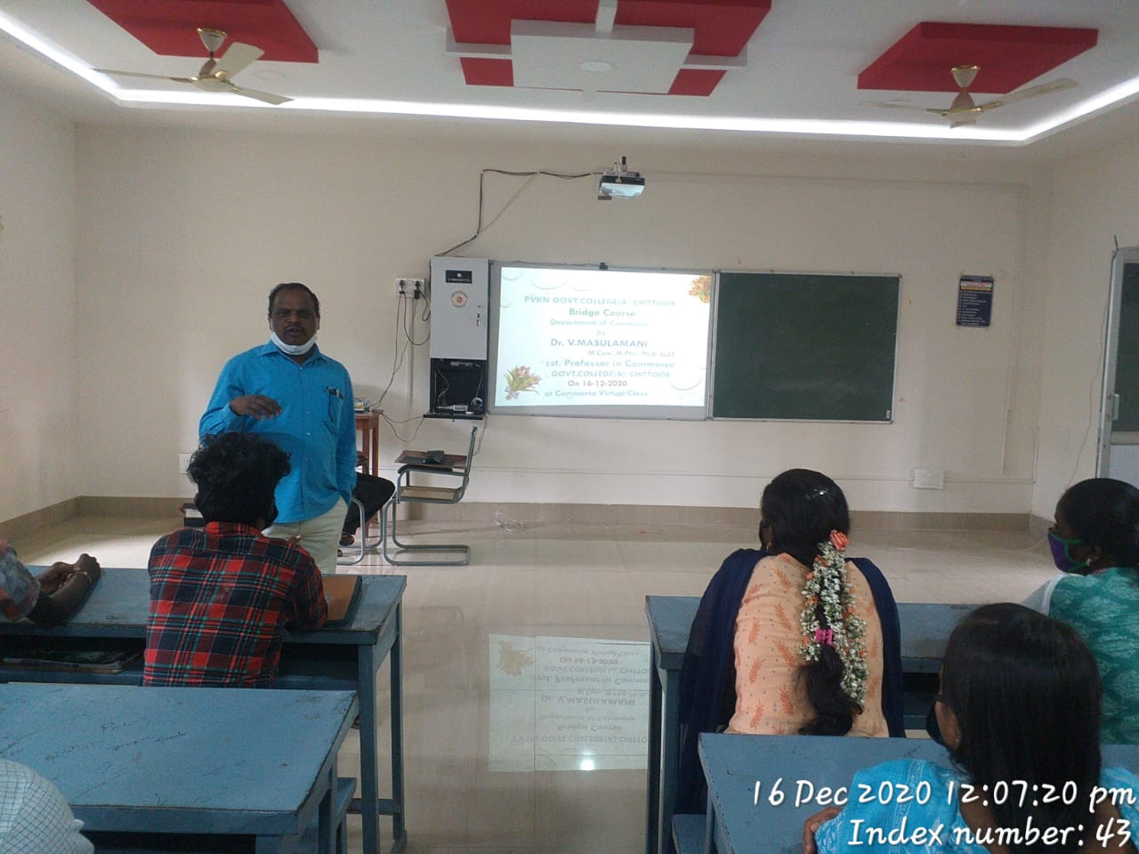

**BRIDGE COURSE PHOTOS 17-12-20**

|  |  |
| --- | --- |
| C:\Users\Commerce\Desktop\Bridge Course Photos 2020\17-12-20\WhatsApp Image 2020-12-23 at 13.44.36 (1).jpeg | **C:\Users\Commerce\Desktop\Bridge Course Photos 2020\17-12-20\WhatsApp Image 2020-12-23 at 13.43.57.jpeg** |
| **C:\Users\Commerce\Desktop\Bridge Course Photos 2020\17-12-20\WhatsApp Image 2020-12-23 at 13.44.05.jpeg** | **C:\Users\Commerce\Desktop\Bridge Course Photos 2020\17-12-20\WhatsApp Image 2020-12-23 at 13.44.09.jpeg** |
| **C:\Users\Commerce\Desktop\Bridge Course Photos 2020\17-12-20\WhatsApp Image 2020-12-23 at 13.44.39.jpeg** | **C:\Users\Commerce\Desktop\Bridge Course Photos 2020\17-12-20\WhatsApp Image 2020-12-23 at 13.44.02.jpeg** |

**BRIDGE COURSE PHOTOS 18-12-20**

|  |  |
| --- | --- |
| **C:\Users\Commerce\Desktop\Bridge Course Photos 2020\18-12-20\WhatsApp Image 2020-12-23 at 13.44.12.jpeg** | **C:\Users\Commerce\Desktop\Bridge Course Photos 2020\18-12-20\WhatsApp Image 2020-12-23 at 13.44.21.jpeg** |
| **C:\Users\Commerce\Desktop\Bridge Course Photos 2020\18-12-20\IMG-20201218-WA0073.jpg** | **C:\Users\Commerce\Desktop\Bridge Course Photos 2020\18-12-20\WhatsApp Image 2020-12-23 at 13.44.46.jpeg** |
| **C:\Users\Commerce\Desktop\Bridge Course Photos 2020\18-12-20\WhatsApp Image 2020-12-23 at 13.44.28.jpeg** | **C:\Users\Commerce\Desktop\Bridge Course Photos 2020\18-12-20\WhatsApp Image 2020-12-23 at 13.44.50.jpeg** |

**BRIDGE COURSE PHOTOS 19-12-20**

|  |  |
| --- | --- |
| **C:\Users\Commerce\Desktop\Bridge Course Photos 2020\19-12-20\WhatsApp Image 2020-12-23 at 13.44.32.jpeg** | **C:\Users\Commerce\Desktop\Bridge Course Photos 2020\19-12-20\WhatsApp Image 2020-12-23 at 13.44.36.jpeg** |
| **C:\Users\Commerce\Desktop\Bridge Course Photos 2020\19-12-20\WhatsApp Image 2020-12-23 at 13.44.56 (1).jpeg** | **C:\Users\Commerce\Desktop\Bridge Course Photos 2020\19-12-20\WhatsApp Image 2020-12-23 at 13.44.43.jpeg** |
| **C:\Users\Commerce\Desktop\Bridge Course Photos 2020\19-12-20\WhatsApp Image 2020-12-23 at 13.44.28 (1).jpeg** | **C:\Users\Commerce\Desktop\Bridge Course Photos 2020\19-12-20\WhatsApp Image 2020-12-23 at 13.44.52.jpeg** |

**BRIDGE COURSE PHOTOS 21-12-20**

|  |  |
| --- | --- |
| **C:\Users\Commerce\Desktop\Bridge Course Photos 2020\21-12-20\IMG-20201221-WA0032.jpg** | **C:\Users\Commerce\Desktop\Bridge Course Photos 2020\21-12-20\WhatsApp Image 2020-12-23 at 13.44.49.jpeg** |
| **C:\Users\Commerce\Desktop\Bridge Course Photos 2020\21-12-20\WhatsApp Image 2020-12-23 at 13.44.18 (1).jpeg** | **C:\Users\Commerce\Desktop\Bridge Course Photos 2020\21-12-20\WhatsApp Image 2020-12-23 at 13.44.34.jpeg** |
| **C:\Users\Commerce\Desktop\Bridge Course Photos 2020\21-12-20\WhatsApp Image 2020-12-23 at 13.44.24.jpeg** | **C:\Users\Commerce\Desktop\Bridge Course Photos 2020\21-12-20\WhatsApp Image 2020-12-23 at 13.44.51.jpeg** |

**BRIDGE COURSE PHOTOS 22-12-20**

