PVKN.Govt.College(A), Chittoor
Department of Hindi
Activities 2019-20
1. Name of the Activity | Hindi Elocution Competition
2. S.no of the Activity | 01/2019-20
3. Date | 16.09.2019
4. Number of students participated | 21
5. Number of faculty involved | 01
6. Aim & Objectives:
(i) To improve the speaking skill of students.
(ii) To develop the confidence, body language and historical knowledge of the students.
(iii) Every year from 14 September to 21 September, Rajbhasha Week or Hindi Week is celebrated on the occasion of Hindi Diwas. Different competitions are organized throughout this week.

7. Brief Report:
Hindi elocution competition was conducted to UG students of this college on 16.09.2019 from 2 pm to 3pm in Room no.127. Topic for the competition is “राष्ट्रभाषा हिन्दी ” This competition is conducted as part of the Hindi divas celebrations-2019.

8. Programme outcomes:
(i) This competition helped to develop the knowledge of Hindi
(ii) It helped the students to develop the study skills, research skills and communication skills.
(iii) Built confidence
(iv) The art of Public speaking to develop students.

HINDI ELOCUTION
1ST PRIZE - S.AFSANA 2ND M.SCS
2ND PRIZE - KARTHIK 1ST B.A

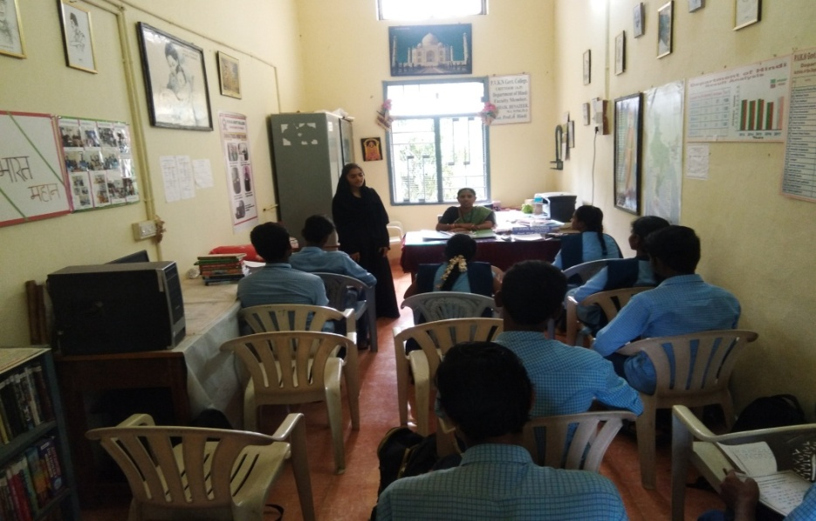

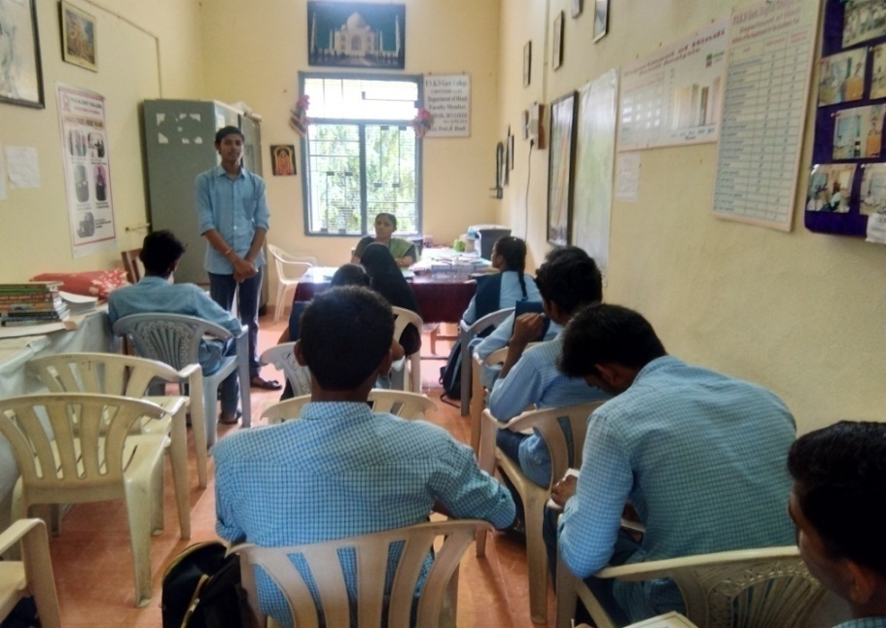
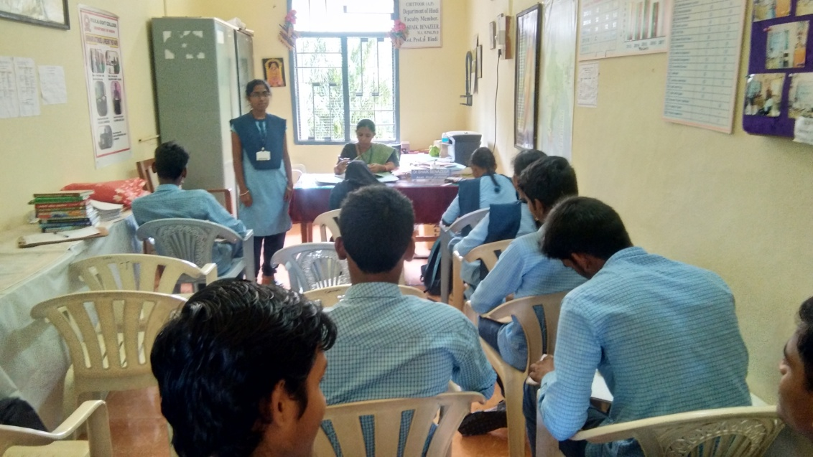
Signature of the Department in Charge/Coordinator:

