PVKN.Govt.College(A), Chittoor
Department of Hindi
Activities 2019-20
1. Name of the Activity | Hindi Essay writing Competition
2. S.no of the Activity | 02/2019-20
3. Date | 18.09.2019
4. Number of students participated | 32
5. Number of faculty involved | 01
6. Aim & Objectives:
(i) To improve the writing skill of students.
(ii) To develop the Hindi language and History of Official Language knowledge of the students.

7. Brief Report:
Essay Writing competition was conducted to UG students of this college on 18.09.2019 from 1.30pm to 3.00 pm in Room no.127. Topic for the competition is “राष्ट्रभाषा हिन्दी : महत्त्व ” This competition is conducted as part of the Hindi day celebrations-2019.

8. Programme outcomes:
(i) This competition helped to develop the knowledge of Hindi.
(ii) It helped the students to develop the study skills, research skills and communication skills of the students.
(iii) explained about the benefits , development and use of Hindi language through essay writing and other activities.
(iv) Improve knowledge to the students and helpful to competitive exams like UPSC, BANK PO other Govt. sector Exams.

ESSAY WRITING :
1ST PRIZE - D.USHA 2ND M.S.CS
2ND PRIZE – N.CHANDANA 1ST B.ZC

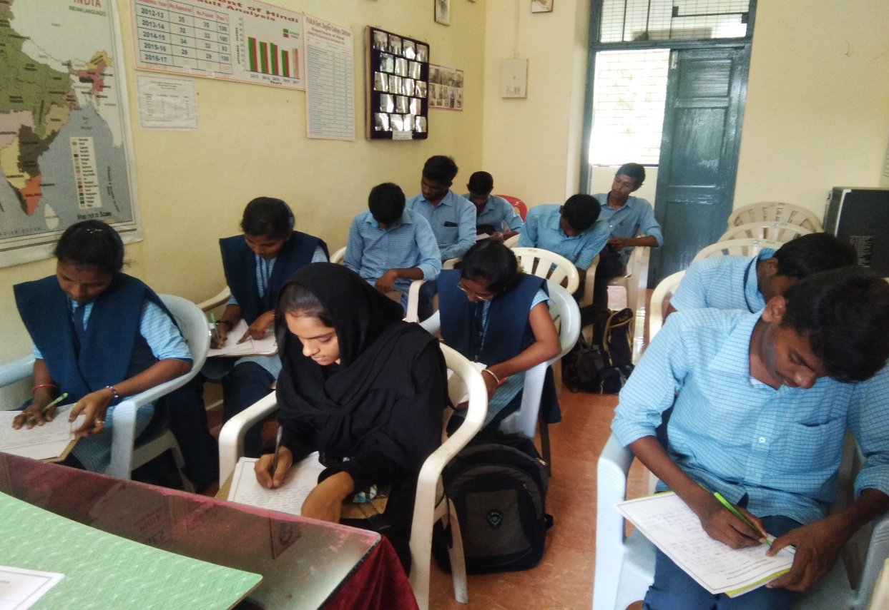
Essay Writing

