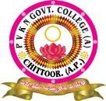
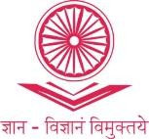
PVKN GOVERNMENT COLLEGE (A)
(Accreditedwith‘A’GradebyNAAC)
INTERNAL QUALITY ASSURANCE CELL(IQAC)
VelloreRoad,CHITTOOR-517002.A.P.
www.pvkngcchittoor.ac.in

Empowering Women – A Legacy of Sustainable Initiatives and Inspiring Achievements

1. Title of the Practice
"Empowering Women: A Legacy of Sustainable Initiatives and Inspiring Achievements"
2. Objectives of the Practice
● Promote Gender Equality: Support equal opportunities for women.
● Foster Economic Independence: Equip women with skills for financial self-reliance.
● Raise Awareness: Educate women on their rights and opportunities.
● Support Sustainable Development: Involve women in environmental and community- focused activities.
3. The Context
The practice aims to address societal challenges faced by women, aligning with broader gender equality goals. To focus on education, empowerment, and participation in sustainable development of women. `
4. The Practice
Health and Wellness: Over the past five years, 10 health programs have promoted physical and mental well-being among women students through yoga, fitness training, and mental health awareness.
Leadership and Mentorship: 60 programs have been conducted, pairing women students with mentors to guide them academically and in career development, supported by merit scholarships for academic excellence.
Sustainability Projects: 12 programs involving organic farming and environmental initiatives have engaged women in maintaining green spaces and promoting sustainability.
Cultural and Educational Activities:
Sports Achievements: 7 programs celebrated women’s sports victories and participation. Cultural Activism: 6 programs highlighted women’s roles in preserving cultural heritage. NCC and NSS Participation: 10 programs focused on women’s leadership in community service. Blood Donation Drives: 4 drives showcased women’s contributions to community health. All-Round Skilled Women: 10 programs recognized women excelling in academics, sports, and culture. Placement and Progression: 20 placement drives and 15 progression programs supported women in securing jobs and advancing in higher education.
5. Evidence of Success
Participation: Over 70% of women students engaged in these initiatives.
Impact: Numerous success stories highlight the transformative impact on women’s lives. Awards: 5 state-level awards have been received for sports and cultural achievements. Community Feedback: Positive feedback reflects the increased confidence and empowerment of women students.
6. Conclusion
These initiatives have significantly empowered women at PVKN Govt. College, fostering gender equality and sustainable growth. The college continues to build on this strong foundation, driving progress in education and community involvement.

Gender Sensitized Activities
One Day National Webinar on Gender Equity
To create Gender sensitized community within the campus as well as in the society, PVKN college organized One Day National Webinar on Gender Equity was conducted on 06-05-2022.
Dr. P. Neeraja, Assistant professor in Women Studies, Sri Padmavathi Mahila university, Tirupati delivered a talk on gender equity.

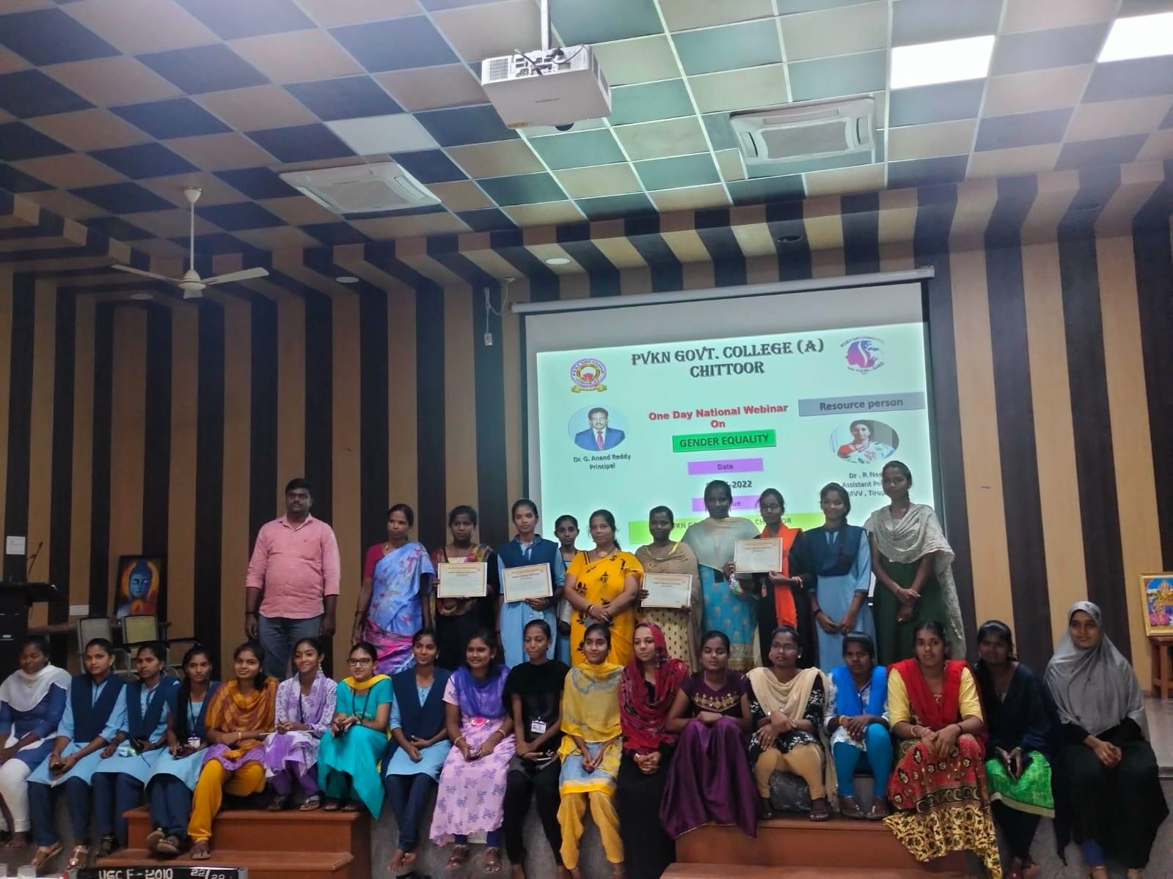
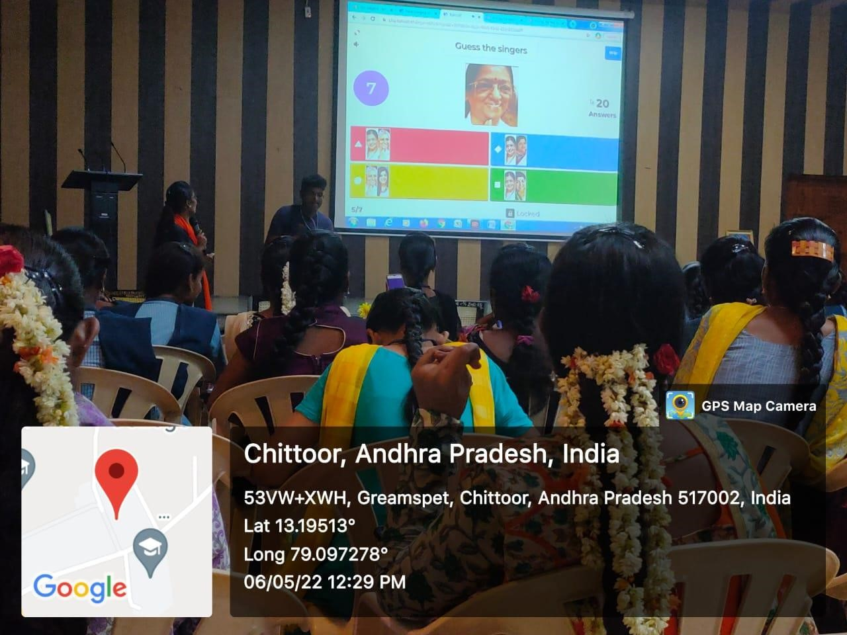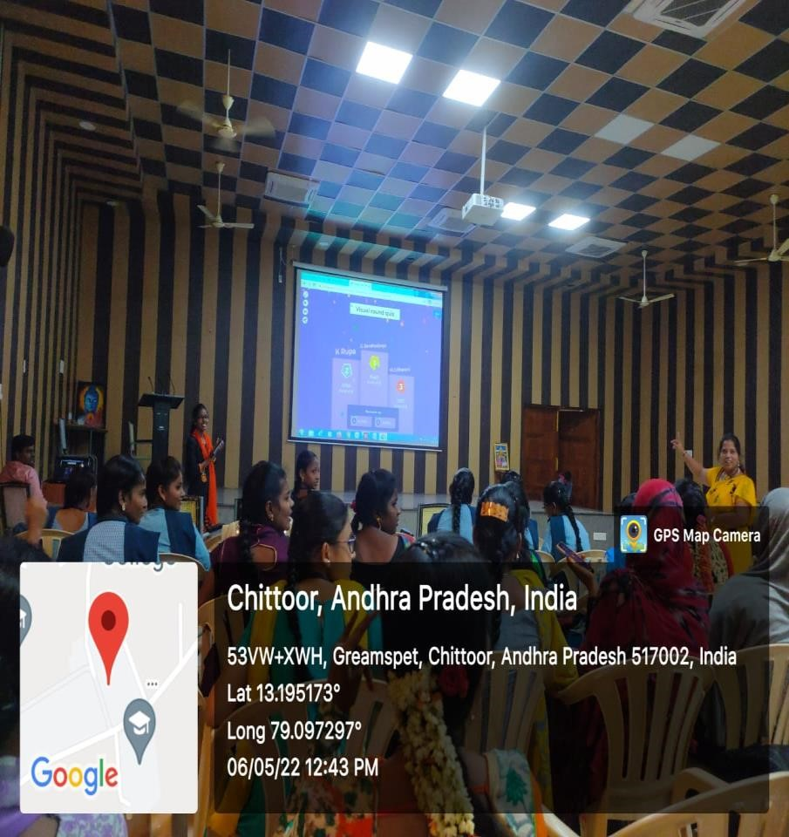

Save Girl Child

To ensure survival, protection and empowerment of the girl child, Women Empowerment Cell conducted a programme, “Save Girl Child” on 24-01-2023.
Resource persons from District medical and Health department delivered talk on importance of a girl child for the society.
Participants were sensitized on gender equity, women empowerment, self-employment and women education.

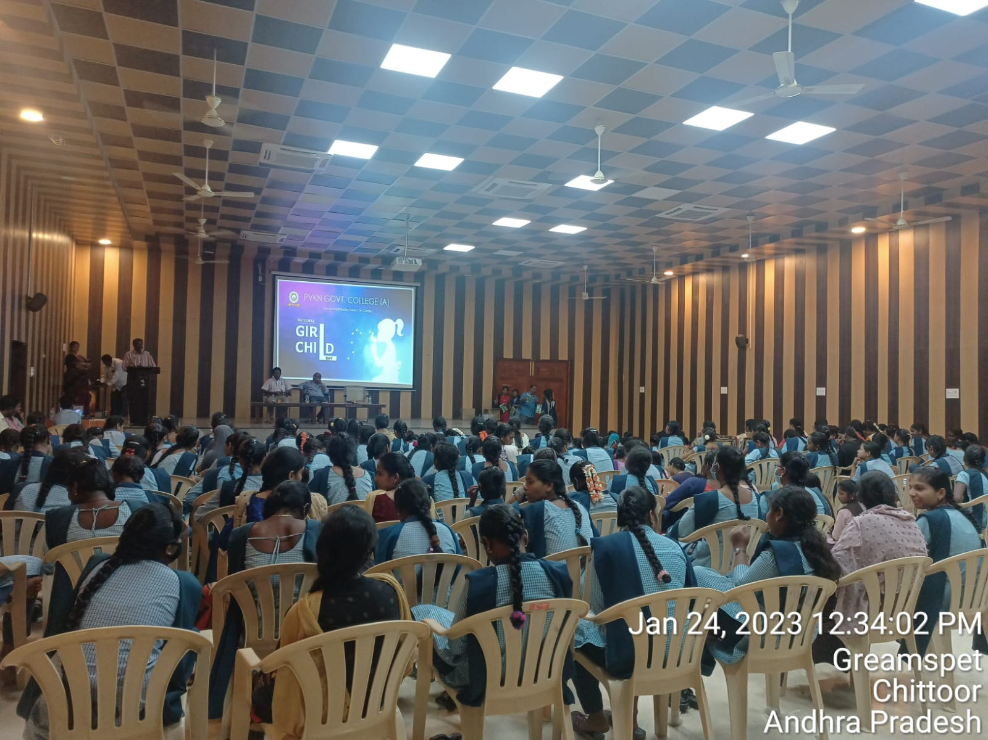

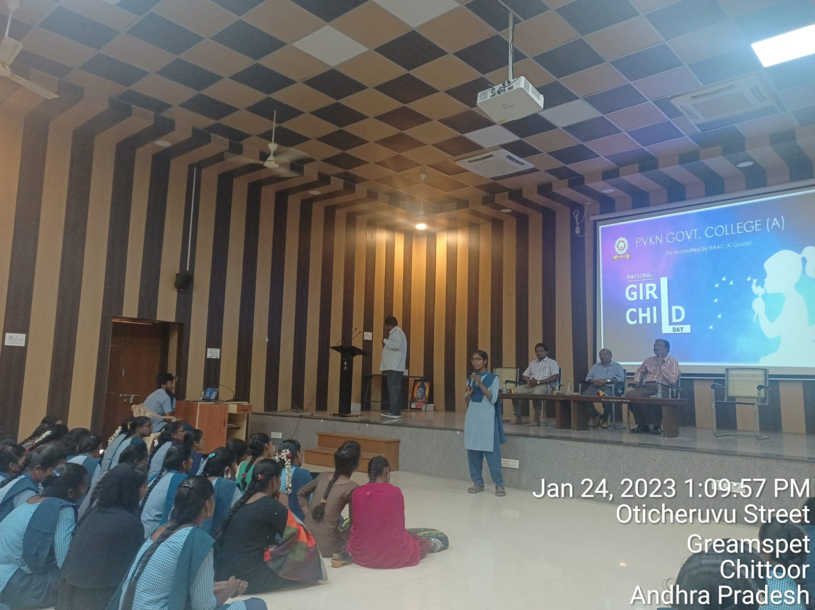

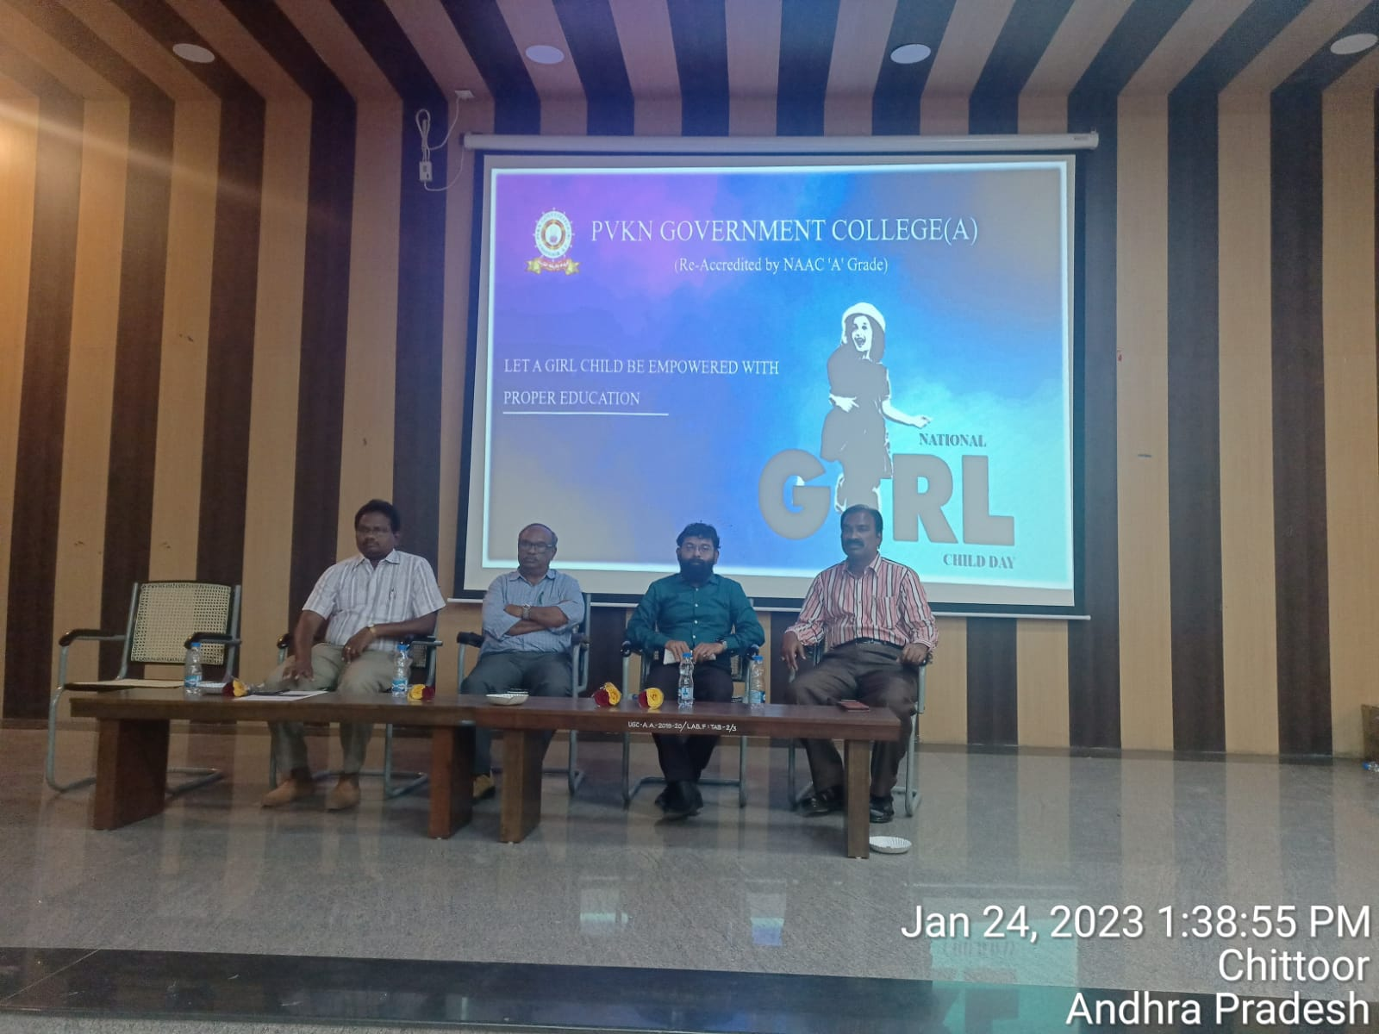

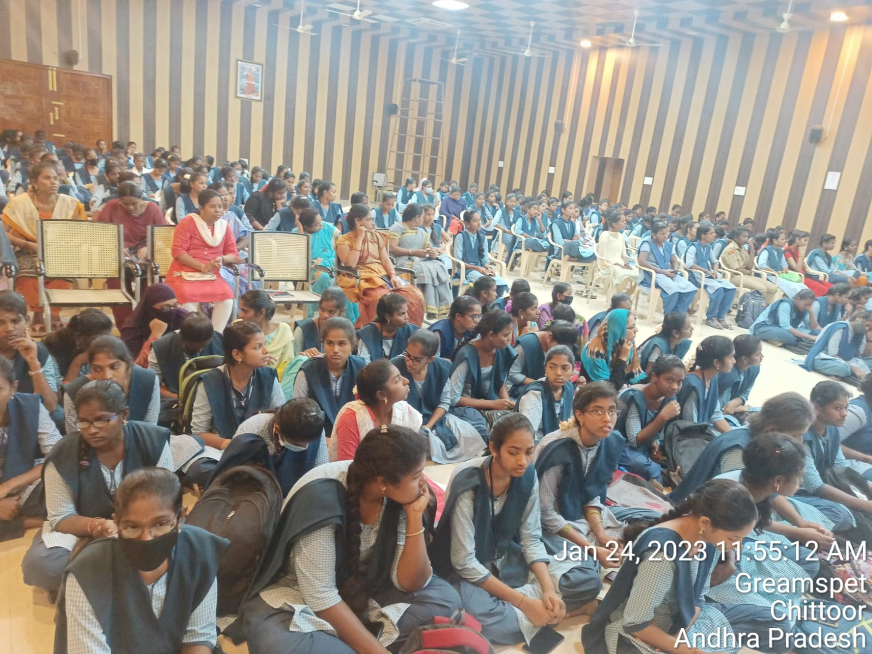

World Suicide Prevention Day
World Suicide Prevention Day was conducted jointly by Women Empowerment Cell and NSS on 08-09-2022.
Chief guest: Smt. K. Naga Sowjanya, Sub Inspector of police, Disha police station, Chittoor.

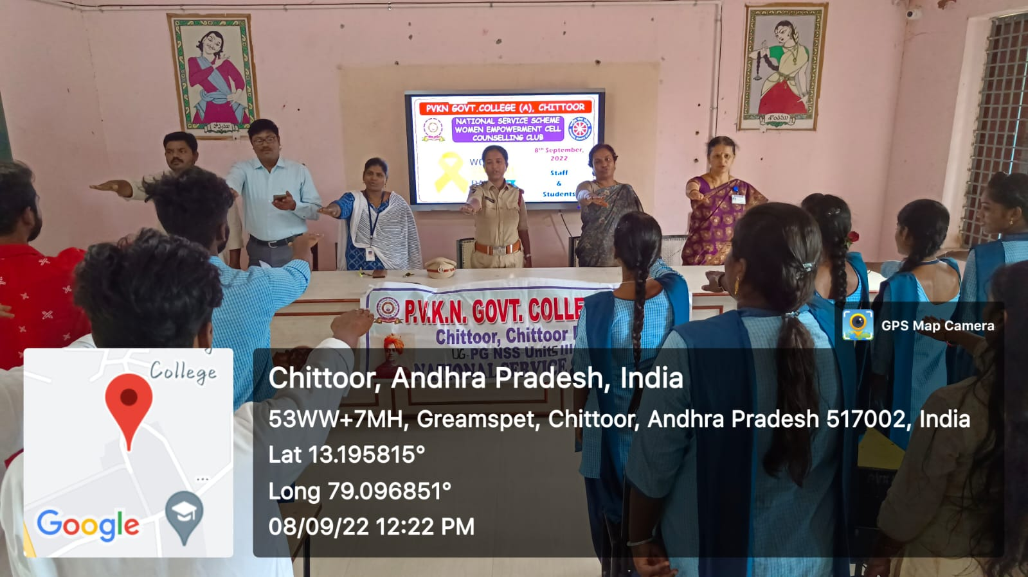

YOGA INTERNATIONAL Day
Women Empowerment Cell organized YOGA International Day on 21-06-2022. Many participants took part in this event and performed YOGA. Smt.Hemalatha, student of Diploma in Yoga of P.V.K.N.Govt.Degree College demonstrated YOGA. She explained the importance of 12 Surya Namaskara’s.
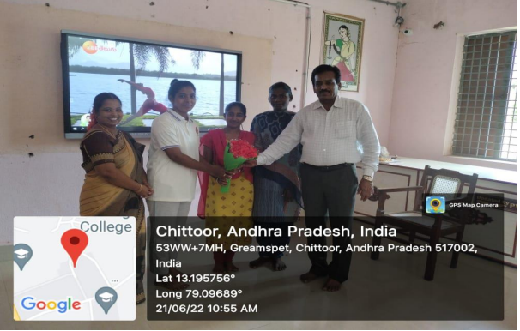

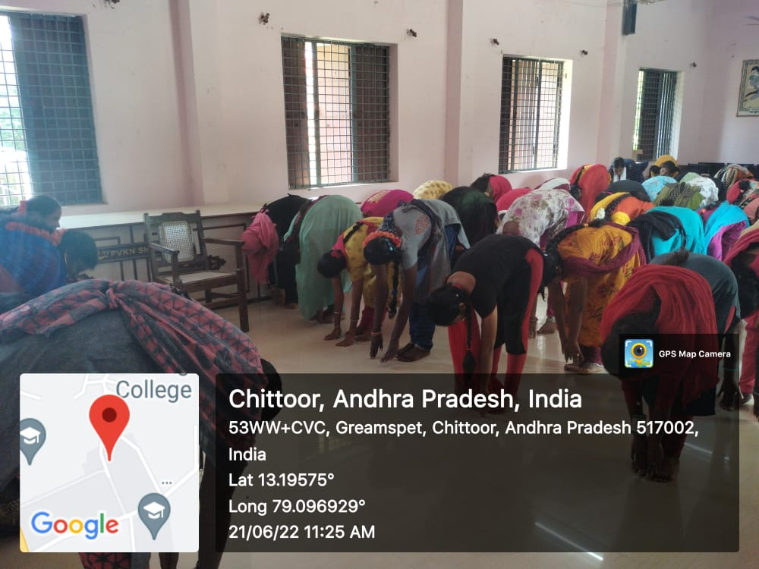
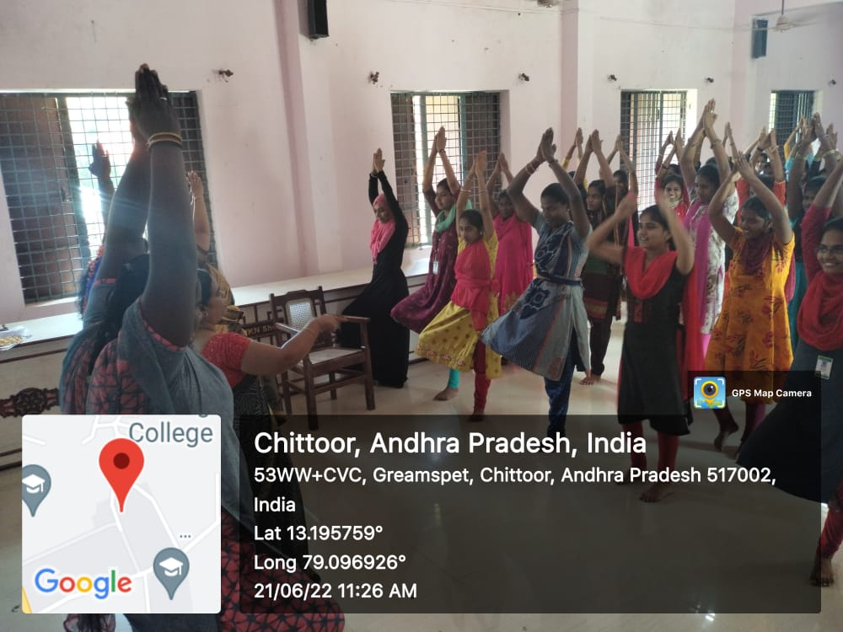

Drawing, Painting and Elocution Competition on “ Role of Women in Freedom Struggle” On 13-08-2022
Women Empowerment Cell conducted Drawing, Painting and Elocution competition for the students on 13-8-22 on topic: “Role of women in freedom struggle”

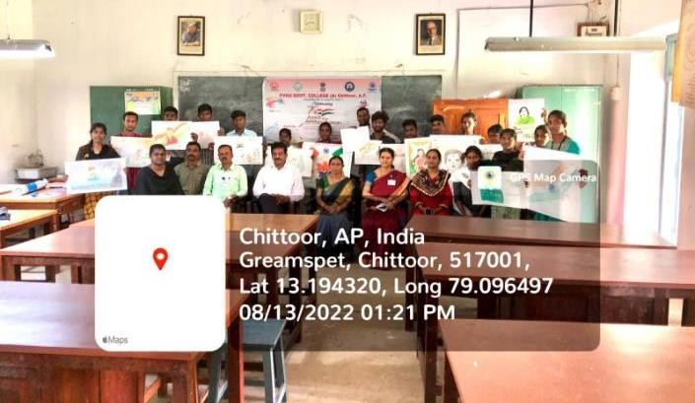

Disha Awareness Programme on 2022
The Empowerment through Self-Defense for women and girls is a skill-based, interactive programme, which educates participant s about gender-based violence. Using empowerment as a tool, it equips them to recognize signs of potentially dangerous behaviours encouraging them to save themselves with confidence.
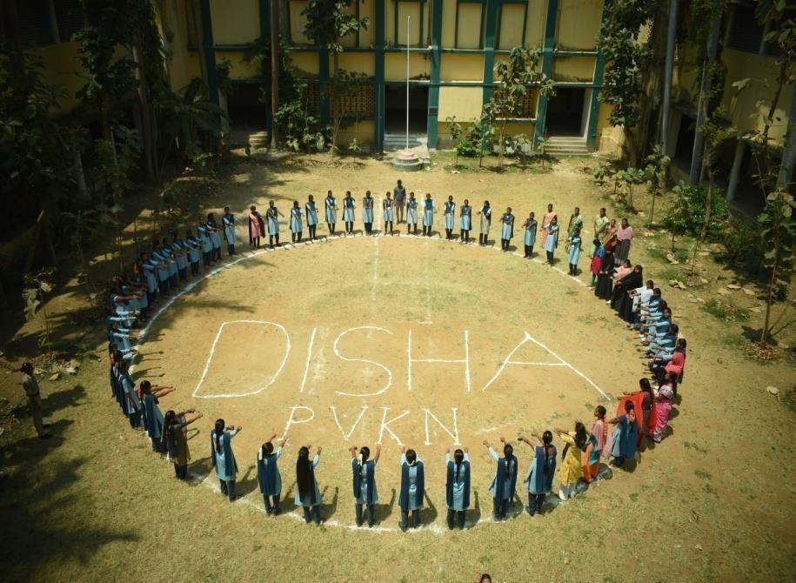
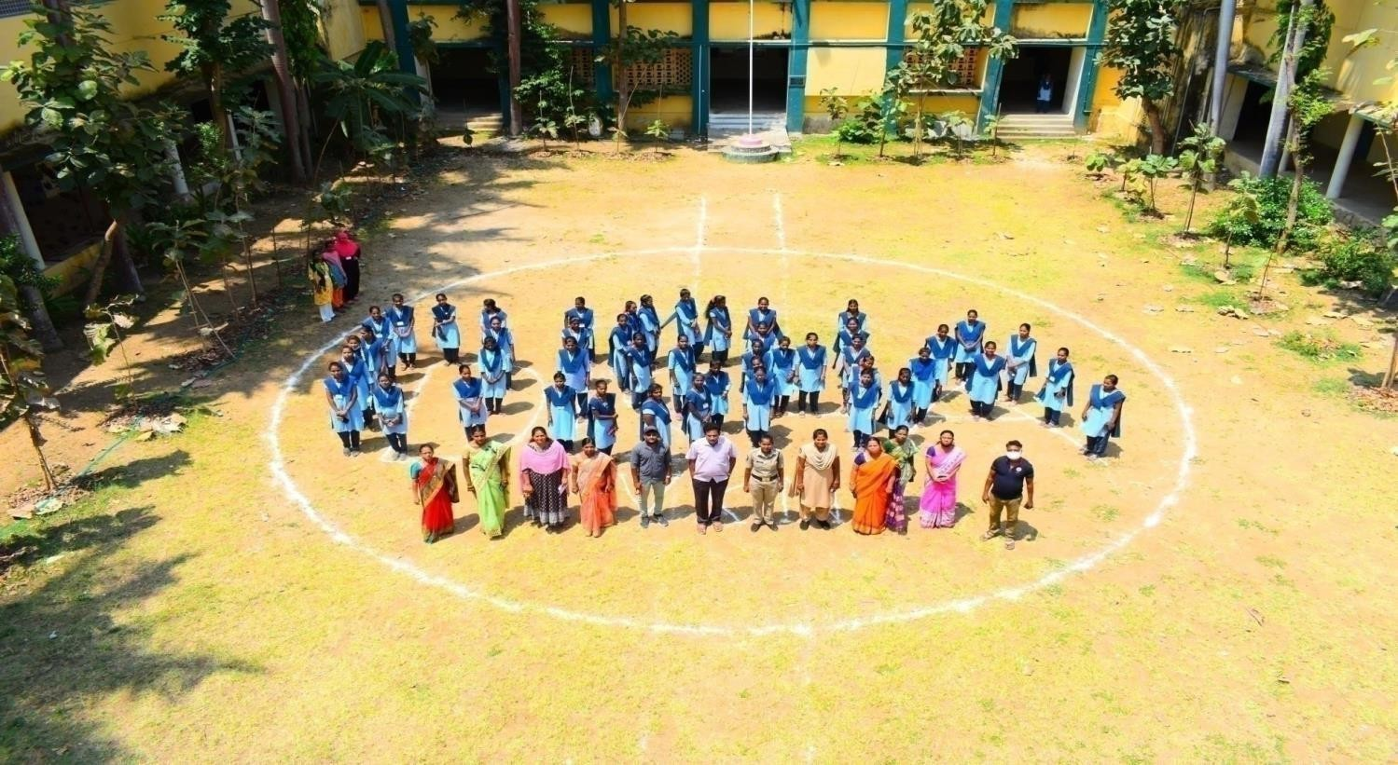

Self Defence
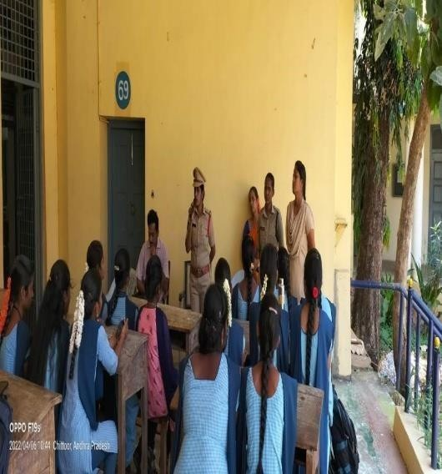
Disha app importance explained by Disha team at P.V.K.N. GOVT. College(A), Chittoor.

Techniques of Self defence explained by the students Shahataj and P.Nanditha

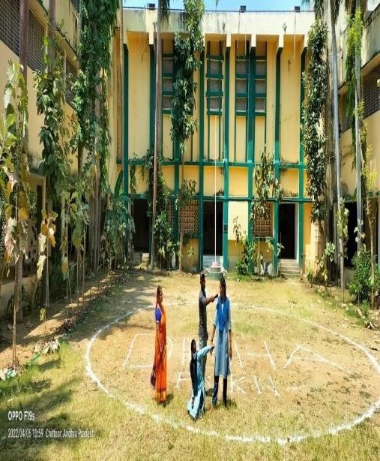

Orientation Programme on awareness of safety for girl students
The PVKN college held a one day awareness cum sensitization programme for the women students on all aspects of their learning experiences. The college has taken several measures to enhance safety & security on campus by constituting Grievance Redressal Cell.
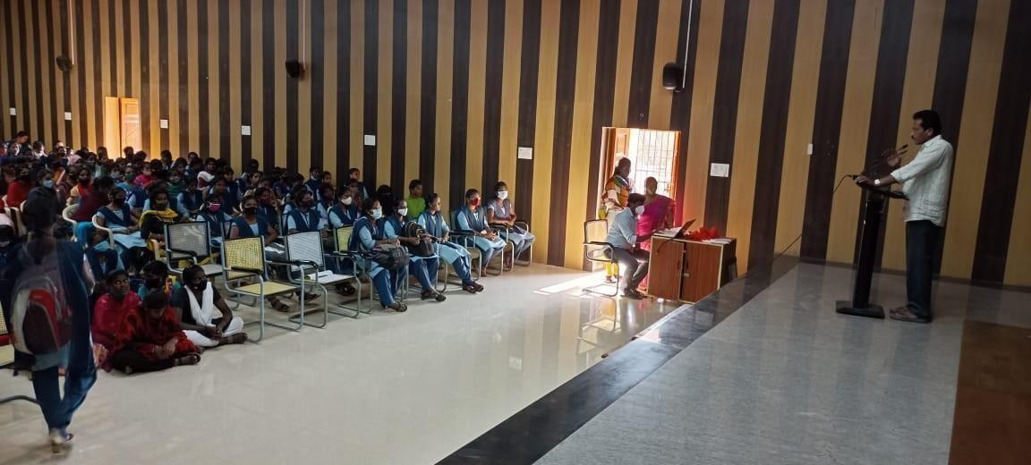
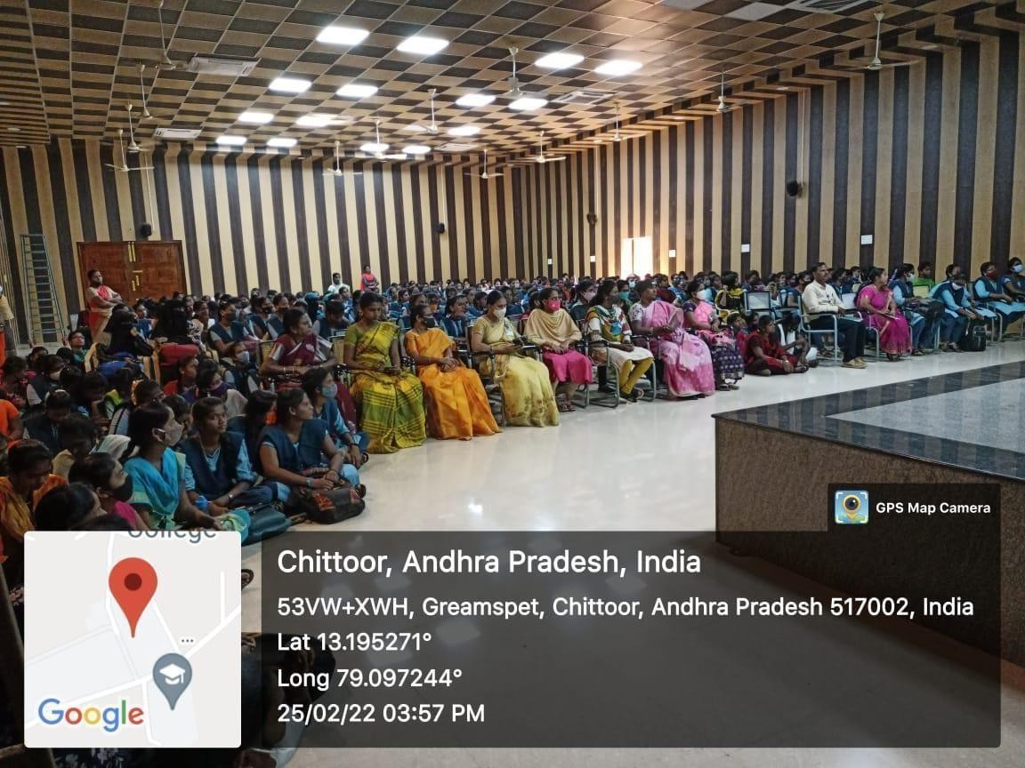

Counselling programme to Women Students on 20-06-2022

In the counselling, they have focused on the personal career, health issues, discipline, human values and stress management of women in their lives. This Programme is conducted to empower Girl Students aiming at intellectual and social upliftment.

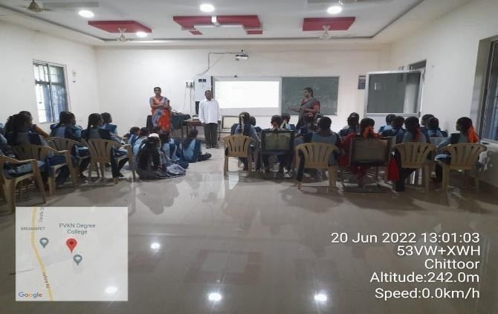

Health awareness program to women students by DEMO, DM&HO, Chittoor on 12-09-2022
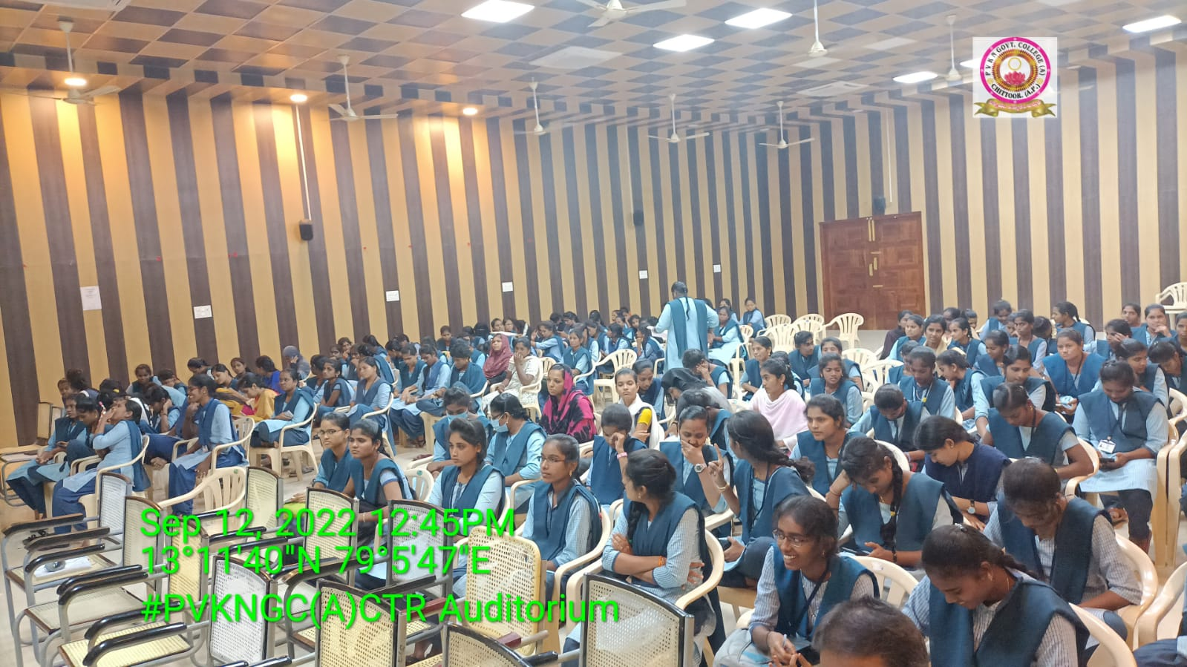
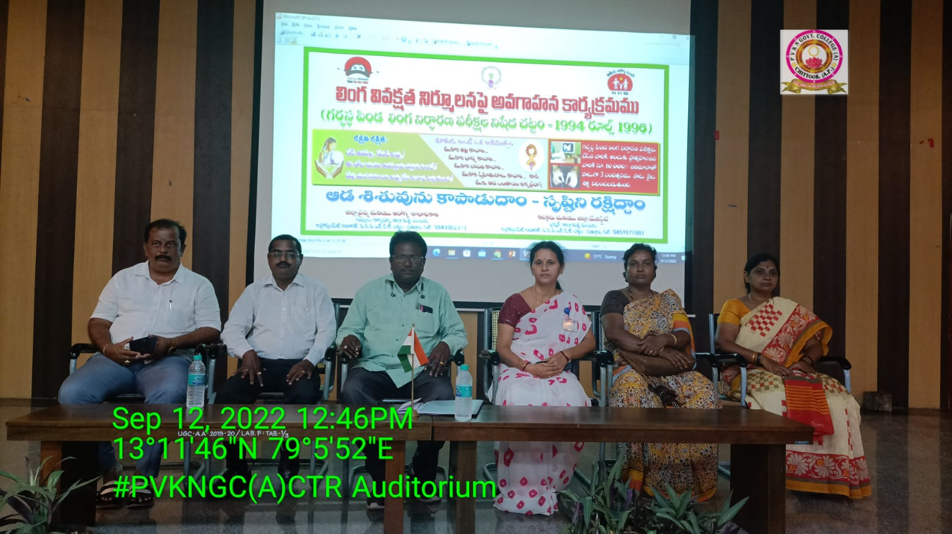

Security Awareness programme by Police Department (LHMS) On 02-11-2018
Awareness programme on security (LHMS) was conducted by the department of police on 02-11-2018.
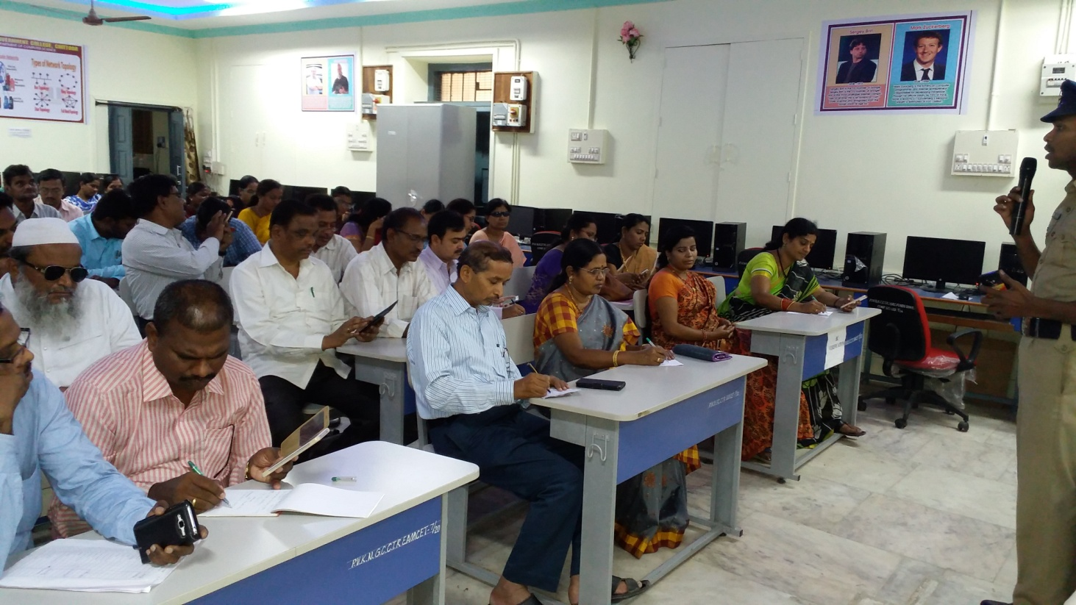
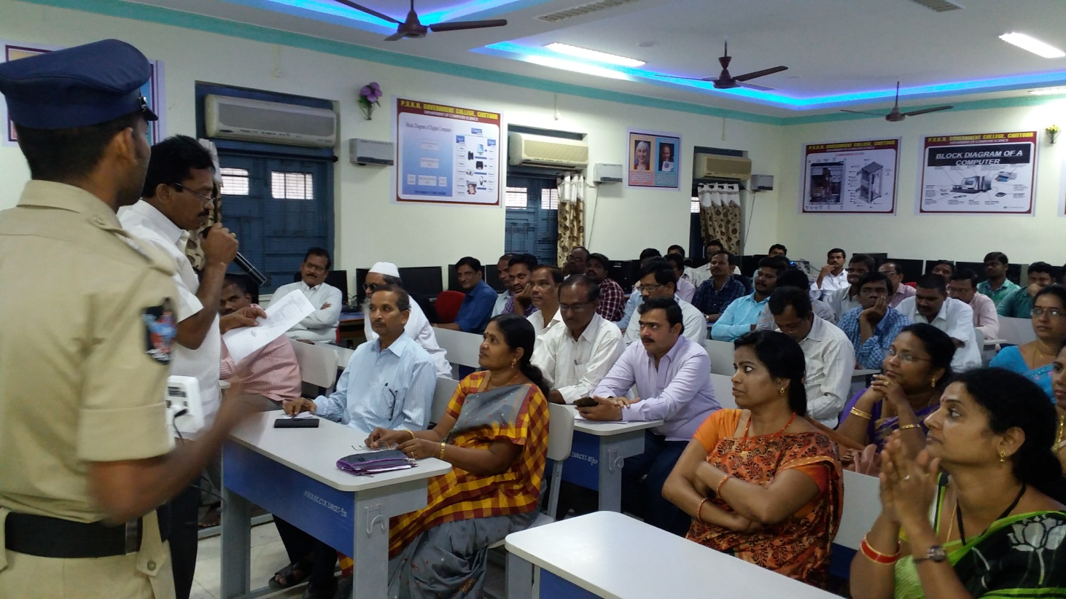

International Women’s Day Celebrations on 08-03-2022

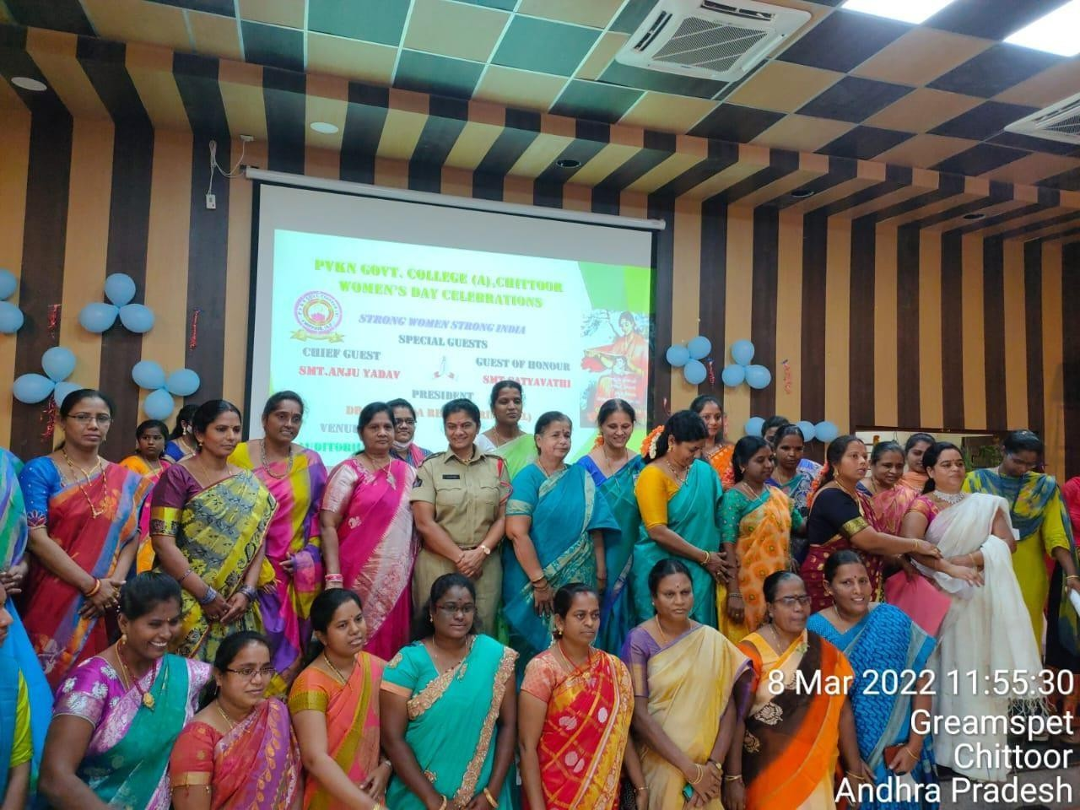

Chief guest of this programme, Smt.Anju Yadav garu, circle inspector of Tirupathi and Smt. Sathyavathi garu. motivated the girl students with their valuable speech. Cultural activities are conducted special skit of short film which was presented by the students which was highly appreciated by the principal and all dignitaries.

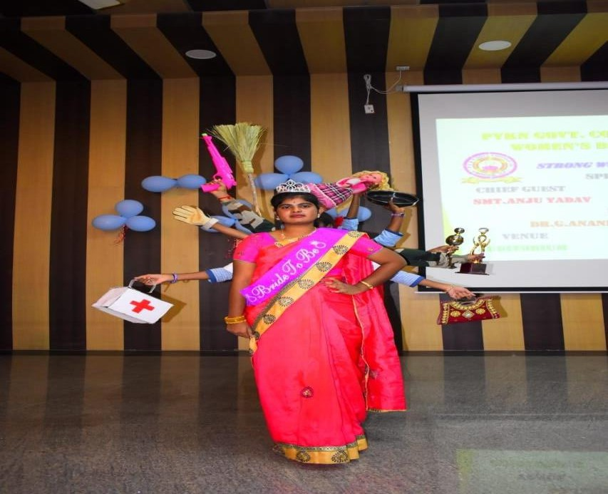
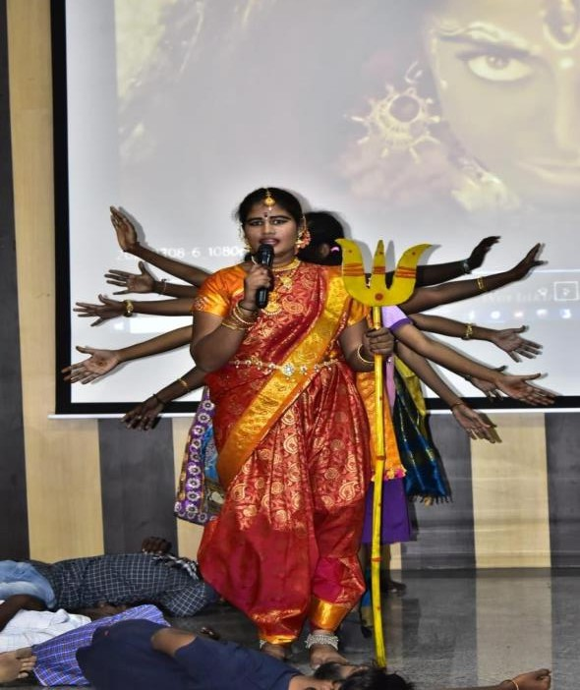

Youth Fest Marathon for Girls on 13-09-2023
Women students of P.V.K.N.Government Degree College participated actively in youth marathon 5K run, 2K run conducted by tourism department. Among 30 students of marathon 5 women students of P.V.K.N. achieved prizes below 10 ranks.
All Women Students strengthen their national unity and bring their importance of sports in this sustainable development.

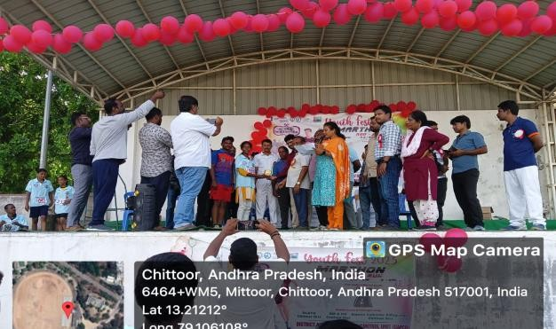
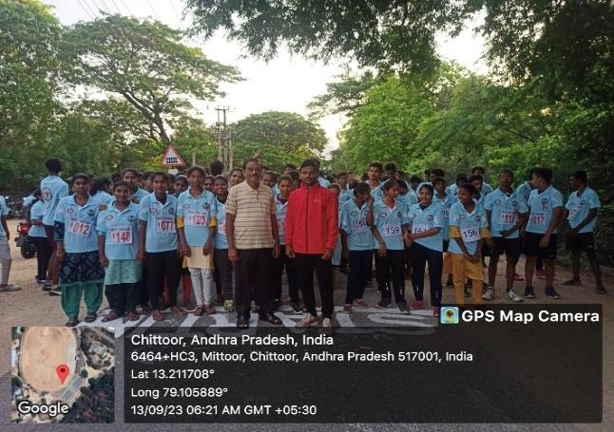
Psychiatric Counselling for Girl Students on 16-09-2023
On the occasion of Psychiatric day Dr. Ravi Kumar interacted with the girl students and counseled regarding the psychiatric condition of youth. Psychological development obtained by the students through counseling.
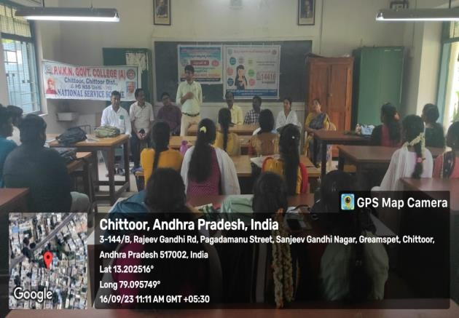
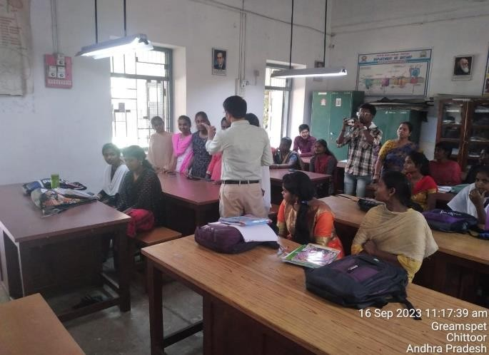

International Women Equality Day on 26-08-2023
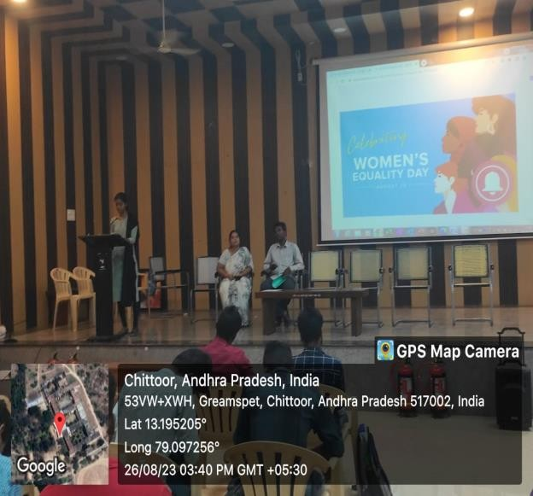
In this programme, Shalini from MSc. Organic chemistry delivered a speech to enlighten the students on the importance of women role and women empowerment in the society. She urged the girl students to follow the famous women personalities who contributed much to the upliftment of women in India.

Benefits of Ayurvedic Products
As a part of this programme Yamini from social welfare department exploded the benefits of Ayurvedic products on 18-08-2023. She stressed to use ayurvedic products instead of chemicals.

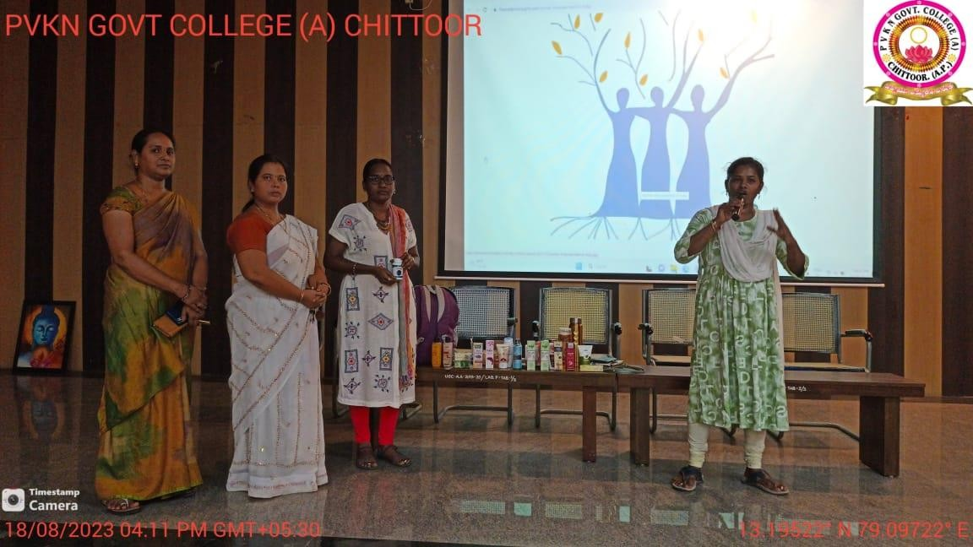
Empowering Women-Promoting Period Hygiene through Sanitary Pad Distribution in various villages on 20-07-2023

In India, millions of women and girls face numerous challenges when it comes to managing their menstrual health and hygiene, particularly in village areas. Limited access to affordable sanitary products, inadequate sanitation facilities, and cultural taboos surrounding menstruation often result in poor menstrual hygiene practices, which can have adverse effects on women's health and overall well-being. In order to emphasize the importance of usage of sanitary pads and promoting education about period hygiene, Women Empowerment Cell of P.V.K.N. Govt. Degree College conducted awareness on usage of sanitary pads and distribution of sanitary pads.
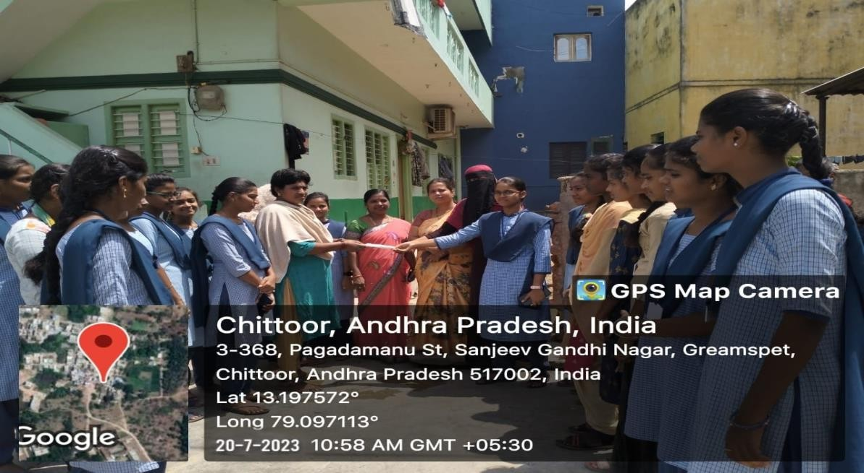

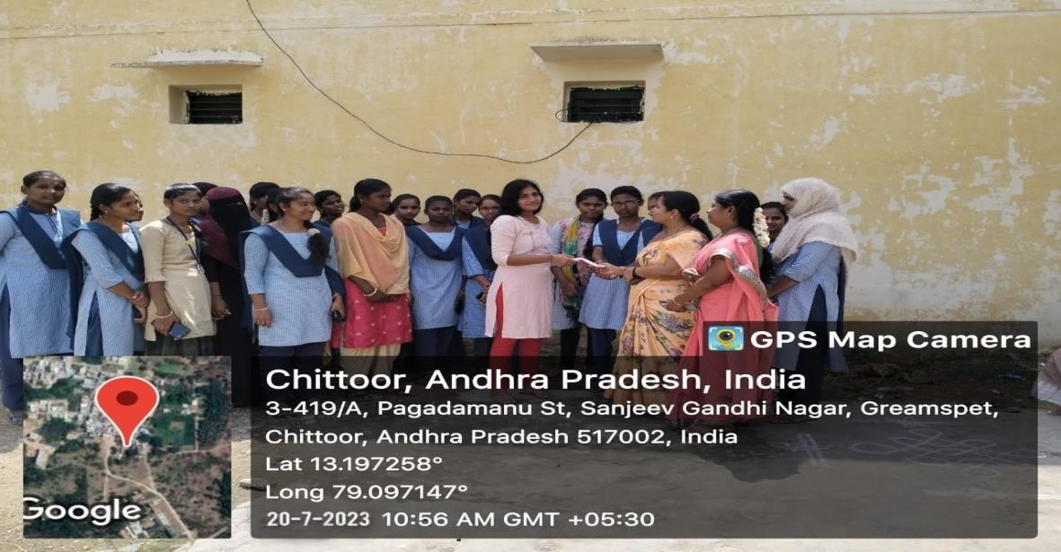

“PVKN WOMEN SPORTS” on International Women’s DAY 2024

As a part of this programme, various Sports competitions are conducted for women staff and students. Students and staff participated effectively.

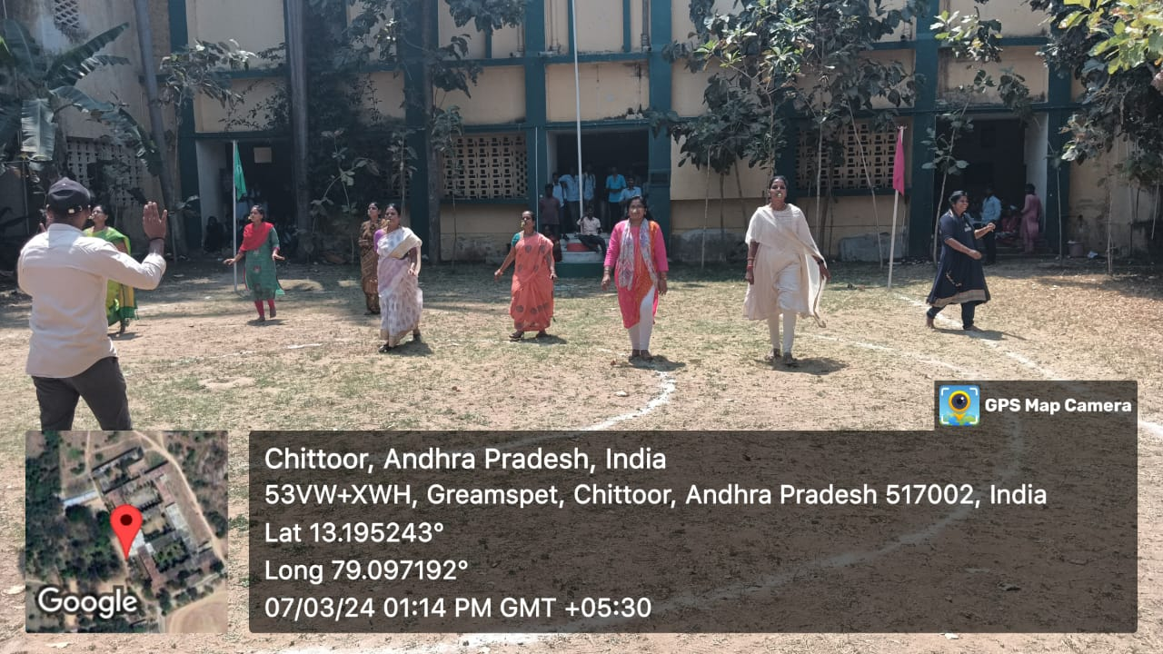
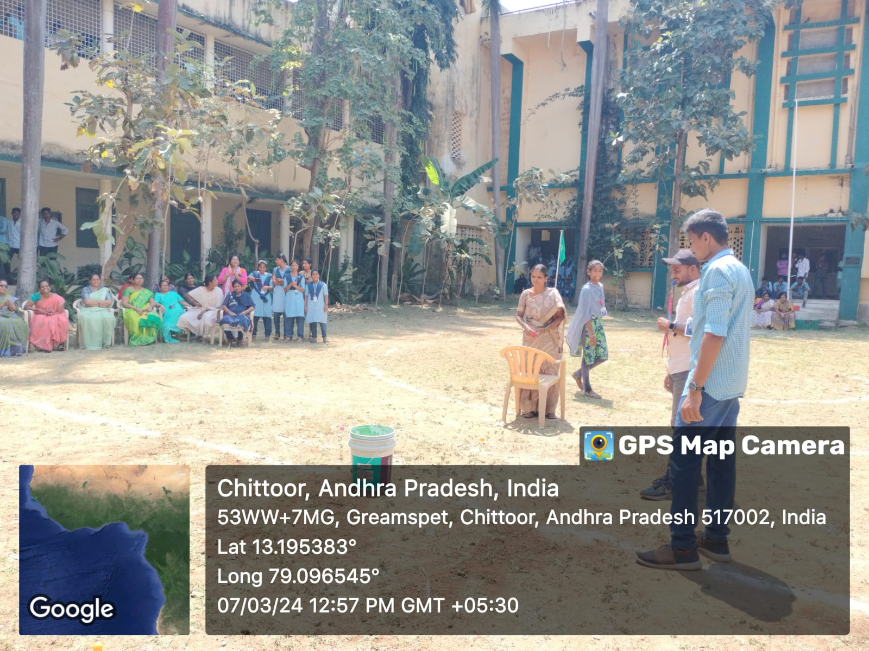

‘PVKN WOMEN OF WONDER’ Poster Presentation on 30-07-2024
The Women Empowerment Cell hosted an event" Women of Worth, Women of Wisdom, Women of Wonder" to give the all the girl students a platform to showcase talent in their fine arts. There were no winners because this event was not a competition but an encouraging step to celebrate the talents of our women students.

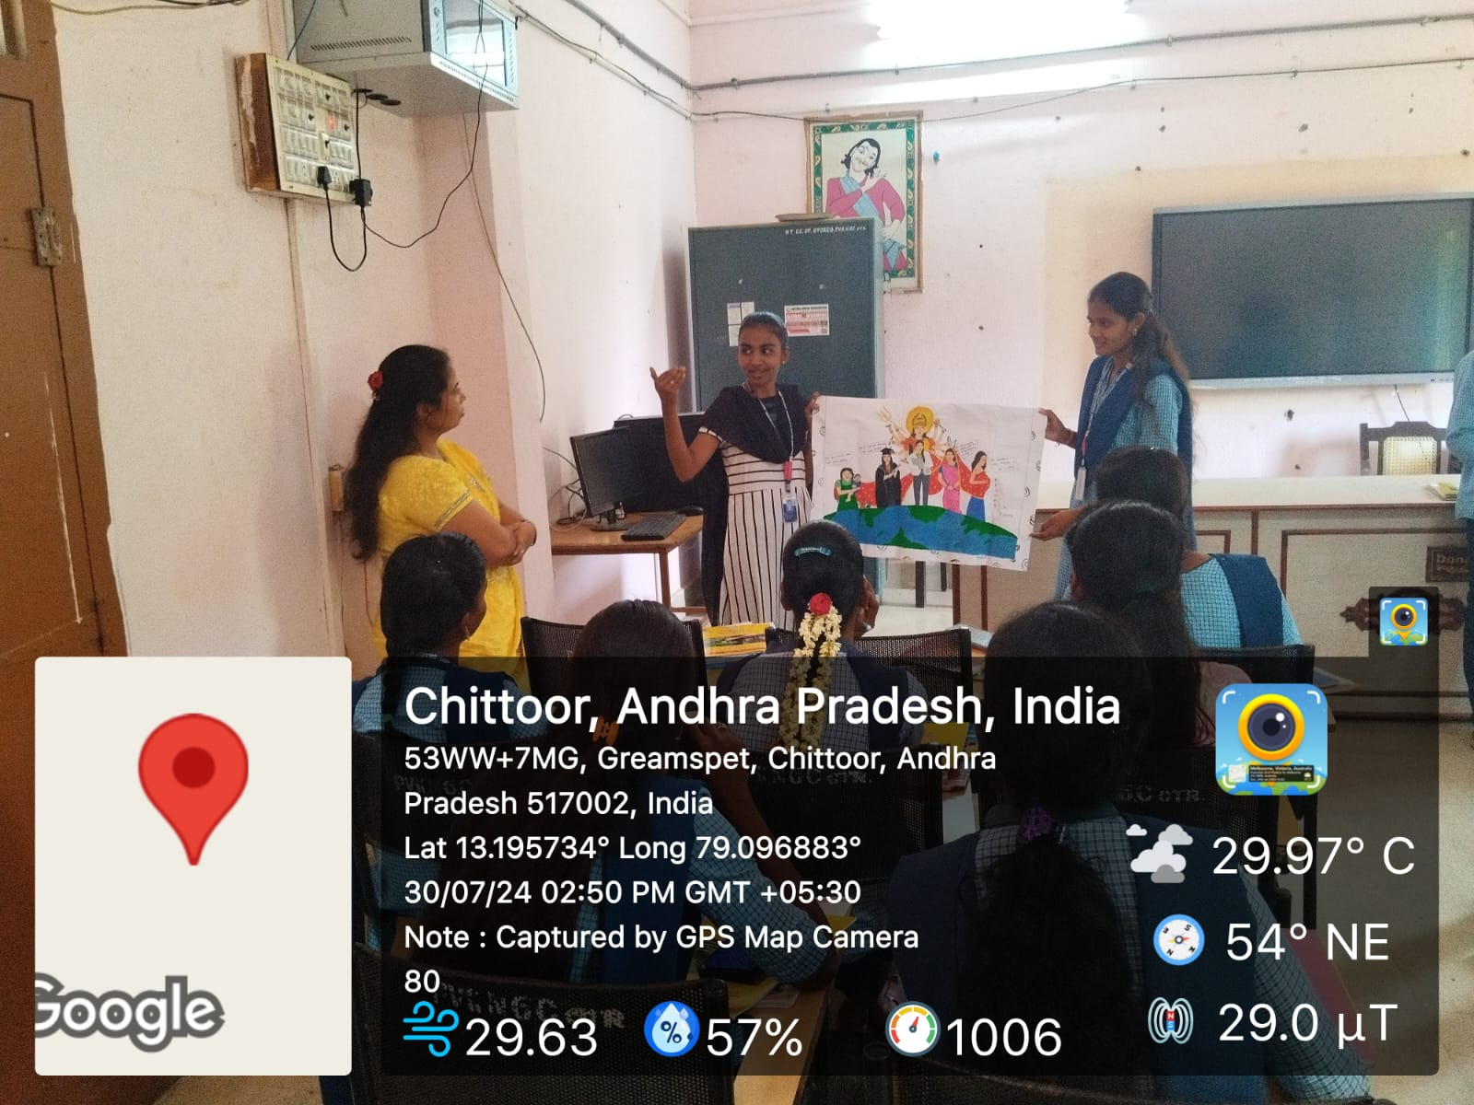

Natioanal Hanloom Day on 07-08-2024
This event aims the contributions of skilled handloom weavers to our country's culture and economy. Student Madhupriya highlights the significance of the handloom industry in our past and provides more power to those who are employed in it with her speech.

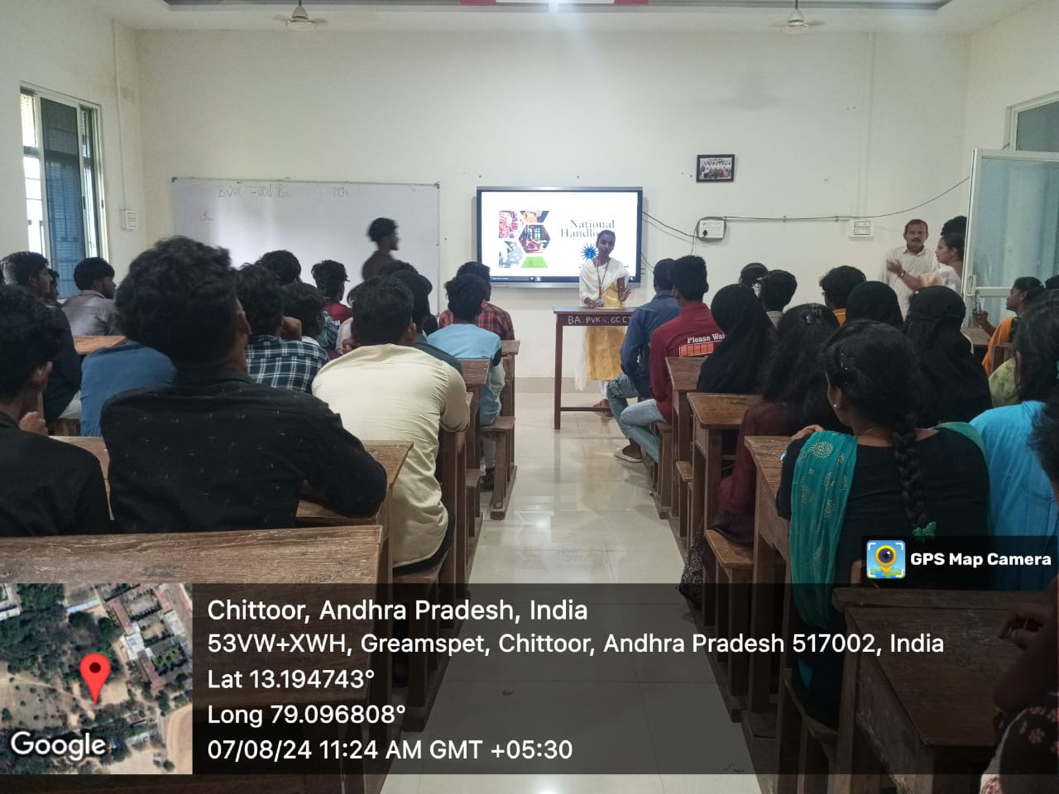
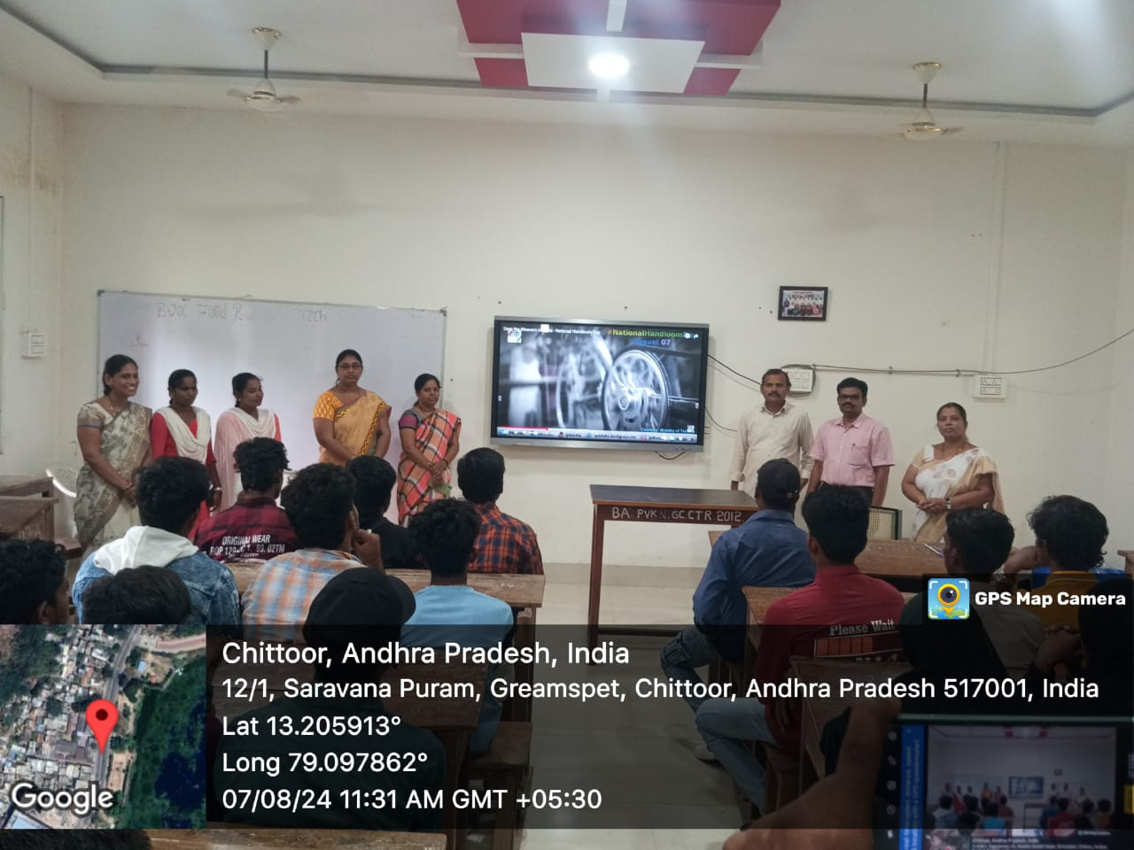

Consanguine marriage awareness programme on 10-09-2024

In India, marriages are considered as the most important ritual and social institution, which establish a strong relationship between two families. Parents only consider the benefits of consanguineous marriages but they neglect the consequences. Women empowerment cell of PVKN Government college (A) has conducted awareness programme by collaborating with Apollo medical college students to educate adolescents regarding consanguineous marriage and its consequences and also to access their knowledge before and after the intervention. Total 64 students participated in the study.

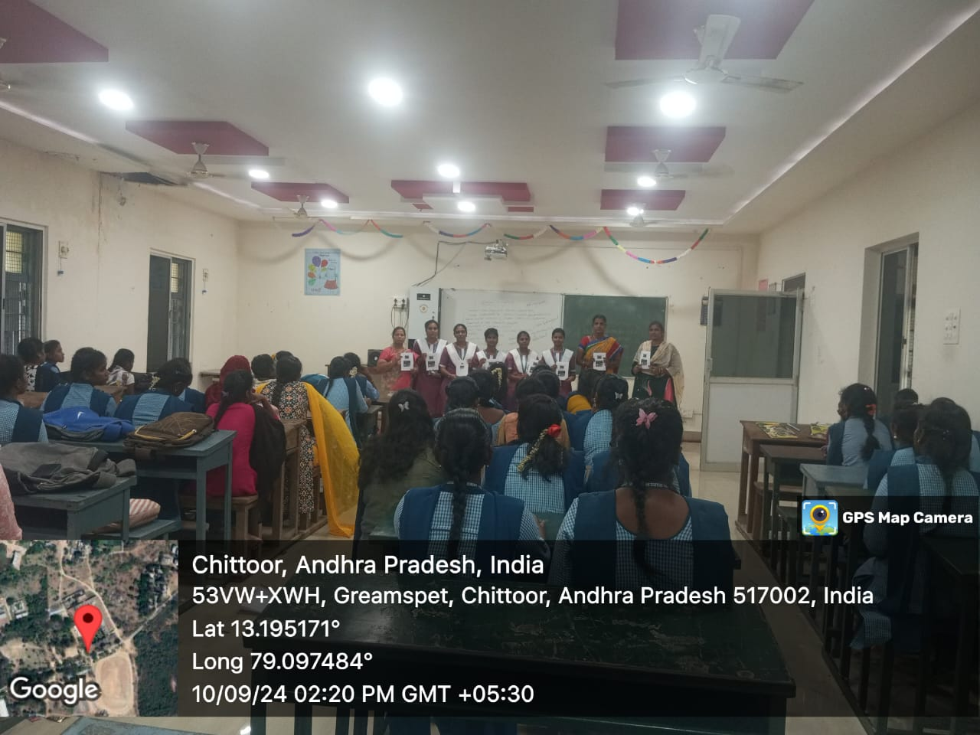

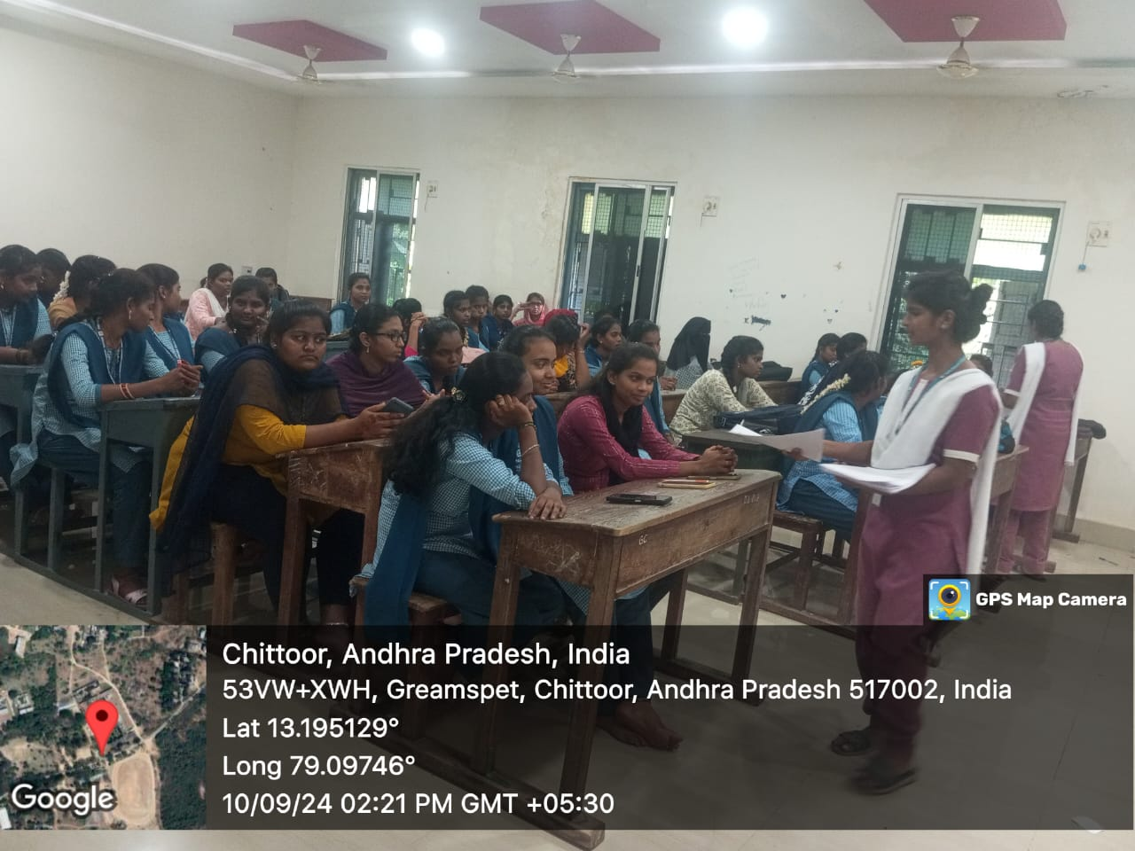

International Day of Girl Child on 11-10-2024

On this occasion WEC of PVKN conducted online quiz to get awareness on the importance of international day of the Girl child. Around 82 members participated in this quiz in which high scored 3 members declared as winners in the prayer section.

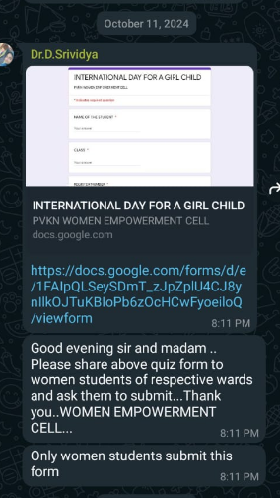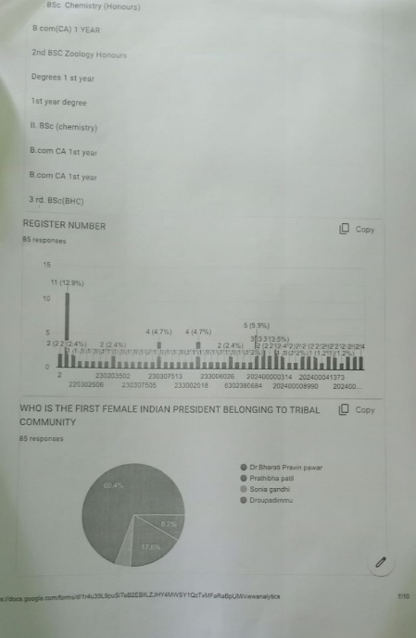

Cultural Fest

Rangoli competitions
