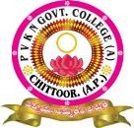
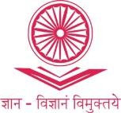
PVKNGOVERNMENTCOLLEGE (A)
(Accreditedwith‘A’GradebyNAAC)
INTERNALQUALITYASSURANCECELL(IQAC)
VelloreRoad,CHITTOOR-517002.A.P.
www.pvkngcchittoor.ac.in
7.1 Institutional values and Social Responsibilities

7.1.3. Describe the facilities in the institution for the management of the following types of degradable and non-degradable waste
a. Solid waste Management
b. Liquid waste management
c. Biomedical waste management
d. E-waste management
e. Hazardous chemicals and radioactive waste management.

Solid Waste Management
Due to the routine activities carried out in the campus, solid waste that includes plastic, paper, food, metals and glass etc. Dust bins are available in the campus to maintain the campus eco-friendly and clean. The waste is segregated and handed over to municipal corporation, Chittoor. Also awareness programmes were organized in the campus.

Collecting Degradable and nondegradable wastes in separate bins
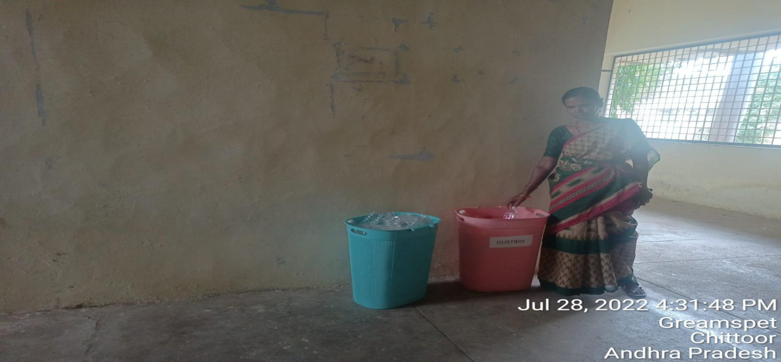

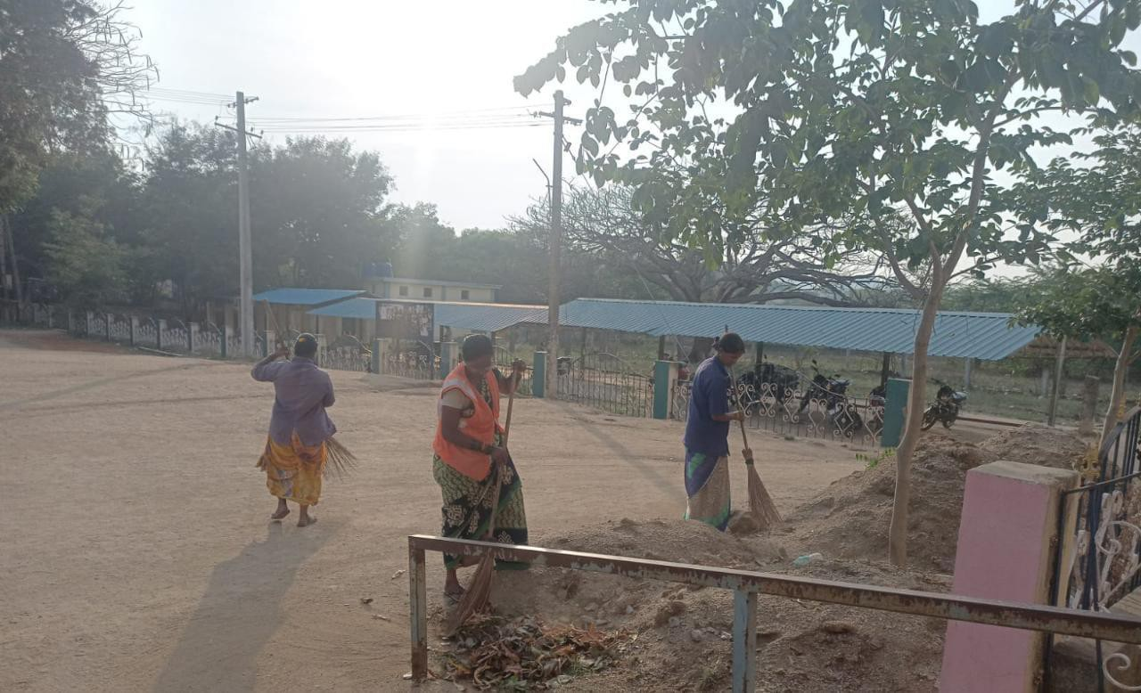

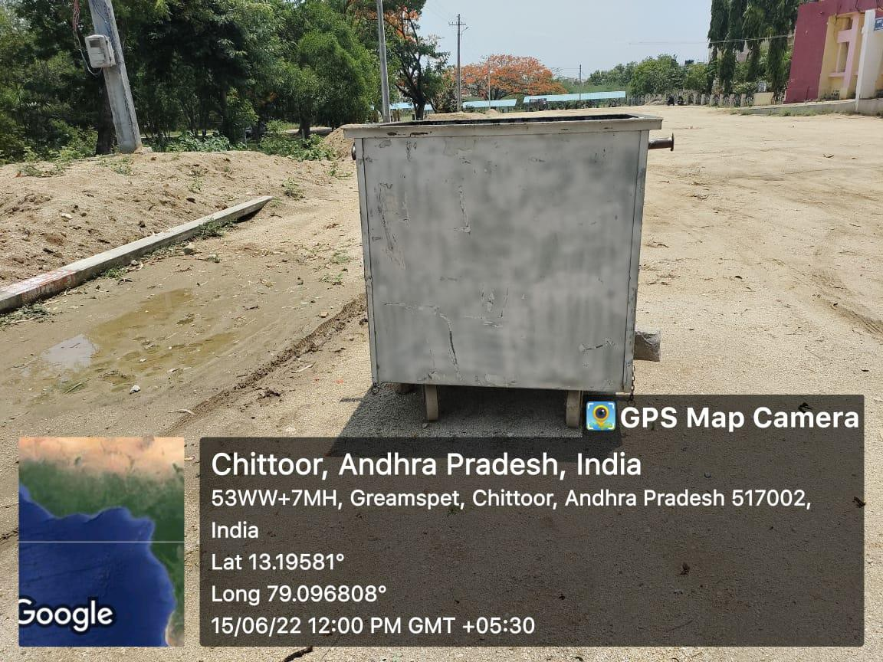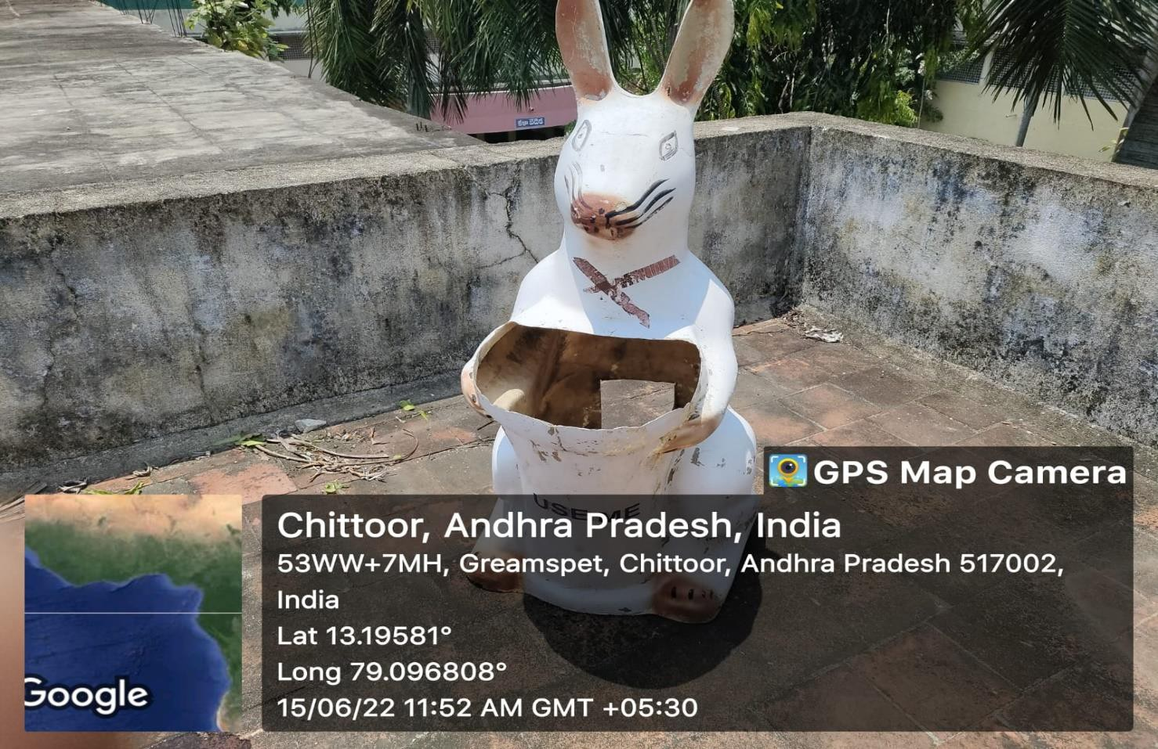

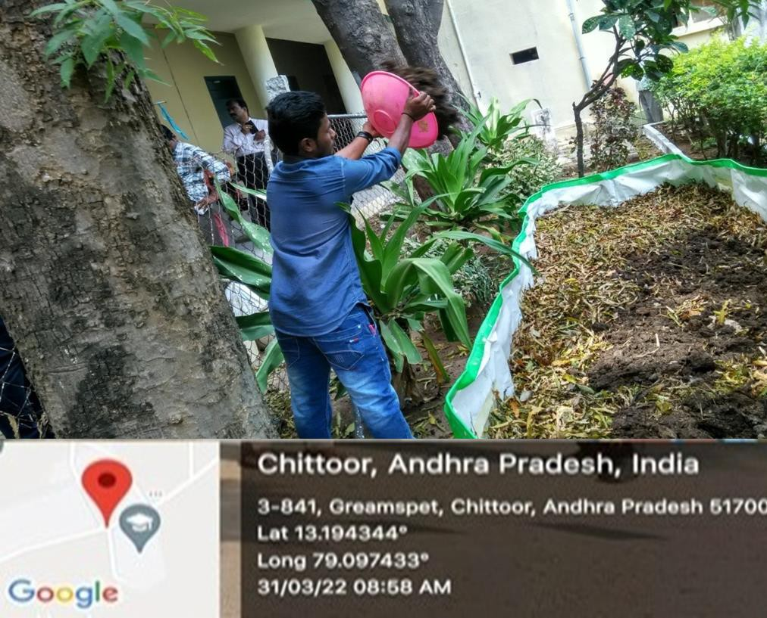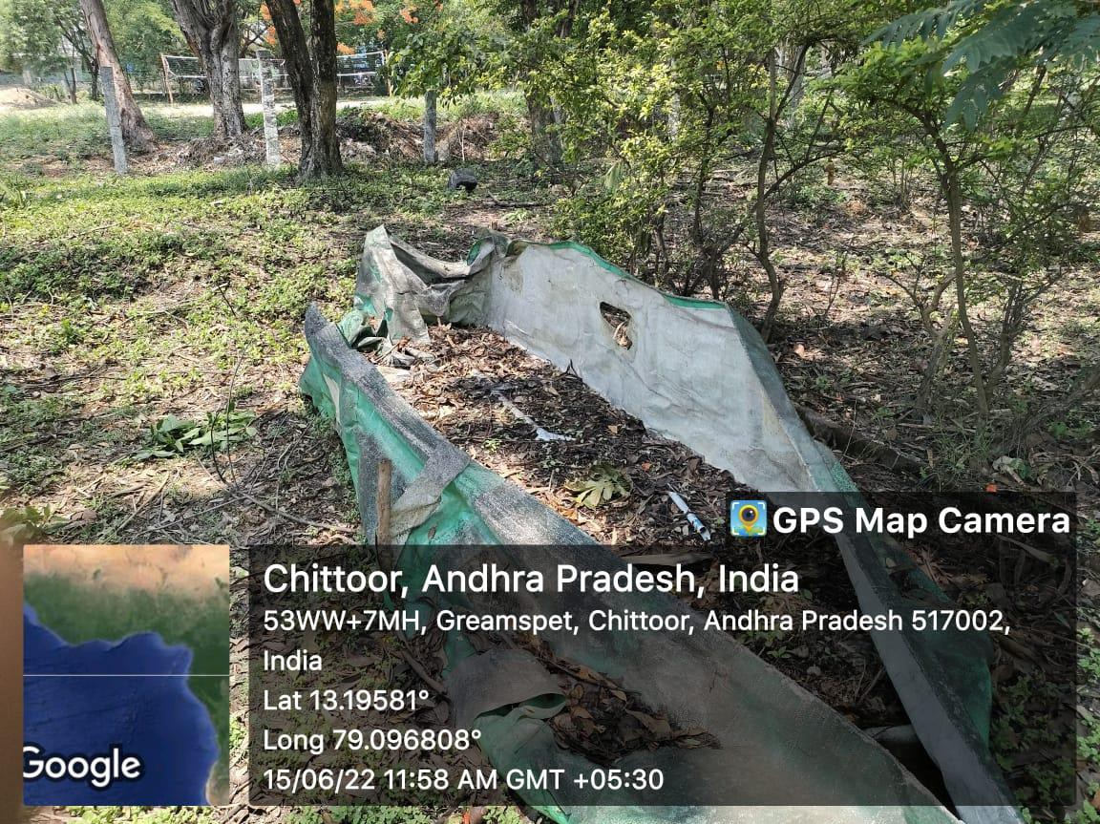Converting solid plant wastes into Vermicompost

Clean and Green on 20-07-2023
As a part of Clean and Green Programme, NSS volunteers in groups actively involved in the
cleaning of the campus. The open areas in the campus were cleaned by removing the weeds, grass and plastic waste.
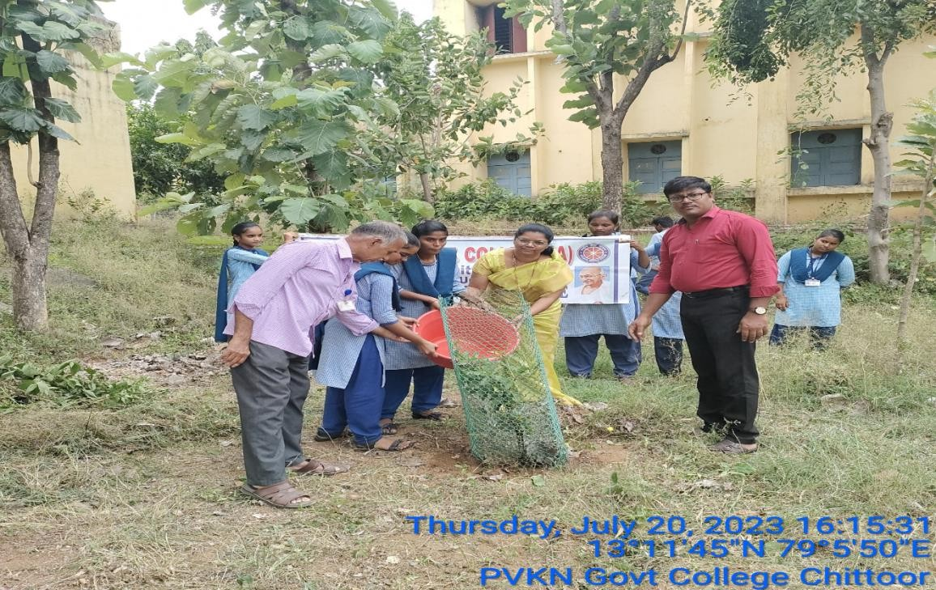
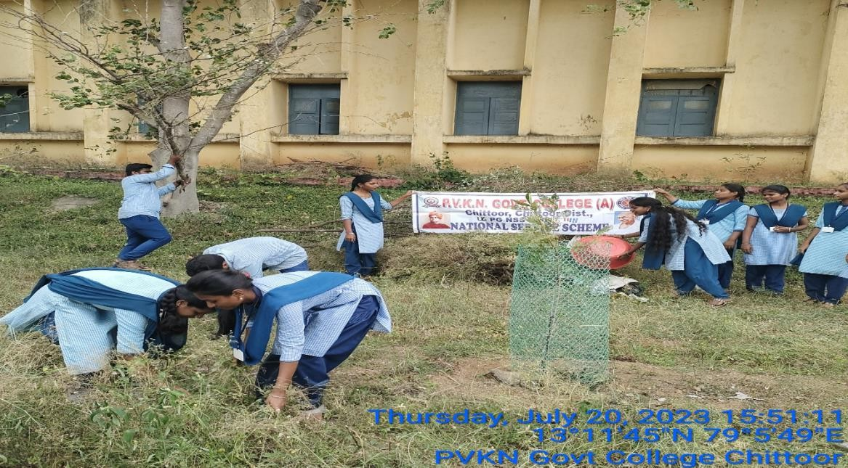

Farm yard manure preparation from biodegradable wastes
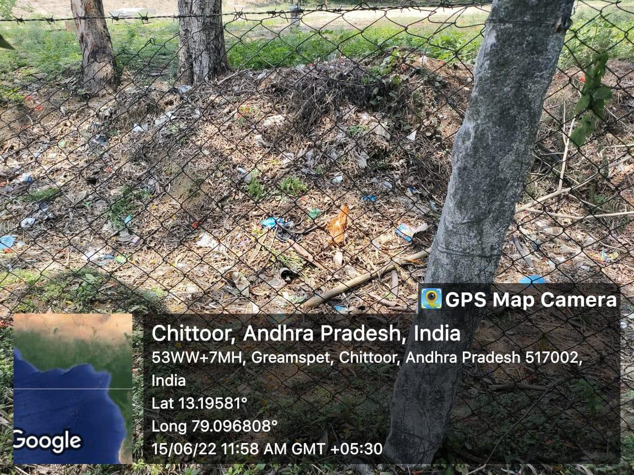
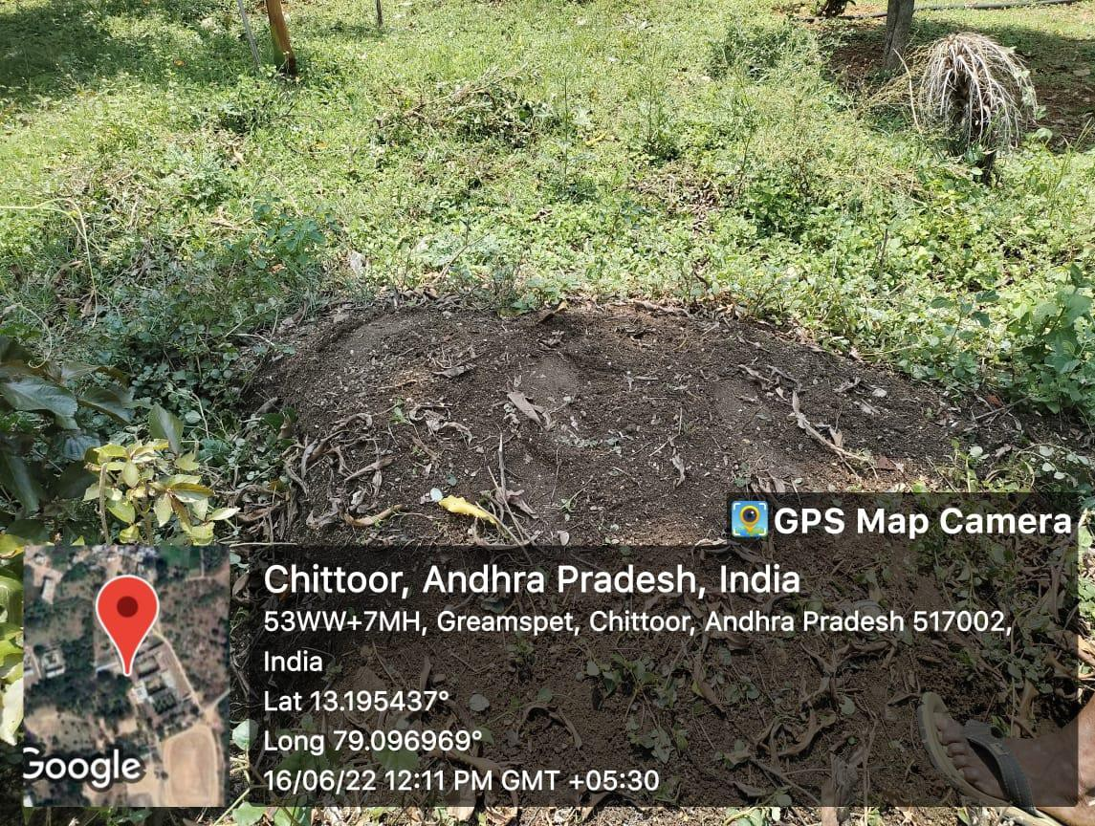

Liquid Waste Management
Unlike solids, liquid waste cannot be easily picked up and removed from environment. Liquid waste causes pollution. Therefore there is a necessity to manage liquid waste properly.
PVKN College adopted liquid waste treatment in the campus to reduce the chemical and biological load of domestic sewage and useful for gardening purpose.

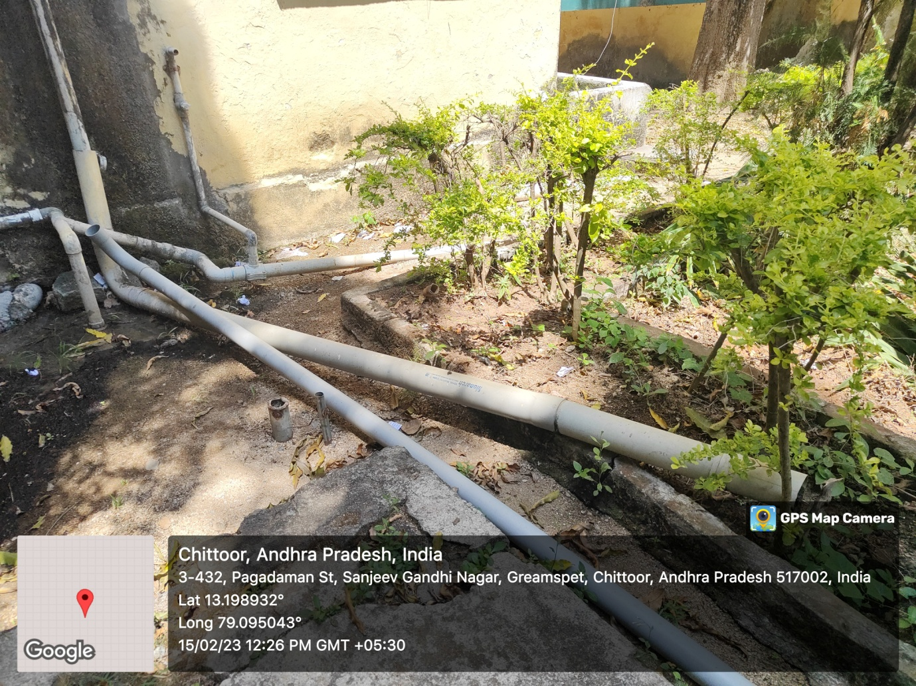

Liquid Waste Management

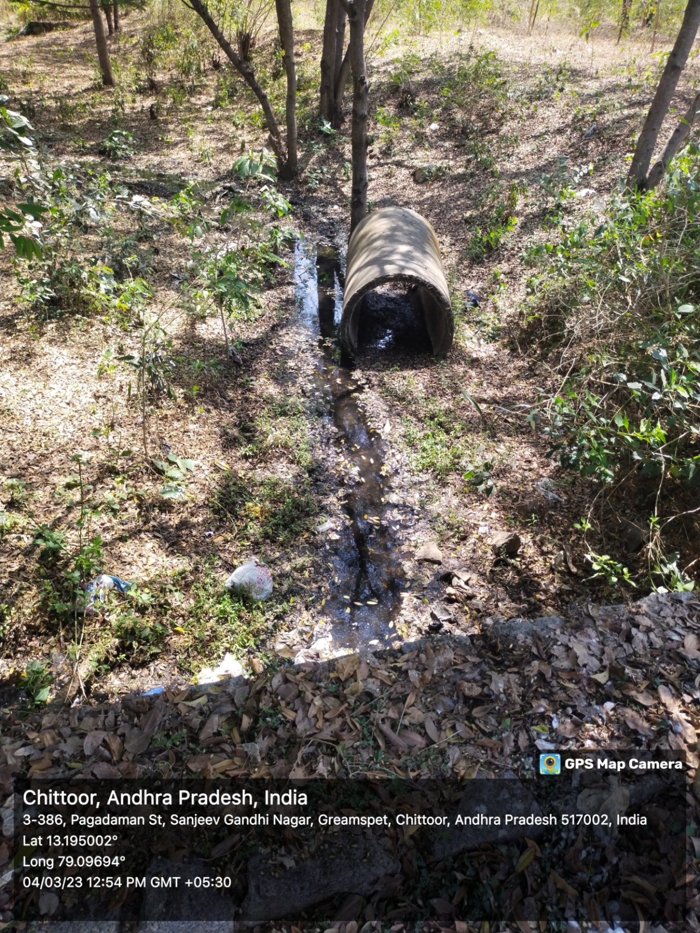
Liquid Waste Management

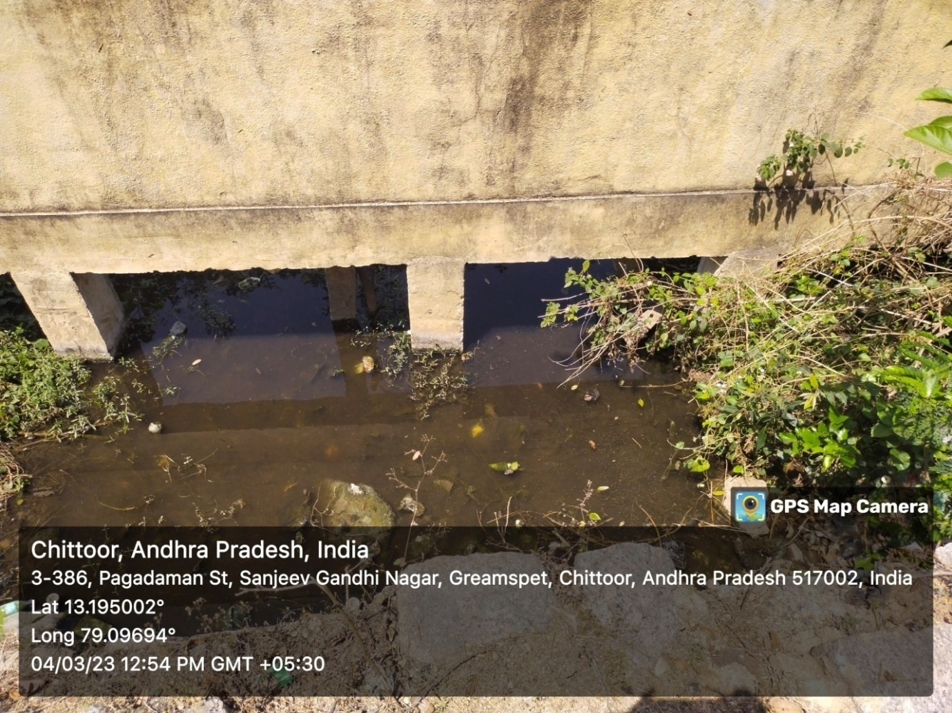
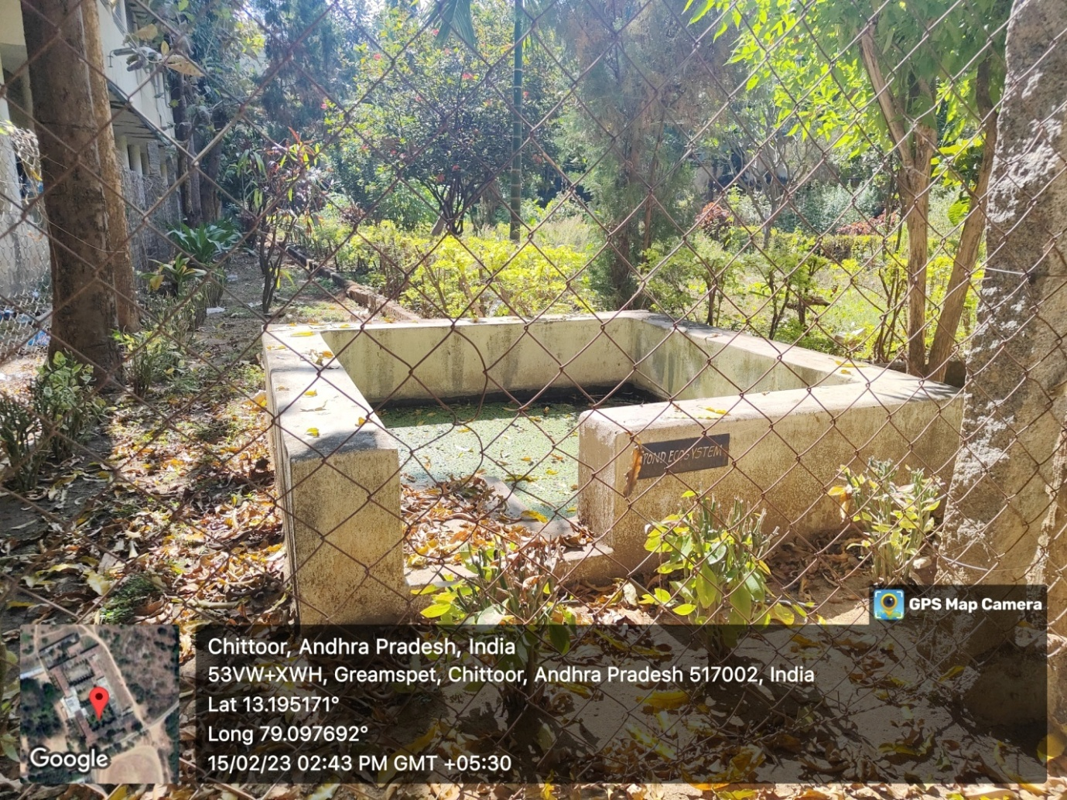

E Waste Management
Various sources such as laboratories and administrative offices of the institution are responsible for the generation of E wastes. PVKN college faculty and students are made aware of safe disposal of E waste. The institution Conducts workshops to educate students and staff about e-waste hazards and management techniques.

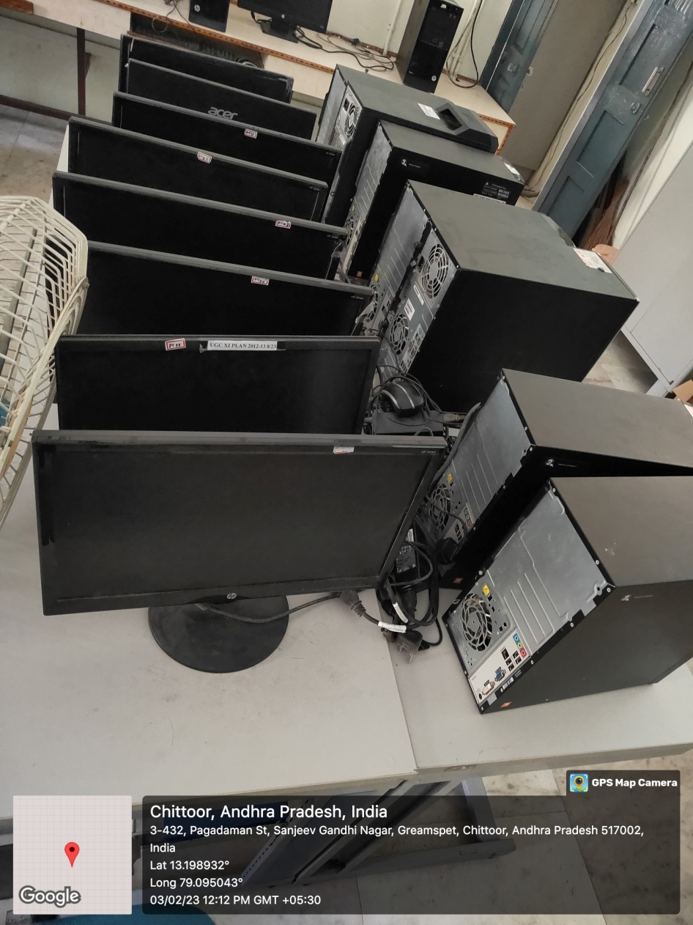

E Waste Management

Hazaradous Chemicals and Radioactive Management
In general, different types of chemicals were used in the laboratories, particularly, chemistry labs for conduction of experiments. Among them, some chemicals might be dangerous while others may not be dangerous. Highly toxic chemicals should be handled carefully. In view of this, the chemistry department of PVKN College arranged the chemicals in lab with proper care.
