POETRY AND SPOEKEN WORD EVENTS:
HOSTING EVENTS WHERE STUDENTS CAN SHARE ORIGINAL POEMS RECITATIONS AND PROMOTING CREATIVE EXPRESSION
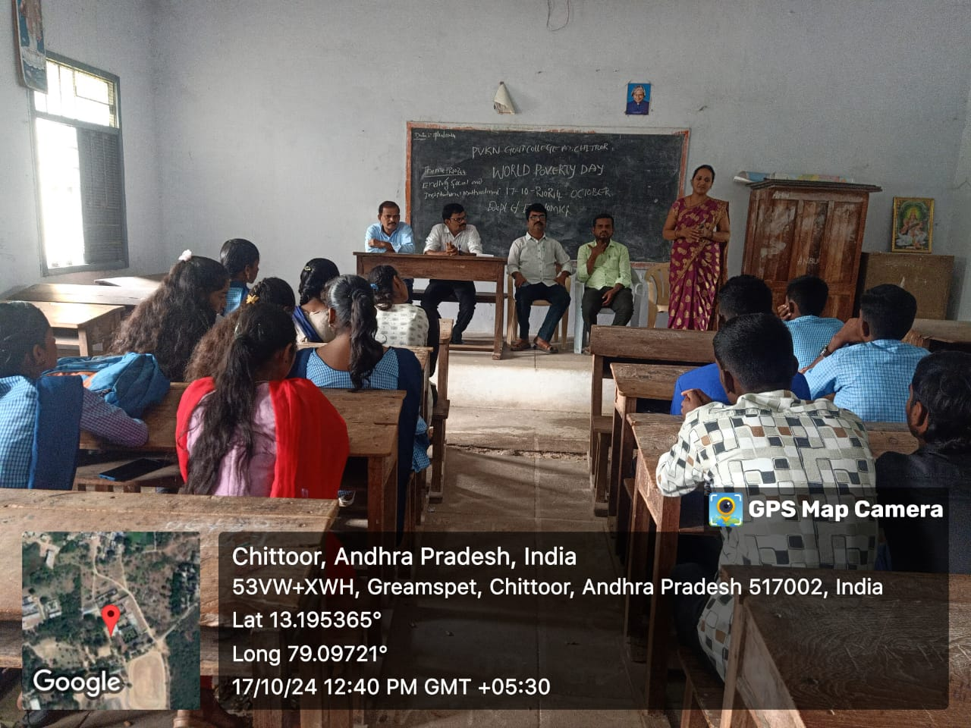
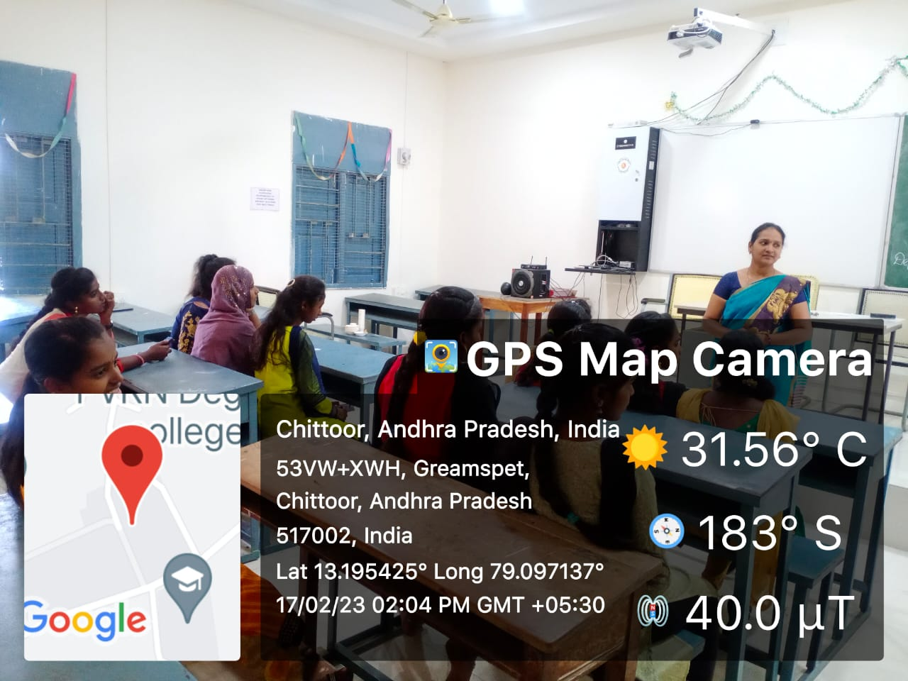
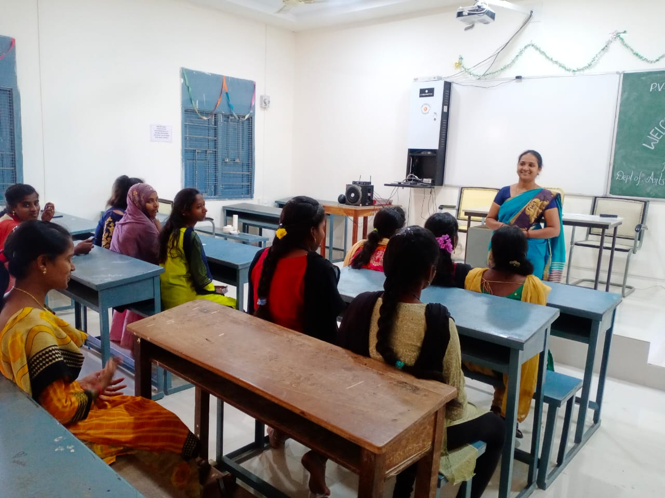
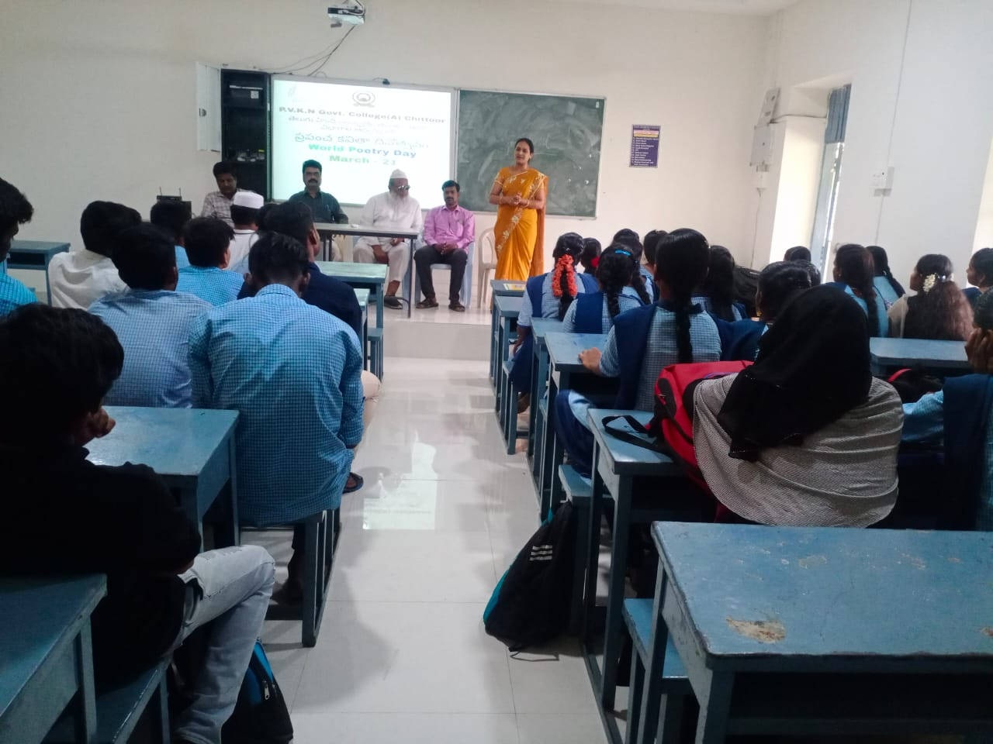
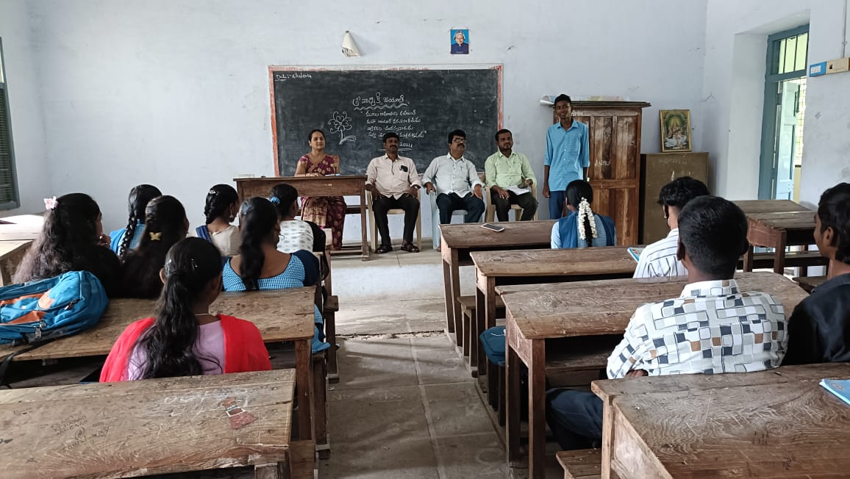

VISITING THE GIRLS HOSTEL
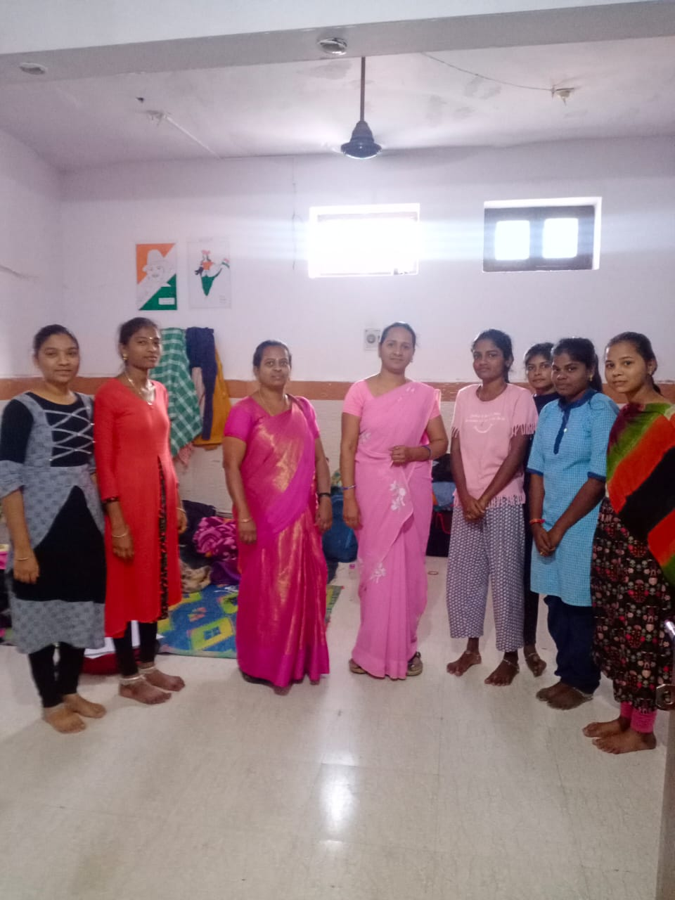
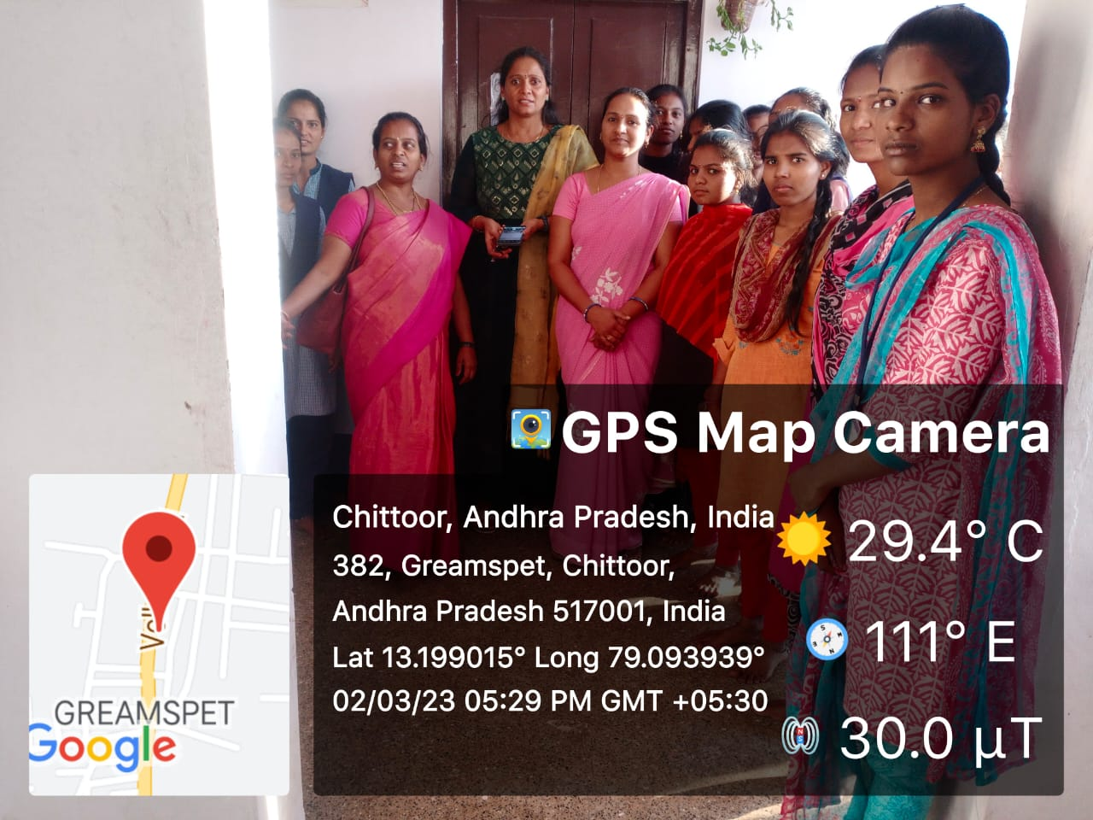
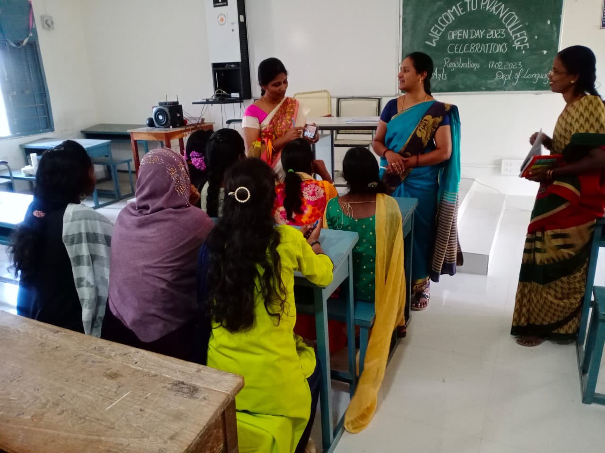

SHORT TEARM INTERNSHIP FOR B.COM STUDENTS

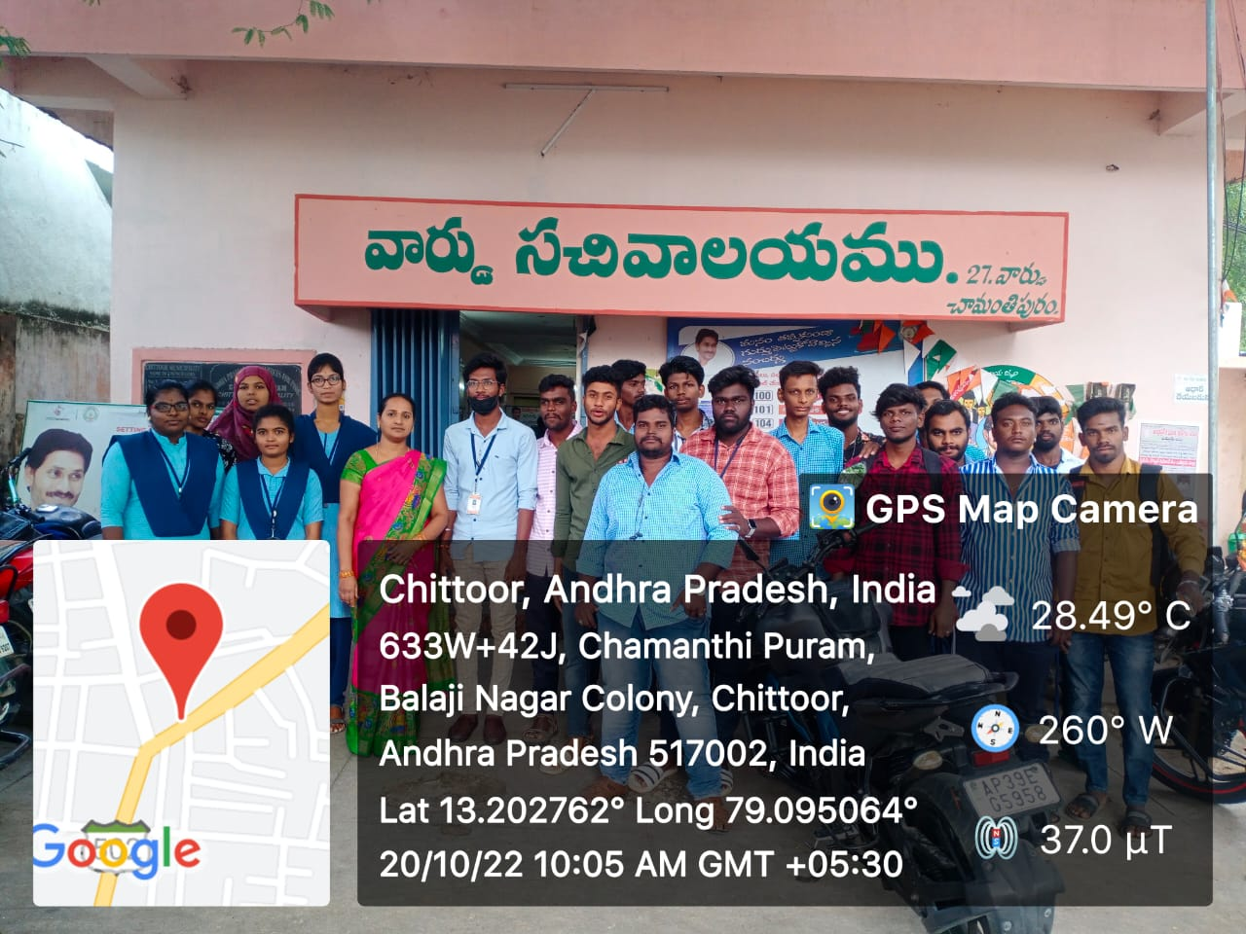
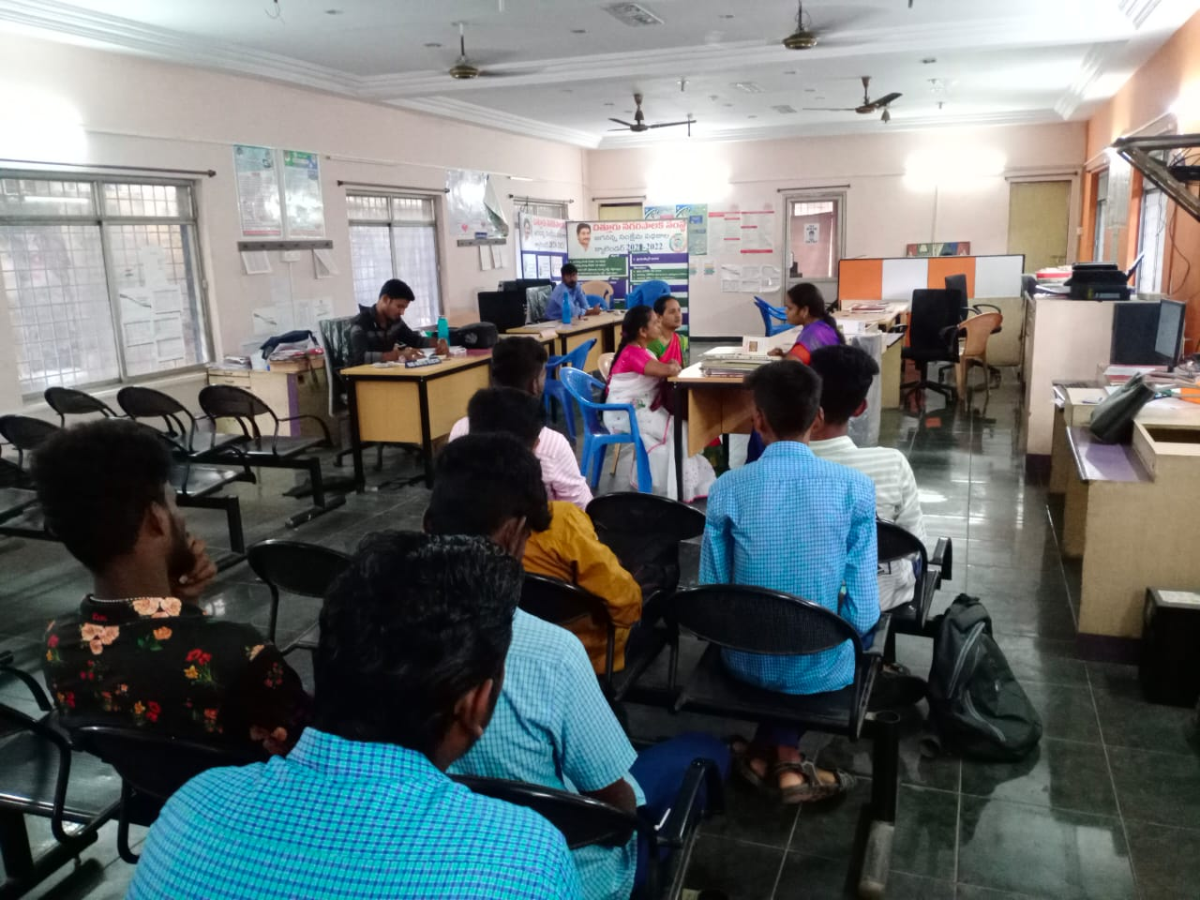
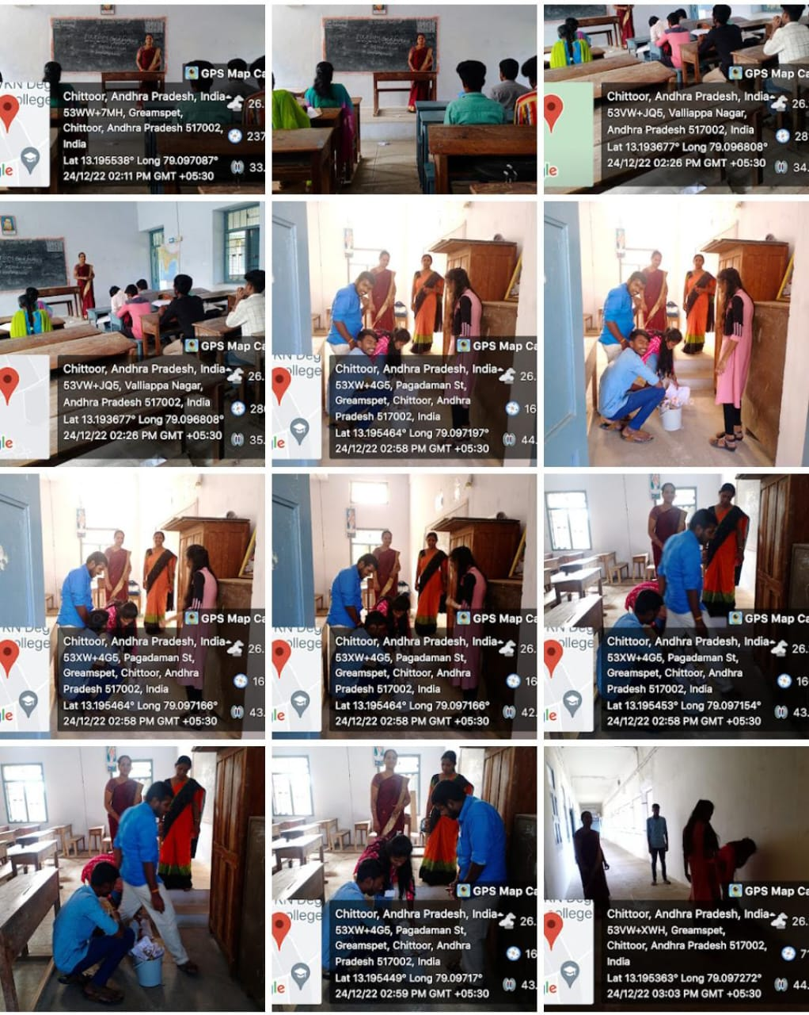
CONDUCT CLEAN AND GREEN PROGRAMME

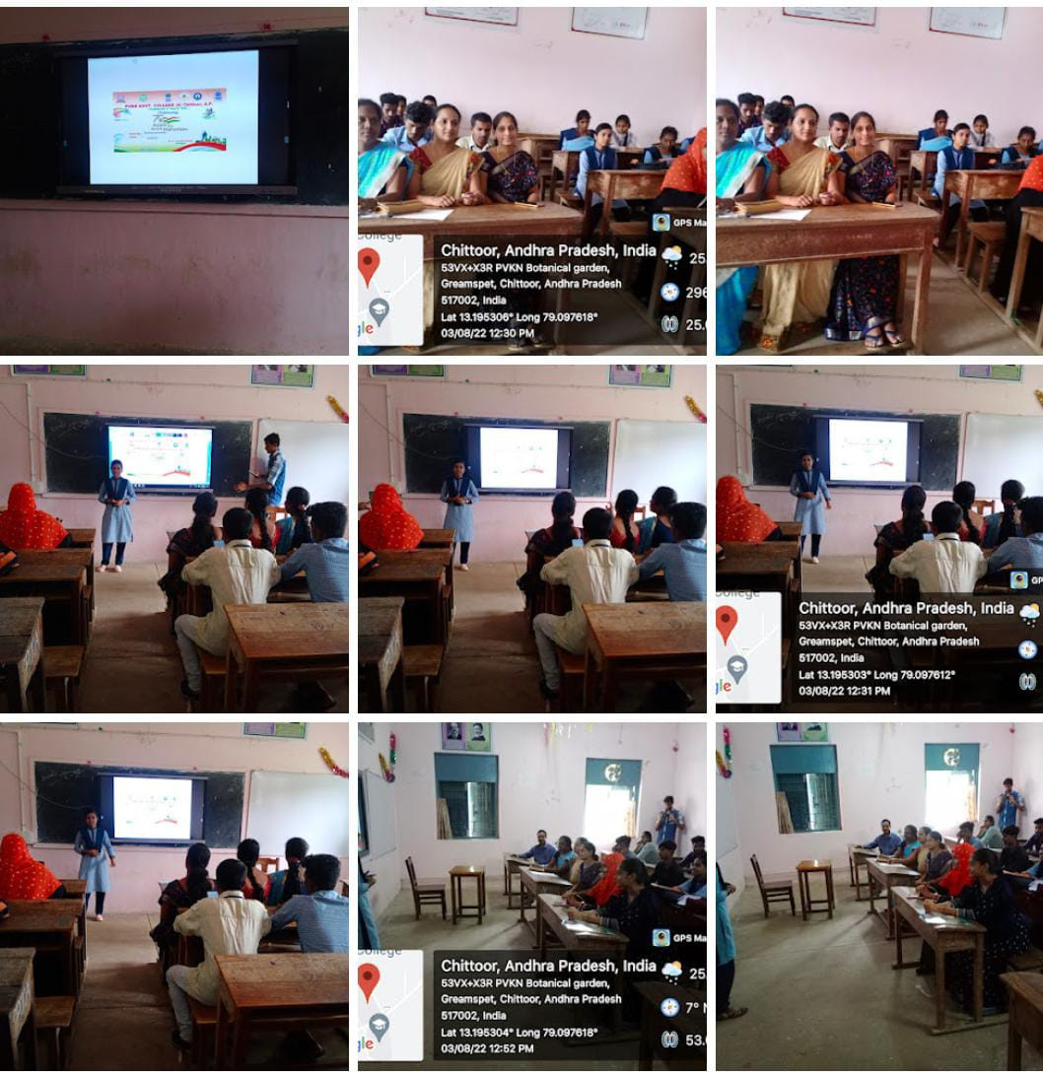
CONDUCT A STUDENTS SEMINAR
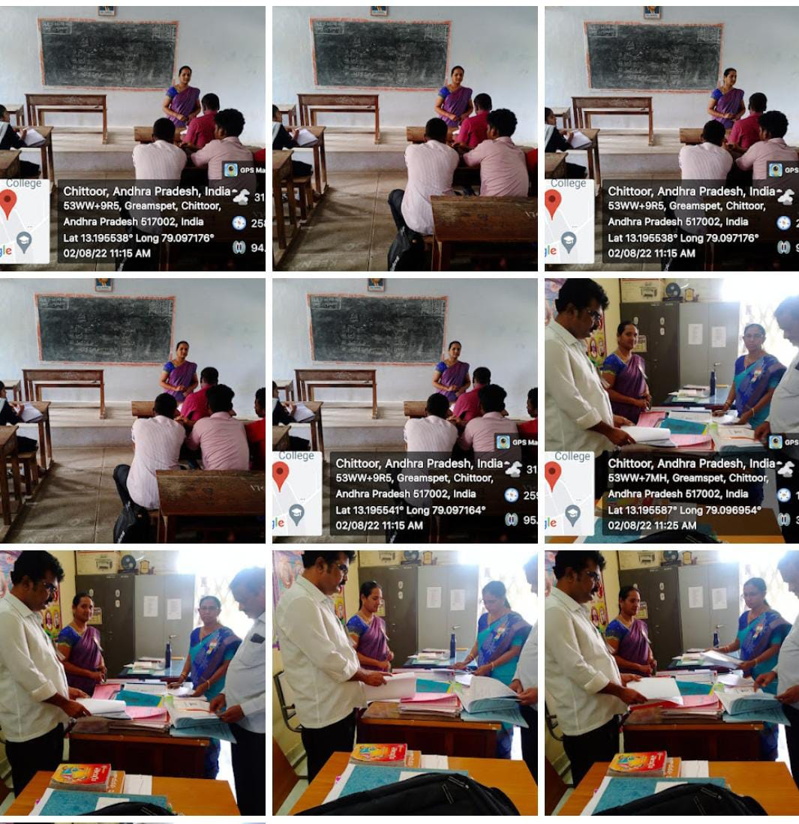

DEPARTMENT EVALUATION

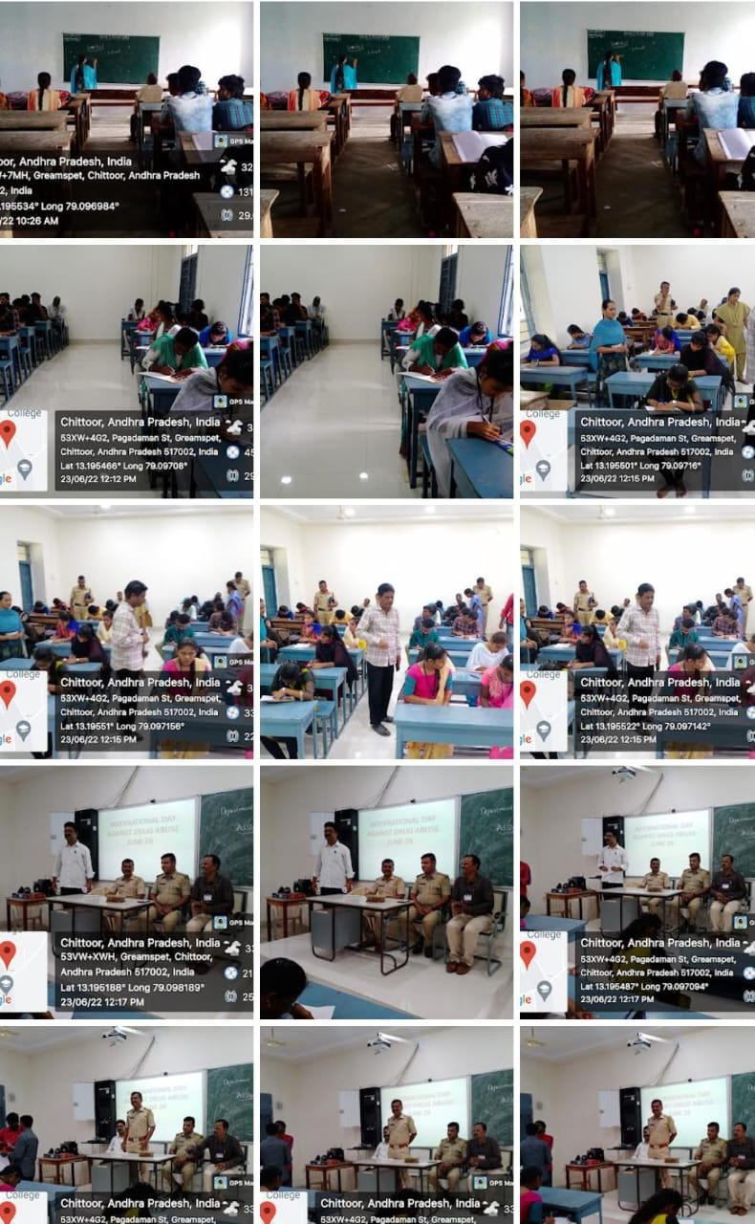

AWARENESS OF ANTIDRUG PROGRAMME
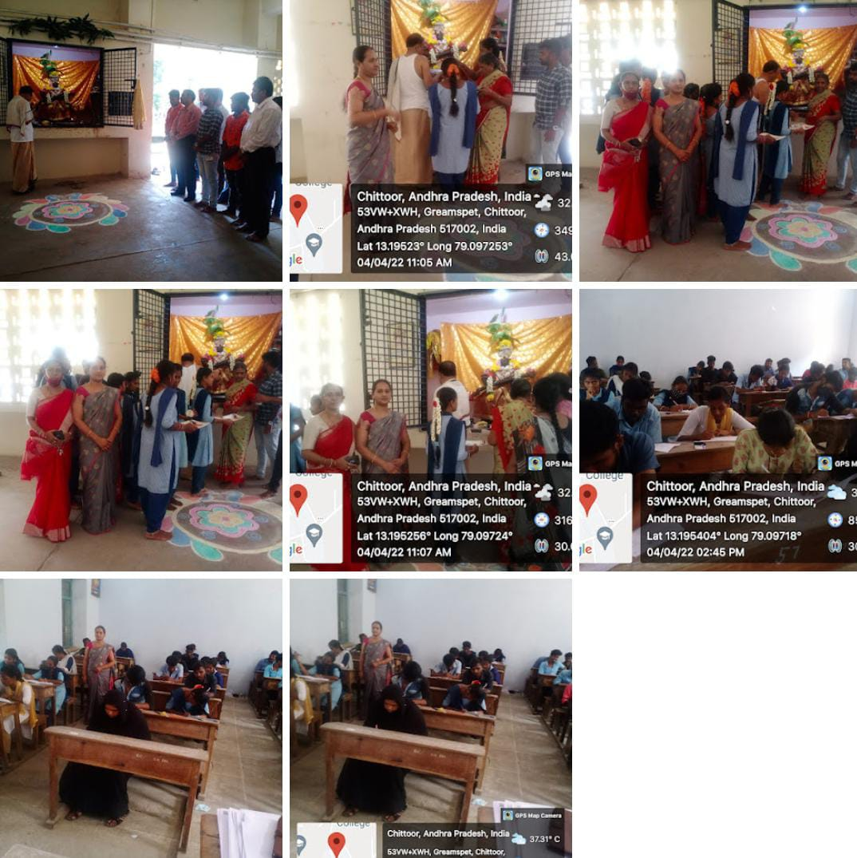

CELEBRATING ON SARASWATHIPOOJA IN OUR COLLEGE
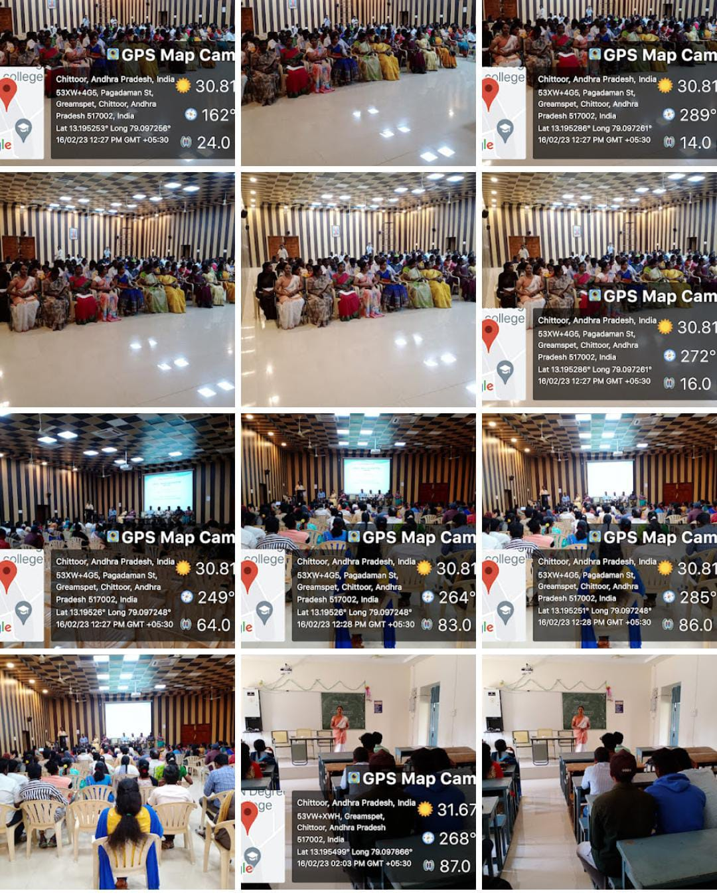

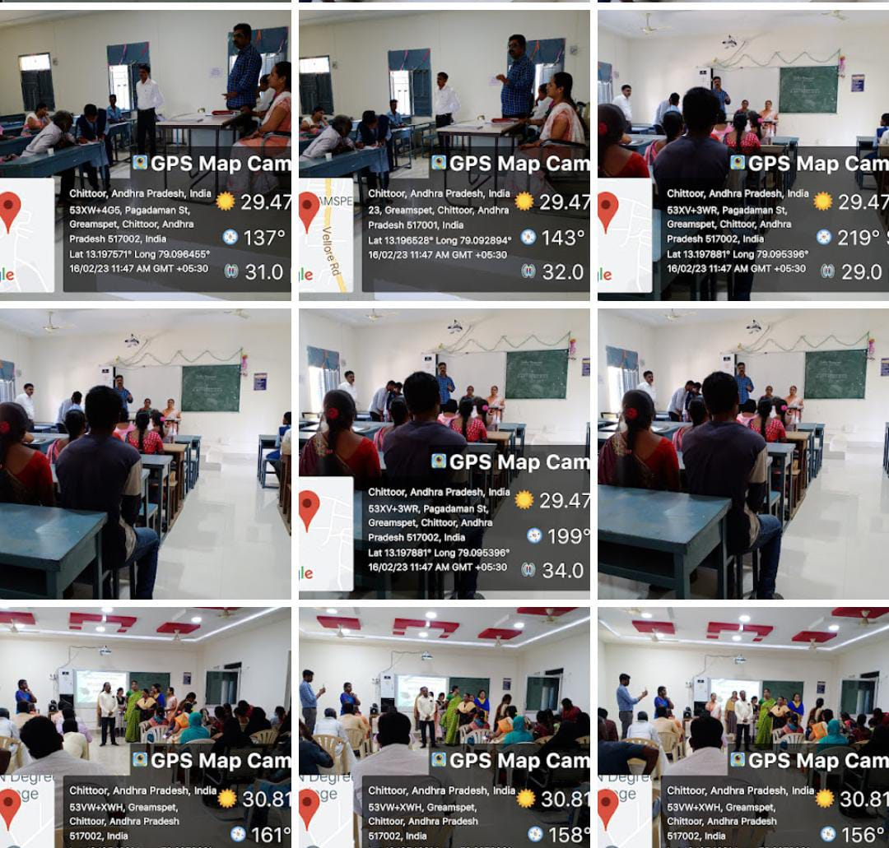
CONDUTED MENTOR-MENTI PROGRAMMER

