COMMISSIONERATE OF COLLEGIATE EDUCATION GOVERNMENT OF ANDHRA PRADESH
Template/Guidelines for Monthly College Newsletter
PVKN CAMPUS ROOTS
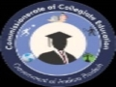
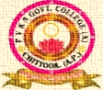
PVKN GOVERNMENT COLLEGE(A)
CHITTOOR
MOTTO: Learn Today – Lead Tomorrow
VISION: “Aims to lead social Progress by Promoting equality and education.”
MONTH: DECEMBER YEAR: 2024
PRINCIPAL’S MESSAGE
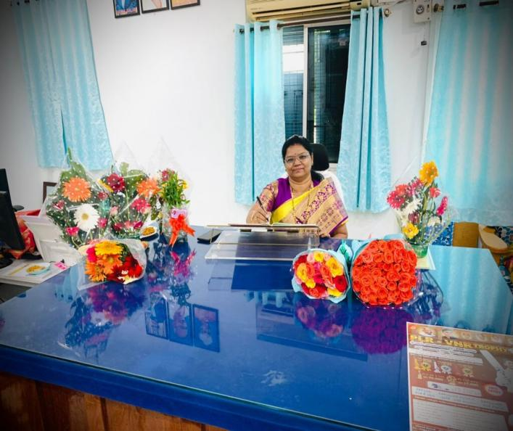
Education is an essential ornament that can lead to our success. Life brings to us different challenges and education helps us in dealing with those challenges in a better way. Education raises the individual to a higher level of awareness and understanding. It provides a person with a unique standard in life and also a feeling of well-being which differentiates human beings from other creatures.

Imparting Value Education is the prime objective of PVKN Govt College, Chittoor. The college has the potential to face the challenges of varied requirements of the students. This prestigious institution has got all the paraphernalia which provides an amicable and congenial atmosphere to achieve the targeted goals.
EDITORIAL BOARD | 1. Dr. P. JEEVAN JYOTHI, Principal
EDITORIAL BOARD | 2.Sri M. AJJANNA, Lecturer in English

CONTENTS
Sl. No | Titles | Page No
1 | Computer Literacy Day | 3
2 | Workshop on Safety Measures to be taken during Menstruator period | 4
3 | Kattamanchi Ramalinga Reddy Jayanthi | 6
4 | Human Rights Day | 7
5 | Geetha Jayanthi | 8
6 | National Mathematics Day | 9
7 | Extension Activity | 12
8 | Guest Lecture | 13
9 | Online workshop – Virtual Labs for Faculty & Students | 14

Celebrated Computer Literacy Day
DEPARTMENT OF COMPUTER APPLICATIONS
Date: 03-12-2024

On the occasion of Computer Literacy Day, the students of B.Com Computer Applications presented an insightful poster presentation focusing on various aspects of technology. The event aimed to highlight the latest advancements in the field, including artificial intelligence, cloud computing, and cybersecurity. Each poster showcased the practical applications and impact of these technologies on different industries. The students effectively conveyed complex concepts through visual elements and concise explanations. The presentations encouraged discussions and deepened understanding of the growing role of technology in modern business. Overall, it was an engaging and informative session that demonstrated the students' knowledge and creativity.
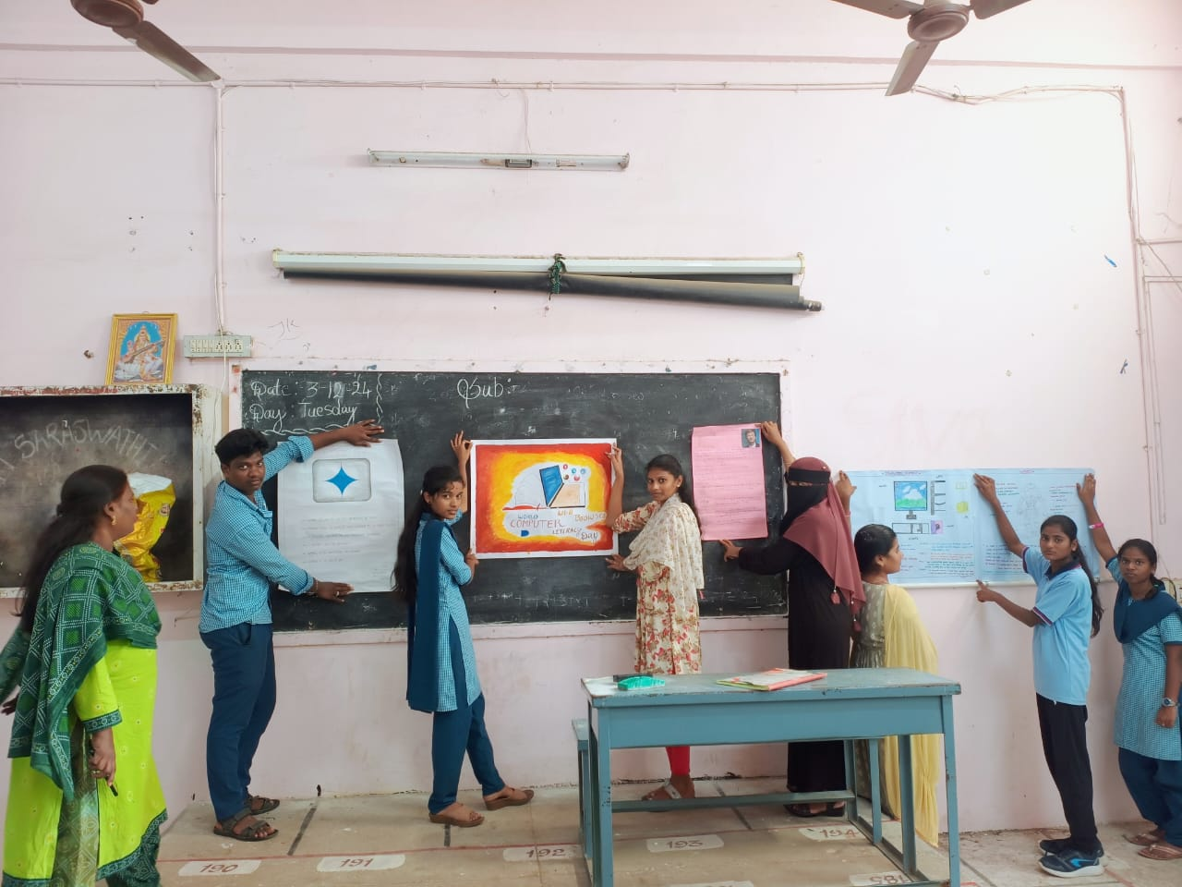
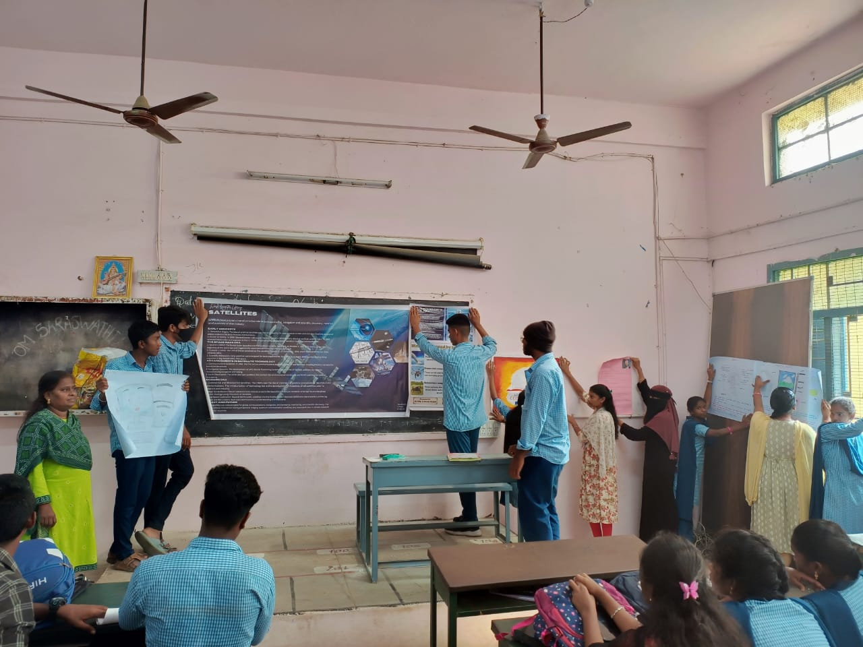

Workshop on “Safety measures to be taken during menstruation period”
Women empowerment cell
06-12-2024
The Women Empowerment Cell of PVKN conducted a workshop on safety measures during menstruation, focusing on health, hygiene, and well-being. The primary objective was to raise awareness about the importance of menstrual hygiene and educate women on the safe use of menstrual products. Resource persons Ananth Raj and Jayasree from the Femi9 group shared expert insights on maintaining cleanliness, managing discomfort, and addressing emotional health during periods with their demonstration. All women students and staff participated, engaging in discussions and learning practical tips for better menstrual care. The session emphasized the need for supportive environments for menstrual health.
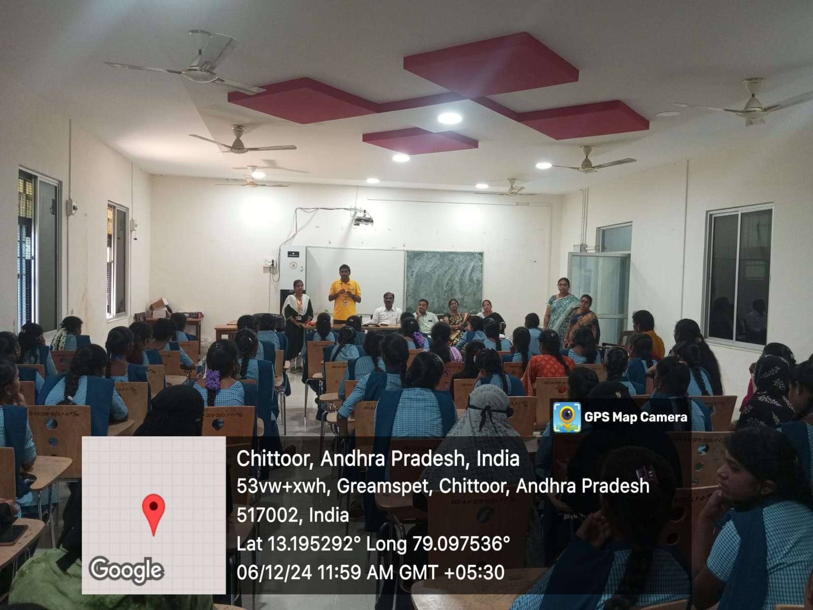

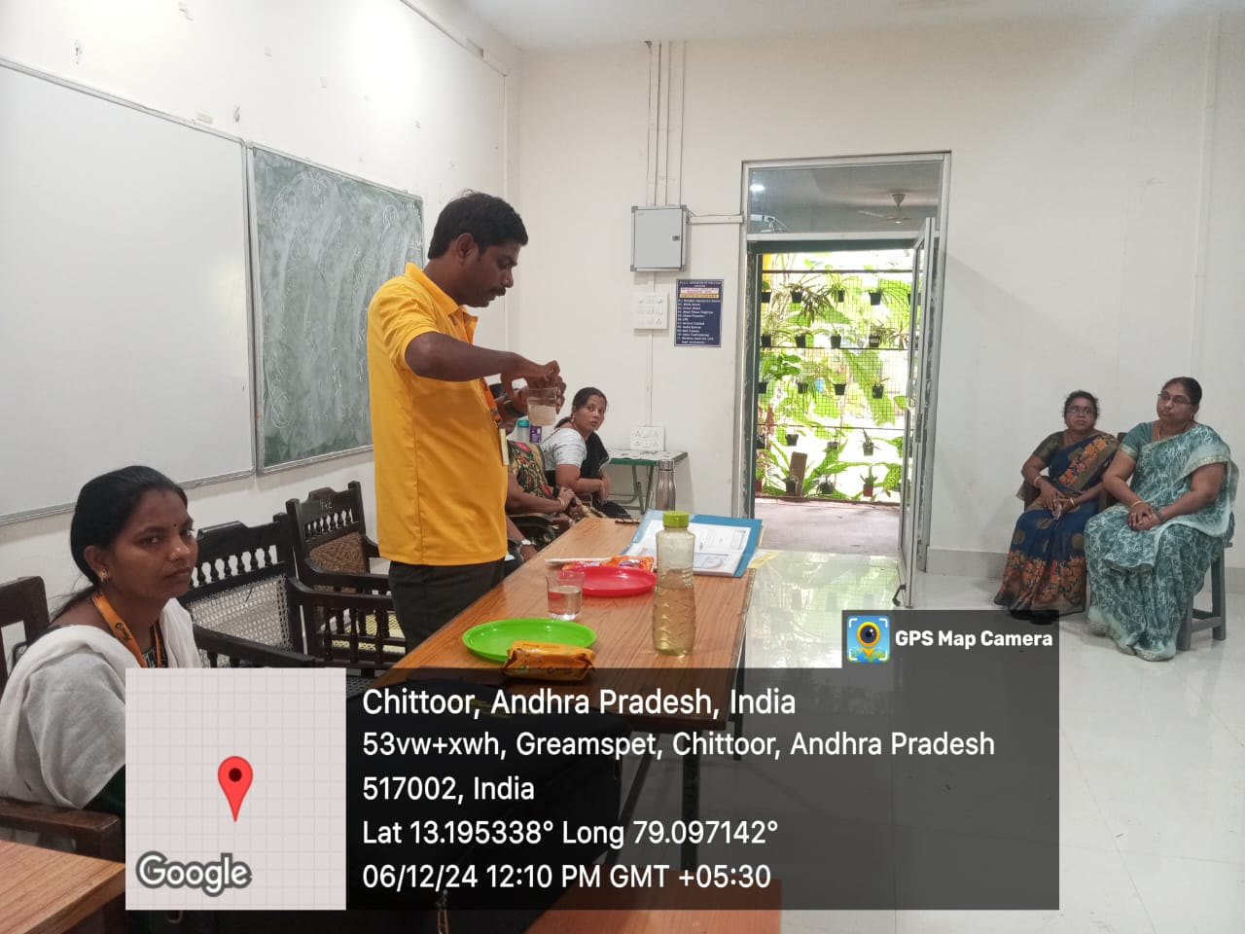
KATTAMANCHI RAMALINGA REDDY JAYANTHI
DEPARTMENT OF TELUGU
DATE:10/12/2024

Aim & Objectives:
Students learn about Kattamanchi Ramalinga Reddy Life History and his works on Telugu Literature and criticism and his effect on Telugu Literature.
Kattamanchi Ramalinga Reddy JAYANTHI celebrations conducted by Department of Telugu on 10.12.2024. Dr. P. C. CHENNAKESAVULU Lecturer, In Charge, Department of Telugu preside over the function. SRI B. GOPIRYA NAICK, Lecturer in Telugu, Dr.P. JAYACHANDRUDU, Lecturer in Telugu spokes about the life and works of Kattamanchi Ramalinga Reddy. students also spoke about Kattamanchi Ramalinga Reddy JAYANTHI. Students are actively participated in this programme.

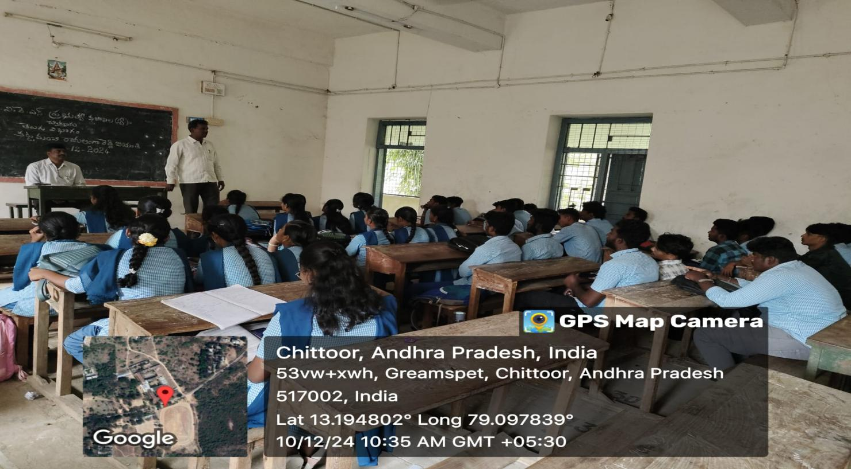

Human Rights Day
Department Political Science
Date: 10/12/2024

- Brief Report:
Department of Political Science Human Rights Days conducted on 10-12-2024. Human Rights Day, observed every year on 10th December highlights the importance of human rights as a foundation for justice, peace, and equality. 2024 Theme: "Our Rights, Our Future, Right Now" emphasizes the relevance of human rights in shaping a peaceful and sustainable future.
- Programme outcomes:
Human Rights Day 2024 aims to spread awareness about human rights education among the youth and the significance of promoting the values of equality, justice and dignity from an early age. The day reaffirms the importance of committing towards safeguarding human dignity for the nation and its citizens.

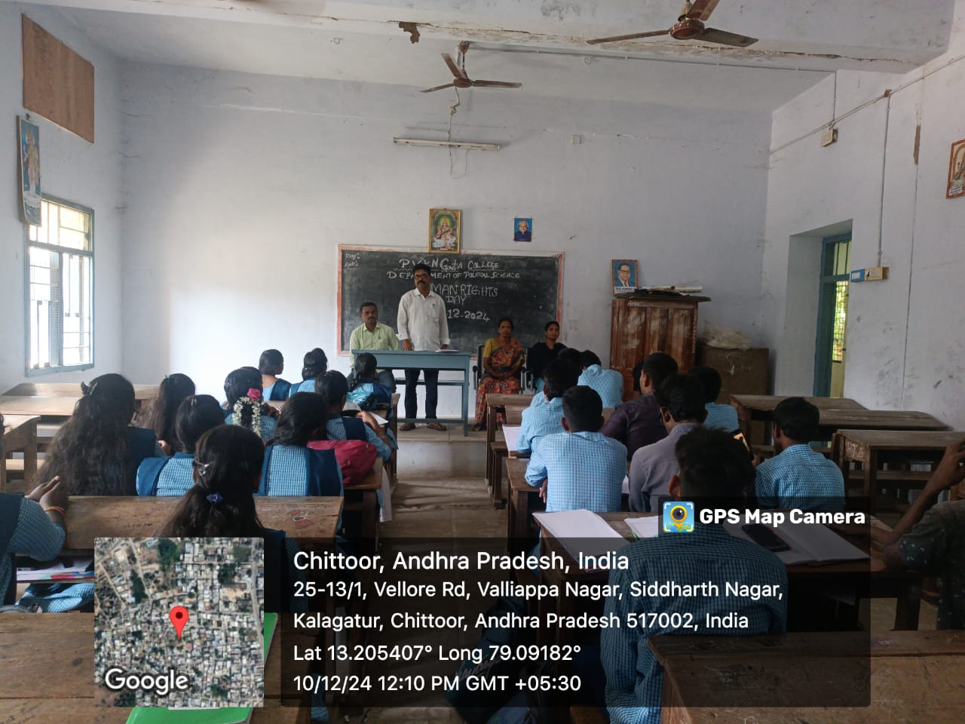

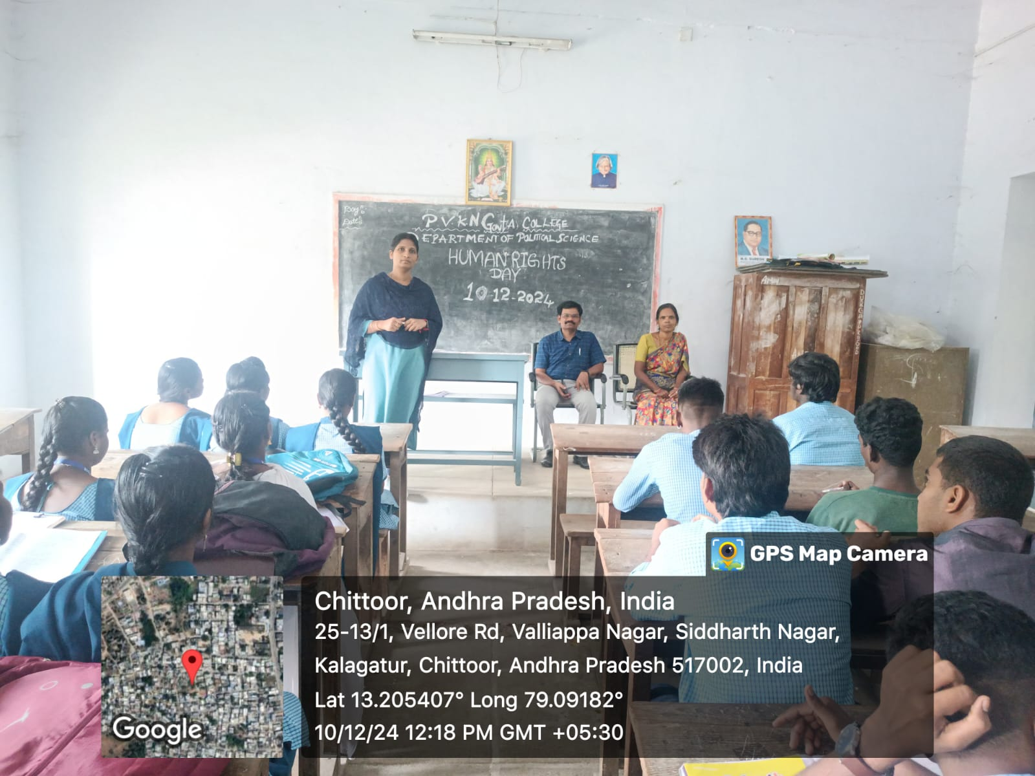

GEETHA JAYANTHI
DEPARTMENT OF SANSKRIT
Date: 11/12/2024
Aim & Objectives:
The Bhagavad Gita is the divine conversation between a man named Arjuna and God himself in the human form, Lord Krishna.
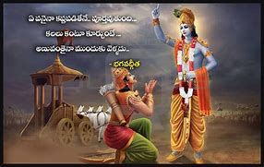
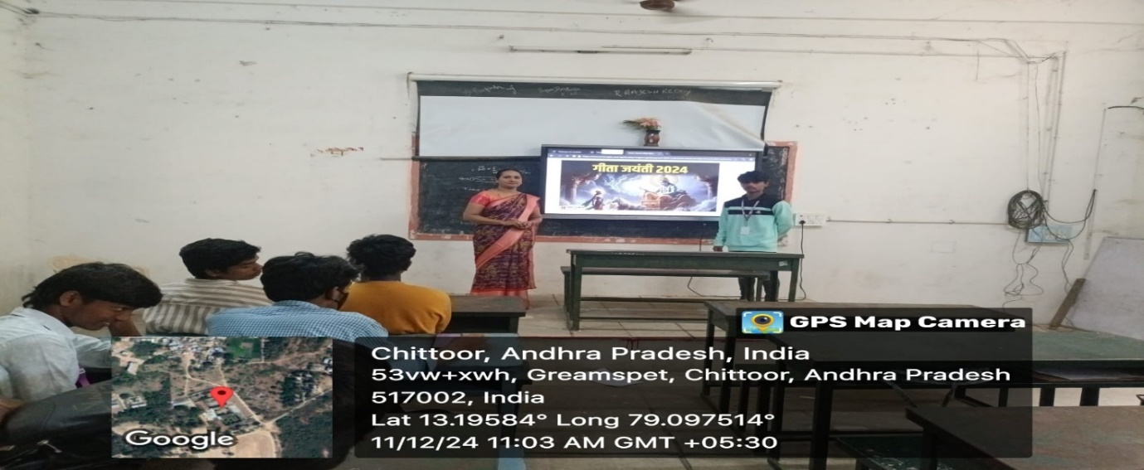

NATIONAL MATHEMATICS DAY CELEBRATION
Department of Mathematics
Date: 21-12-2024
- AIM:
- Celebrate Srinivasa Ramanujan: Honor the contributions of the renowned Indian mathematician to the field of mathematics
- Promote the importance of mathematics: Highlight the significance of mathematics in everyday life
- Inspire young people: Encourage children to think critically and logically, and to develop mathematical skills
- Promote mathematical knowledge: Spread awareness about the importance of mathematics and encourage the use of mathematics in every field of study
- Stress that formal education is not the only way to achieve success: Show that there are other ways to achieve success

Event Details:
- Date: 21st December 2024
- Venue: Room no : 55
- Activity Coordinator: Dr S . Nagendra (HOD)
- Name of the Lecturers who participated:
1. R. Jayalakshmi
2. P. Kavitha
3. Dr P. Bhanu Prakash
4. Dr P. Udaya Bhaskar Reddy

- Participants: 40 students have participated in the activity.

Brief Report:

National Mathematics Day Celebrated on 21/12/2024 at 12:30 PM on the eve of National Mathematics Day- 22-12-2024.
Dr P. Jeevan Jyoti, Principal attended as Chief Guest and gave lecture on importance of that day regarding the Occasion. Explained the history of Evolution of numbers by HOD. Poster presentation by students related to Life history of Srinivasa Ramanujan.

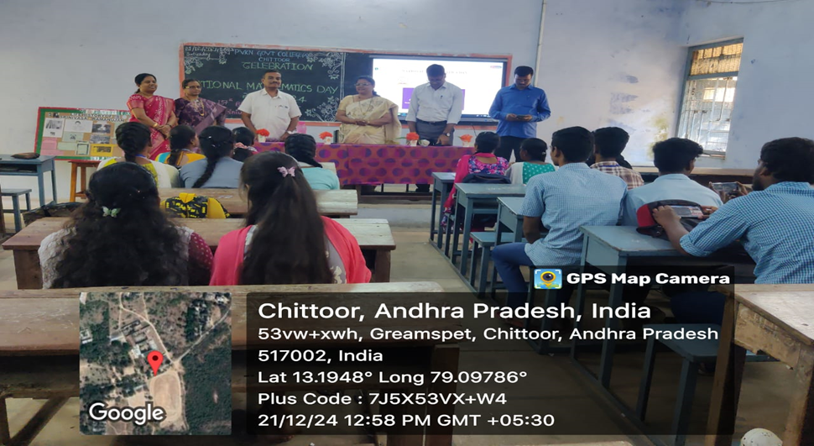

PRINCIPAL’S REMARKS REGARDING THE OCCASION

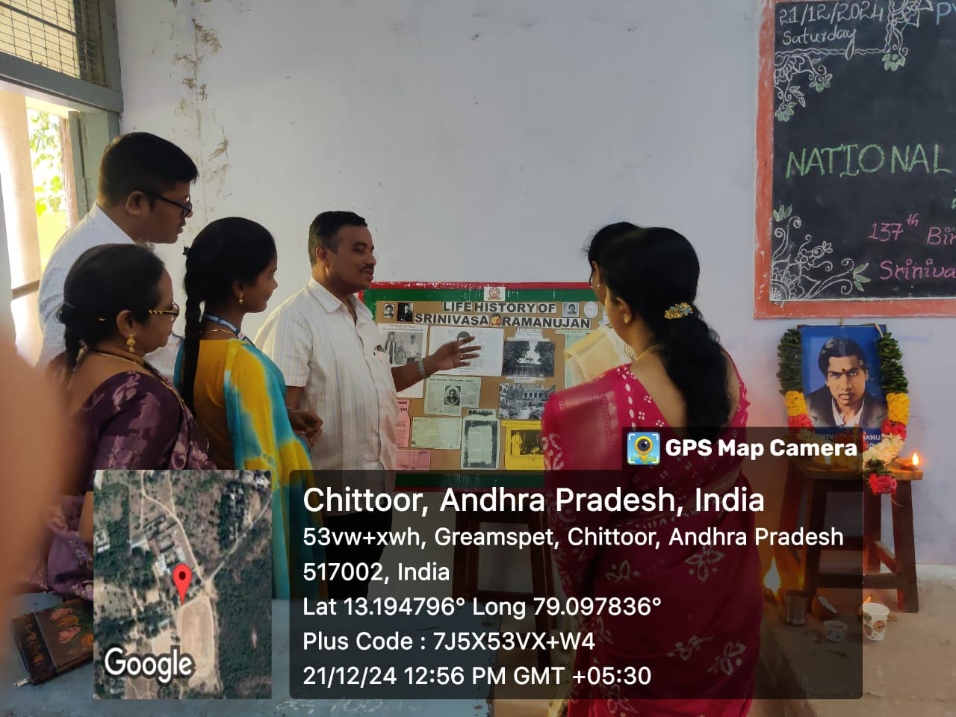
POSTER PRESENTATION BY STUDENTS

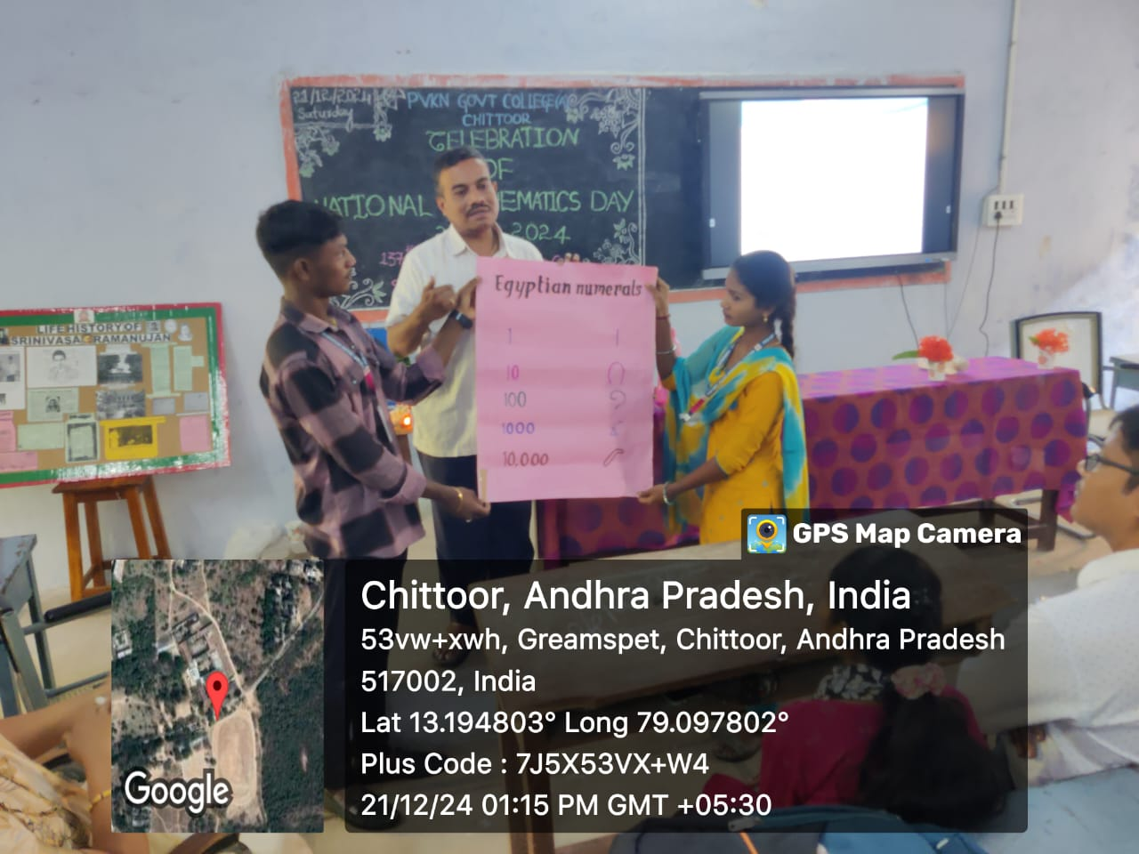
EXPLAIN THE HISTORY OF EVOLUTION OF NUMBERS BY HOD

EXTENSION ACTIVITY
Department of Mathematics
Date: 23-12-2024

Brief Report : Dr .Nagendra , Lecturer in Mathematics Acted as a
Judge for students Projects on Mathematics at Sri
Chaitanya E-techno School, Chittoor.

Programme outcomes: Maths Project helps students to exhibit their theories into practical knowledge and get real-time experiences. It will help them to grow interpersonal skills
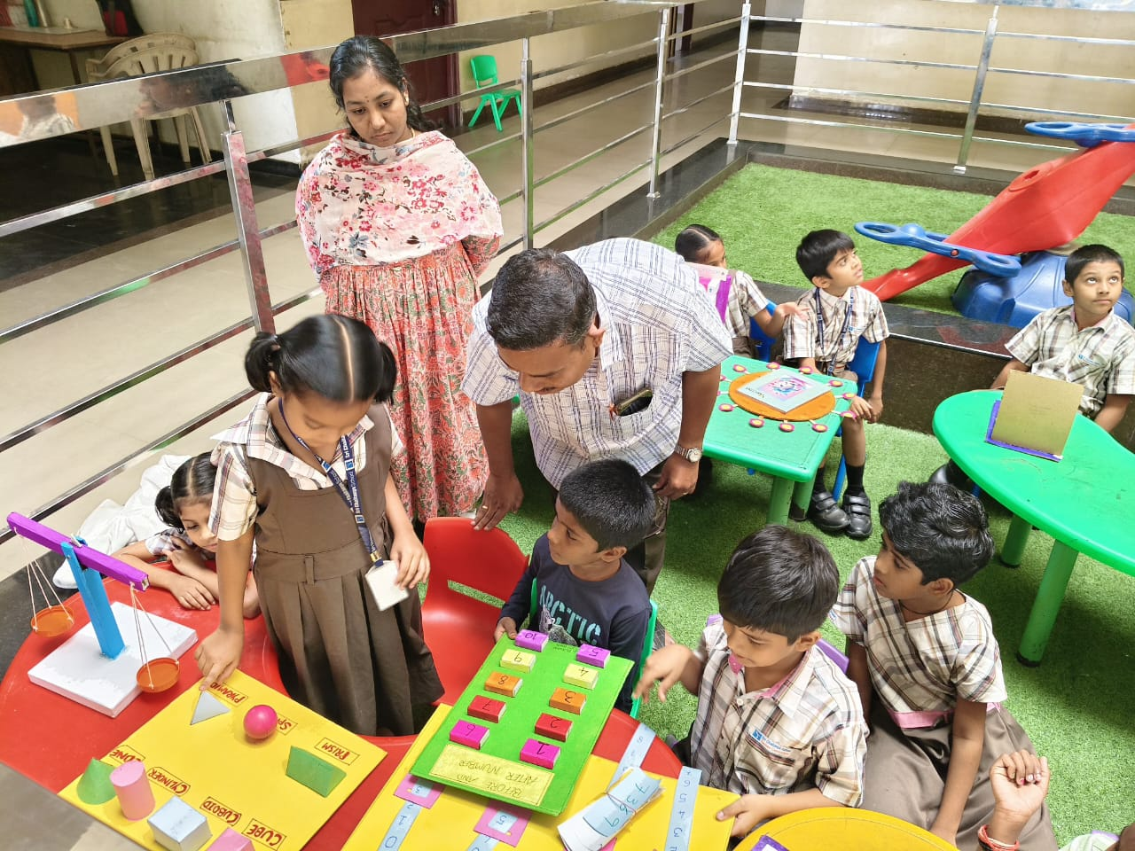

GUEST LECTURE
Department of Mathematics
Date: 23-12-2024

Brief Report : Dr .Nagendra , Lecturer in Mathematics gave a Guest Lecture on
“ Life History of Srinivasa Ramanujan “ in Sri Chaitanya
E- Techno School , Chittoor at 12:00 Noon. On occasion of
National Mathematics day - 22-12-2024

6. Programme outcomes: The Guest lectures supplement the regular curriculum for the students. They provide additional information, practical insights, and relevant industry practices that the students can use to enhance their basic understanding.24 Dec 2023

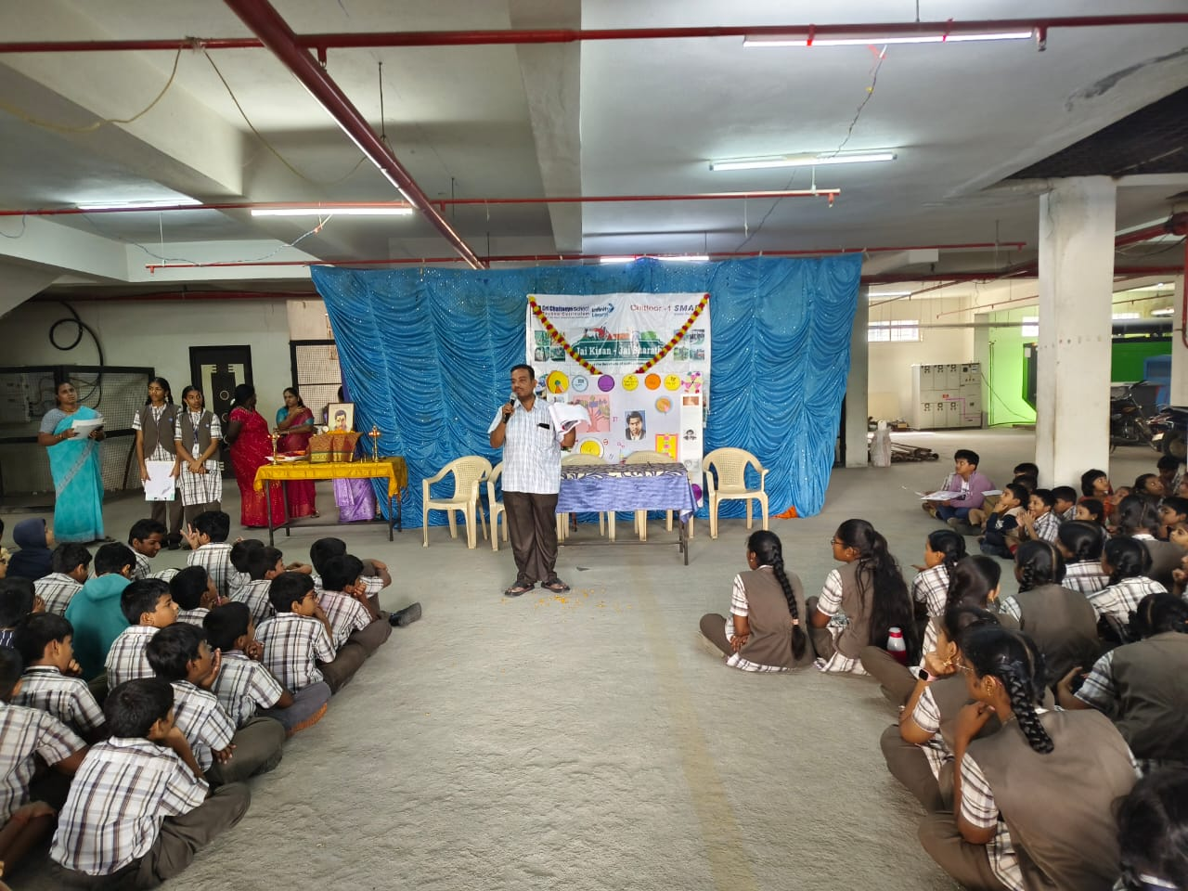

On-Line Workshop-Virtual Labs for Faculty & Students (VLFS)
Date: 27-12-2024-2.00 to 4.30 Pm

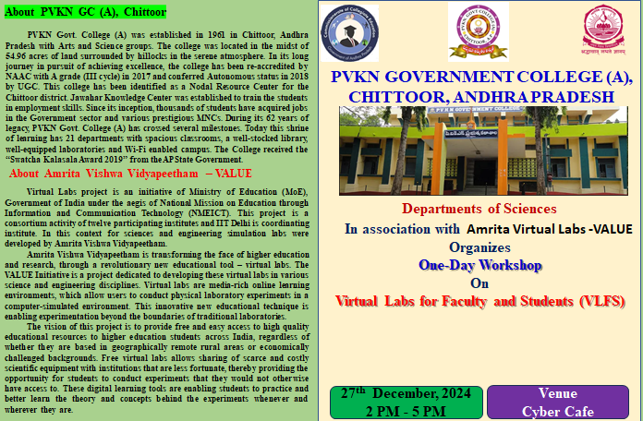

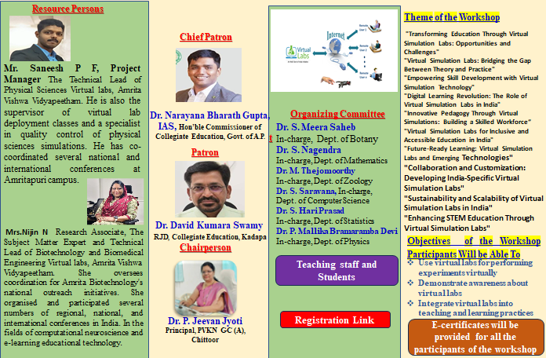

Report on One-Day Online Workshop
Topic: Virtual Labs for Faculty & Students
Date: 27th December 2024
Time: 2:00 PM to 4:30 PM
Venue: Cyber Cafe @ Room No: 76
As per the Proceedings of our CCE, on 29-11-2024, our PVKN Govt. College (A) Nodal Centre was organised - Orientation program for Science Faculty and Students by Amrita Virtual Labs- VALUE- Conducted the online workshop -On 27th Dec- 2024- Friday - Afternoon from 2.00 PM to 5.00 PM- Through Google meet.
Total 234 Number of participants are registered by both Faculty & Students through online in Google form.
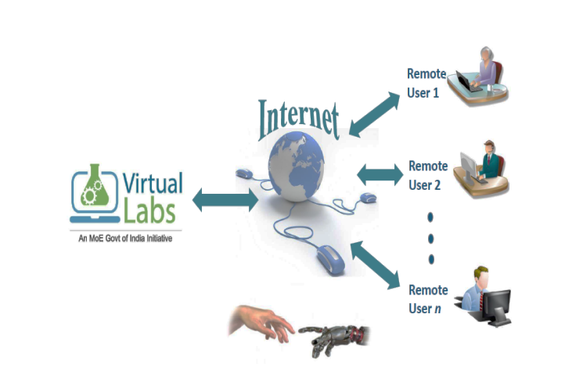
Workshop Objectives:
After completion of this workshop the faculty & students are able
• To familiarize faculty and students with virtual lab platforms.
• To demonstrate how virtual labs can complement traditional teaching methods.
• To enhance the understanding of virtual simulations for practical experiments.

Event Highlights
- Welcome Address & Inaugural Session:
The workshop began with a welcome address by Dr. P. Bhanu Prakash, In-charge and Academic Coordinator, and Principal of PVKN Govt. College(A), Dr. P. Jeevan Jyothi, who emphasized the significance of virtual labs in bridging the gap between theoretical knowledge and practical implementation.
- Technical Demonstration:
  - The first resource person Mr. Saneesh P F, Project Manager & The Technical Lead of Physical Sciences Virtual labs, Amrita Vishwa Vidyapeetham. He is also the supervisor of virtual lab deployment classes and a specialist in quality control of physical sciences simulations. He presented an insightful session on the use of virtual labs for various Physical Science disciplines. He is also shared their knowledge and skill regarding the Physical, Chemical & Computer Science simulations virtual labs.
  - Another Resource person Mrs. Nijin N, Research Associate, The Subject Matter Expert and Technical Lead of Biotechnology and Biomedical Engineering Virtual labs, Amrita Vishwa Vidyapeetham. She oversees coordination for Amrita Biotechnology's national outreach initiatives. She organized and participated several numbers of regional, national, and international conferences in India. In the fields of computational neuroscience and e-learning educational technology.
  - A live demonstration showcased hands-on experiments, enabling participants to understand the user interface and functionality of the virtual lab platform.
- Interactive Q&A Session:
Participants were given an opportunity to clarify their doubts and share their feedback. Questions related to the application of virtual labs, technical challenges, and integration into the curriculum were addressed effectively.
- Hands-On Practice:
Attendees were guided through practical exercises to explore virtual labs independently, ensuring active engagement and understanding.
- Conclusion
The On-Line Workshop on Virtual Labs for Faculty and Students (VLFS) has successfully underscored the importance of integrating virtual labs into modern education. Through engaging sessions, hands-on demonstrations, and collaborative discussions, participants have gained valuable insights into leveraging these innovative tools to enhance teaching and learning experiences.

Virtual labs empower educators and students by offering flexible, cost-effective, and safe environments for exploring complex concepts, conducting experiments, and fostering practical skills. This workshop has not only highlighted the technical and pedagogical aspects of virtual labs but has also encouraged the adoption of best practices to ensure an impactful implementation in diverse educational contexts.
As we conclude, we hope that the knowledge and skills acquired during this workshop will enable participants to innovate their teaching methodologies, inspire their students, and make the most of the exciting possibilities that virtual labs offer. Let us continue this journey of transforming education together and creating a brighter future for learning.
Thank you for your active participation, enthusiasm, and commitment to advancing education through Information & Communication Technology.

